

**POST GRADUATE GOVERNMENT COLLEGE FOR GIRLS**

**SECTOR-42, CHANDIGARH**



**MAJOR REPORT**

**ON**

**SCHOOL MANAGEMENT SYSTEM**

MS-21(MAJOR PROJECT)

**Submitted in partial fulfilment of the requirement for the degree of**

**M.Sc. (IT) under PANJAB UNIVERSITY, CHANDIGARH (2021-2022)**

**Submitted by:**

Sonia (**205305**)

M.sc (IT) 4thSem

**Project Guide :-**

Mrs. Sarbjit Kaur **(Internal Guide)**

Assitant Professor PGGCG-42

(Department of Computer Application)

Miss Rekha **(Extrenal Guide)**

Trainer

## (ASwebinfo)

**Acknowledgement**

**ACKNOWLEDGEMENT**

## **“The successful completion of any task would be incomplete without accomplishing the people who made it all possible and whose constant guidance and encouragement secured us the success.”**

It is my proud privilege to express my profound gratitude to the Head of Department of Computer Applications, **Dr. Shweta Bali**  for providing me with the opportunity to avail the excellent facilities and infrastructure. The knowledge and values inculcated have proved to be of immense help at the very start of my career.

I am extremely thankful and pay my gratitude to **Mrs. Sarbjit** Assistant Professor at PGGCG-42 Chandigarh, for her valuable guidance and support on completion of this project in its presently. I would like to thank **ASwebinfo** for providing me with an opportunity to pursue my industrial training, it is the one that exposes you to the industry standards and makes you adapt yourself to the latest trends and technologies. At the same time, it gives an experience of working on a project.

I feel proud and privileged in expressing my deep sense of gratitude to all those who have helped me in presenting this project. I would be failing in my endeavour if I do not place my acknowledgment.

Thanking You

SONIA

**CERTIFICATE**

This is to certify that the project titled **School Management System** is a work carried out by **SONIA (Roll No. 205305)** of M.SC. IT -II (IV Semester) in partial fulfillment of M.SC. IT Course of Panjab University, Chandigarh. She did her Industrial Training from **ASwebinfo.**

During this time period she has regularly reported the progress of her training and project to her internal guide.

**Internal Guide Head of the Department Principal**

**INDEX**

|  |  |  |
| --- | --- | --- |
| **Sr. No.** | **Topics** | **Page no.** |
| 1 | About Organization | 5 |
| 2 | Introduction of Project | 6 |
| 3 | Objective of The Project | 7 |
| 4 | System Analysis | 8 |
| 5 | Front End & Back End | 9-13 |
| 6 | Software Development Life Cycle  Feasibility Study  Requirements Analysis  System Design  Development  Maintenance  System Testing | 13-21 |
| 7 | Data Flow Diagram | 22-25 |
| 8 | Coding with output | 26-296 |
| 9 | Data Base Table | 297-298 |
| 10 | Future Scope | 299 |
| 11 | References/Bibliography | 300 |

**Company Profile**

**ASwebinfo Web Solution Company**

Aswebinfo is the leading company in India. They are popular as the web solution company in Mohali. We believes in innovation and creativity. Aswebinfo provides various services to his clients like:Web designing, Logo design, Banner Designs, flyers designs, landing page designs, SEO (Search Engine Optimization), SMO (Social Media Optimization), SMM (Social Media Marketing), Domain and Web Hosting provider, CMS, Digital Marketing, facebook Likes, views on Videos and web promotion etc.

They have experience in making the best website designs for any kind of the website design. As a web solution company they provide all kind of the web related services to our clients. Our website designing services covers strategic planning, business intelligence, creative, application development, product / service promotion & solution maintenance. Once the client has approved the design our employees start working of that project. They do not have to worry about the maintenance of their websites. Aswebinfo never compromise with the need of the clients. We always keep an eye on every single thing. Giving the best quality of product is our main motive. Since, there is large number of companies that deals in the web services and SEO. But we provide equal panorama, exceptional infrastructure and working environment to our employees.

**Objectives**

* To promote the applications of Information Technology and Computer Science.
* Reduce time consumption
* Reduce error scope
* Easy operations for operator of the system
* No paper work requirement

**Aswebinfo offers the following services**

* Logo Designing
* Website Designing
* Website Hosting
* Website Development
* Content Writing
* Industrial Training with Live Projects
* SMO Service
* Google Adwords
* Facebook Ad
* Digital Marketing

**INTRODUCTION**

**Project Title:** School Management System

## **Project Advisor:** Mrs. Sarbjit (Internal Guide)

**Project Manager:** Miss. Rekha Droch (Exteranl Guide)

A Major Project titled “School Management System” *MS-21(Major Project)* is to manage the details of each and every members of the School, whether it is Student, Teacher.

It will keep the record of all the candidate enrolling in the website.

Not only the records of students but also of the teachers.

The application is reduced as much as possible to avoid errors while entering the data. No formal knowledge is needed for the user to use this system. Thus by this all it proves it is user-friendly. School Management System is secure and reliable website. It can assist the user to concentrate on their activities rather to concentrate on the record keeping work. Thus it will help organization in better utilization of resources.

This project will handle whole the activities of the school. School Management system has most of the facilities that a modern school requires to computerize its day-to-day jobs. It provides facilities to keep the records of student, fees, teaching and non-teaching staff with all their required details along with all required transaction handling. It has facilities to generate various types of reports, which are required by the management during normal business operations to operate the business effectively

# OBJECTIVES

The main objective of the Major Project titled “School Management System” **is to** manages the records of student and teachers.

The purpose of the project is to build an application program to reduce the manual work for managing student record.

The application is reduced as much as possible to avoid errors while entering the data. No formal knowledge is needed for the user to use this website.

The main objective of this project is to computerize the manual system & reduce the time consumption. In other words we can say that our project has the following objectives:-

* Make all the system computerize
* Reduce time consumption
* Reduce error scope
* All system managements are automated
* Centralized database management
* Easy operations for operator of the system
* No paper work requirement

**SYSTEM ANALYSIS**

Analysis is a detailed study of the various operations performed by a system and their relationship within and outside of the system. In general view system is collection of people, procedures and equipment. People are not the only important component of any information system. Information is produced and used by people in an organization in their everyday activities to make decisions. Information system establishes procedures ensuring that right people receive right data at right time. These procedures determine what is to be done at it enter and passed through the system. System analysis is the method that is used to analyse the system, design them and build them. Analysis is used to gain an understanding of existing and what is required in system. The analysis phase ends with the system description and a set of requirements of the new system. Analysis is a process of diagnosis the situation with the boundaries of system kept in mind to produce a report based own findings.

**IDENTIFICATION OF NEED**

Detailed information requirement analysis of organization is collected from present system. As a person has to be changed with the prevailing conditions of society, in the same a system has to be changed accordingly.

Computerized organization is the today’s demand. In comparison to the old system, the computerized system is more reliable and cost effective. In the present organization, the data is scattered whereas the data should be integrated at one place so that the modifications can be made easily and it becomes easy for any authorized person to get information from these files.

* **Preliminary investigation**

To meet the above-mentioned requirement, we need android based platform. It should be a simple device/simulator because the user going to use it are not much familiar with these kinds of systems so it should be a simple, easy to use an understandable to all persons.

* **Objectives**
  + 1. Efficiency: when all the work is done by device then it will increase the efficiency, so all the activities will be done faster.
    2. This application also save time for making test results.
    3. This application runs on android platform so user can access it anytime anywhere.

At present time, every person is in hurry, nobody has spare time. Every passenger wants quick service. With this application, every passenger will avail every type of services.

## **FRONT END USED**

* **HTML:-**

**HTML** stands for HyperText Markup Language. It is used to design web pages using a markup language. HTML is the combination of Hypertext and Markup language. Hypertext defines the link between the web pages. A markup language is used to define the text document within tag which defines the structure of web pages. This language is used to annotate (make notes for the computer) text so that a machine can understand it and manipulate text accordingly. Most markup languages (e.g. HTML) are human-readable. The language uses tags to define what manipulation has to be done on the text.

HTML is a markup language used by the browser to manipulate text, images, and other content, in order to display it in the required format. HTML was created by Tim Berners-Lee in 1991. The first-ever version of HTML was HTML 1.0, but the first standard version was HTML 2.0, published in 1995.

* **CSS:-**

**C**ascading **S**tyle **S**heets, fondly referred to as **CSS**, is a simply designed language intended to simplify the process of making web pages presentable. CSS allows you to apply styles to web pages. More importantly, CSS enables you to do this independent of the HTML that makes up each web page. It describes how a webpage should look: it prescribes colors, fonts, spacing, and much more. In short, you can make your website look however you want. CSS lets developers and designers define how it behaves, including how elements are positioned in the browser.

while html uses tags, css uses rulesets.  
CSS is easy to learn and understand, but it provides powerful control over the presentation of an HTML document.

* **JAVASCRIPT:-**

**JavaScript** is a lightweight, cross-platform, and interpreted compiled programming language which is also known as the scripting language for webpages. It is well-known for the development of web pages, many non-browser environments also use it. JavaScript can be used for [**Client-side**](https://www.geeksforgeeks.org/server-side-client-side-programming/) developments as well as [**Server-side**](https://www.geeksforgeeks.org/server-side-client-side-programming/) developments. Javascript is both imperative and declarative type of language .JavaScript contains a standard library of objects, like [**Array**](https://www.geeksforgeeks.org/arrays-in-javascript/), [**Date**](https://www.geeksforgeeks.org/javascript-date-objects/), and [**Math**](https://www.geeksforgeeks.org/javascript-math-object/), and a core set of language elements like **operators**, **control structures**, and **statements**.

* **BOOTSTRAP:-**

Bootstrap is a free and open-source tool collection for creating responsive websites and web applications. It is the most popular HTML, CSS, and JavaScript framework for developing responsive, mobile-first websites. It solves many problems which we had once, one of which is the cross-browser compatibility issue. Nowadays, the websites are perfect for all the browsers (IE, Firefox, and Chrome) and for all sizes of screens (Desktop, Tablets, Phablets, and Phones). All thanks to Bootstrap developers -Mark Otto and Jacob Thornton of Twitter, though it was later declared to be an open-source project.

* **PHP:**-

The term PHP is an acronym for PHP: Hypertext Preprocessor. PHP is a server-side scripting language designed specifically for web development. It is open-source which means it is free to download and use. It is very simple to learn and use. The files have the extension “.php”.

Rasmus Lerdorf inspired the first version of PHP and participated in the later versions. It is an interpreted language and it does not require a compiler.

* PHP code is executed in the server.
* It can be integrated with many databases such as Oracle, Microsoft SQL Server, MySQL, PostgreSQL, Sybase, and Informix.
* It is powerful to hold a content management system like WordPress and can be used to control user access.
* It supports main protocols like HTTP Basic, HTTP Digest, IMAP, FTP, and others.
* Websites like www.facebook.com and www.yahoo.com are also built on PHP.
* One of the main reasons behind this is that PHP can be easily embedded in HTML files and HTML codes can also be written in a PHP file.
* The thing that differentiates PHP from the client-side language like HTML is, that PHP codes are executed on the server whereas HTML codes are directly rendered on the browser. PHP codes are first executed on the server and then the result is returned to the browser.
* The only information that the client or browser knows is the result returned after executing the PHP script on the server and not the actual PHP codes present in the PHP file. Also, PHP files can support other client-side scripting languages like CSS and JavaScript.

**Components:-**

**MySQL-database php**

**Javascript,**

**Html, CSS,**

**bootstrap**

(FRONT-END) (SCRIPTING-LANGUAGE) (BACK-END)

* **BACK END USED**

## My SQL

MySQL is the world's most popular open source database software, with over 100 million copies of its software downloaded or distributed throughout its history. With its superior speed, reliability, and ease of use, MySQL has become the preferred choice for Web, Web 2.0, SaaS, ISV, Telecom companies and forward-thinking corporate IT Managers because it eliminates the major problems associated with downtime, maintenance and administration for modern, online applications.

Many of the world's largest and fastest-growing organizations use MySQL to save time and money powering their high-volume Web sites, critical business systems, and packaged software — including industry leaders such as Yahoo!, Alcatel-Lucent, Google, Nokia, YouTube, Wikipedia, and Booking.com.The flagship MySQL offering is MySQL Enterprise, a comprehensive set of production-tested software, proactive monitoring tools, and premium support services available in an affordable annual subscription.

MySQL is a key part of WAMP (Windows, Apache, MySQL, PHP / Perl / Python), the fast-growing open source enterprise software stack. More and more companies are using LAMP as an alternative to expensive proprietary software stacks because of its lower cost and freedom from platform lock-in.

MySQL was originally founded and developed in Sweden by two Swedes and a Finn: David Axmark, Allan Larsson and Michael "Monty" Widenius, who had worked together since the 1980's.

## **My SQL PHP**

PHP is a server-side, HTML-embedded scripting language that may be used to create dynamic Web pages. It is available for most operating systems and Web servers, and can access most common databases, including MySQL. PHP may be run as a separate program or compiled as a module for use with a Web server.PHP provides four different MySQL API extensions:

* [MySQL Improved Extension](https://dev.mysql.com/doc/apis-php/en/apis-php-mysqli.html): Stands for “MySQL, Improved”; this extension is available as of PHP 5.0.0. It is intended for use with MySQL 4.1.1 and later. This extension fully supports the authentication protocol used in MySQL 5.0, as well as the Prepared Statements and Multiple Statements APIs. In addition, this extension provides an advanced, object-oriented programming interface.
* [MySQL Functions (PDO_MYSQL)](https://dev.mysql.com/doc/apis-php/en/apis-php-pdo-mysql.html): Not its own API, but instead it's a MySQL driver for the PHP database abstraction layer PDO (PHP Data Objects). The PDO MySQL driver sits in the layer below PDO itself, and provides MySQL-specific functionality. This extension is available as of PHP 5.1.0.
* [Mysql_xdevapi](https://dev.mysql.com/doc/apis-php/en/apis-php-mysql-xdevapi.html): This extension uses MySQL's X DevAPI and is available as a PECL extension named [mysql_xdevapi](https://pecl.php.net/package/mysql_xdevapi). For general concepts and X DevAPI usage details, see [X DevAPI User Guide](https://dev.mysql.com/doc/x-devapi-userguide/en/).
* [Original MySQL API](https://dev.mysql.com/doc/apis-php/en/apis-php-mysql.html): Available for PHP versions 4 and 5, this extension is intended for use with MySQL versions prior to MySQL 4.1. This extension does not support the improved authentication protocol used in MySQL 4.1, nor does it support prepared statements or multiple statements. To use this extension with MySQL 4.1, you will likely configure the MySQL server to set the [old_passwords](https://dev.mysql.com/doc/refman/5.7/en/server-system-variables.html#sysvar_old_passwords) system variable to 1.

* **SDLC**

The Systems Development Life Cycle (SDLC) is a conceptual model used in project management that describes the stages involved in an information system development project from an initial feasibility study through maintenance of the completed application. Various SDLC methodologies have been developed to guide the processes involved including the waterfall model (the original SDLC method), rapid application development (RAD), joint application development (JAD), the fountain model and the spiral model. Mostly, several models are combined into some sort of hybrid methodology. Documentation is crucial regardless of the type of model chosen or devised for any application, and is usually done in parallel with the development process. Some methods work better for specific types of projects, but in the final analysis, the most important factor for the success of a project may be how closely particular plan was followed.

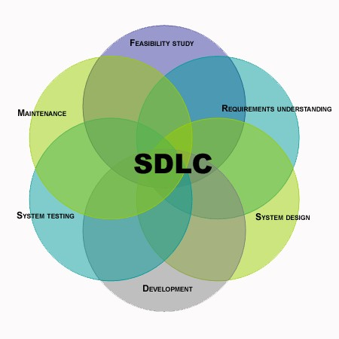

The most common steps in all the development methodologies are as follows:

**1. System/Information Engineering and Modelling:**

As software is always of a large system (or business), work begins by establishing the requirements for all system elements and then allocating some subset of these requirements to software. This system view is essential when the software must interface with other elements such as hardware, people and other resources. System is the basic and very critical requirement for the existence of software in any entity. So, if the system is not in place, the system should be engineered and put in place. In some cases, to extract the maximum output, the system should be re-engineered and spruced up. Once the ideal system is engineered or tuned, the development team studies the software requirement for the system.

**2 Software Requirement Analysis:**

This process is also known as feasibility study. In this phase, the development team visits the customer and studies their system. They investigate the need for possible software automation in the given system. By the end of the feasibility study, the team furnishes a document that holds the different specific recommendations for the candidate system. To understand the nature of the program(s) to be built, the system engineer or "Analyst" must understand the information domain for the software, as well as required function, behavior, performance and interfacing. The essential purpose of this phase is to find the need and to define the problem that needs to be solved.

**SOFTWARE SYSTEM REQUIREMENT**

|  |  |
| --- | --- |
| Operating system | Any (Windows/Linux etc.) |
| Web browser | Any (Mozilla, Chrome, IE etc.) |
| Device/Simulator | Any browser |
| Database | MySQL, PHP API |
| Connection protocol | TCP/IP, HTTPS |
| Editor | Notepad++ |
| Frontend technologies | Html,Css,javascript,bootstrap |
| Backend technologies | MySQL,PHP |

Table.1 Software Requirements for the Application

# HARDWARE REQUIREMENTS

|  |  |  |  |  |  |  |  |  |  |  |  |  |  |
| --- | --- | --- | --- | --- | --- | --- | --- | --- | --- | --- | --- | --- | --- |
| |  |  | | --- | --- | | Processor type | Pentium-III or faster | | Processor speed | 1.0 GHz or more | | System bus | 32/64 bit | | RAM | 1 GB or more | | Hard disk | 150 GB or more | | Device | Android-Platform/Simulator | |  |
| Table.2 Hardware Requirements for the Application |  |
|  |  |
|  |  |

**4 Maintenance:**

The software will definitely undergo change once it is delivered to the customer. There can be many reasons for this. Change could happen because of some unexpected input values into the system. In addition, the changes in the system could directly affect the software operations. The software should be developed to accommodate changes that could happen during the post implementation period.

**Feasibility Study: -**

Feasibility study is carried out to test if the proposed system is worth being implemented. Given unlimited resources and infinite time, all projects are feasible. Unfortunately, such situations are not possible in real time. It is usually carried out by a small group of people who are familiar with the information system techniques; understand the part of business that will be involved and affective by the people that are skilled in analysis and design.

A feasibility study is conducted to select the best system that meets the performance requirements. This entails an identification description, and emulation of candidate systems and selection of best system for the job.

1. **Economic Feasibility:**

Economic analysis is the most frequently used method for evaluating the effectiveness of a candidate system. More commonly known as cost/benefits and saving that are expected from a candidate system and compare them with cost. If benefits outweigh costs, then the decision is made to design and implement the system.

Usually cost benefits analysis is made to find the savings or extra overheads that would arise new development.

1. **Technical Feasibility:**

Technical feasibility centres on existing computer system and to what extent it can support the proposed addition. This involves financial consideration to accumulate technical enhancement.

1. **Operational Feasibility:**

The operational feasibility refers to the assessment of proposed system in the manner that how much this system is feasible for the end users. The system should have capabilities in it. That person with a simple knowledge can also use the system. Our proposed system is user-friendly interface. The user just has to click on the choice with the help of menu. Therefore, the system is feasible on operational front too.

**Requirement Specifications:**

Requirement analysis is a software engineering task that bridges the gap between system level software analysis and software design.

1. **Output:**

First of all, we must determine what the objectives or goals are, what do we intend to achieve, what is the purpose of our work; in other words what is the main aim behind the system. Defining aim is very vital in system work. If we do not know where we want to go, we will not know when we have reached there; we shall be unnecessarily wasting our time and energy in the system.

1. **Input:**

Once we know the output, we can easily determine when the inputs should be sometimes, it may happen that the required information may not be readily available in the proper form.

1. **Accuracy:**

If the data is not accurate the output will be also not be correct.

1. **Timeliness:**

If data is not obtained in time, the entire system is considered to be a bad system.

**SYSTEM TESTING**

Testing is a process of examination and verification of software. In our case, it is a cross-platform mobile application. The objective is to ensure that the entire application works properly and handles all the possible inputs from users. Testing helps the developer to find bugs in the application and gives an opportunity to fix those problems before it is made available.

Testing has different levels:

* Unit Testing,
* Module Testing,
* Integration Testing,
* System Testing,
* User Acceptance Testing.

## Unit Testing

Unit testing is a popular testing method for testing the logic and design of an application. We typically test individual units of source code or sets of one or more functional modules together with controlled input and verify if they are fit for use.

## Module Testing

Module testing is very close to Unit testing. It also involves testing each component of an application. The main difference is that unit testing tests smaller units of source code. Module testing tests modules built using those smaller units of source code. For instance, if we are module testing a refrigerator, we should examine the thermostat module, cooling module, light control and ice making module.

## Integration Testing

Integration testing is the next level of testing after Module testing and it occurs before User Acceptance testing. In Integration testing, we combine individual modules into a working group and test them. Developers should understand every possible failure situation and make sure that the application handles such situations correctly.

## User Acceptance Testing

User Acceptance testing is the most important and final level of testing which requires the developer to work with end users in the real work circumstances to make sure that the application can be handled by the intended audience. The experiences of the end users are recorded and considered to improve the application further.

## Testing Performed for This Application

All the above testing methods were performed on my application throughout the development process to ensure if it is working properly. First, Unit testing was performed to verify each function behaviour in the source code. Functions are organized into modules in the code and Module testing was used to verify their behaviour. Integration testing was used to verify that individual modules can communicate and work together in a meaningful fashion. The application was tested multiple times by considering different cases like invalid and null inputs. Whenever an invalid input is given to the application, it did not accept and showed an error message to the user properly.

Finally, we take the application to end users and got it tested to evaluate further improvements. My advisor, committee members, and friends helped me in evaluating the application and I am thankful to them.

**Data Flow Diagrams (DFDS)**

A data flow diagram, in the simple words, is a hierarchical graphical modal of a system that shows the different processing activities or functions that system performs and the data interchange in this function. In the DFD terminology, it is useful to consider each function as process that consumes some input data & produces some output data.

The DFD (also known as the bubble chart) is a simple graphical formalism that can be used to represent a system in terms of the input data to the system, various processing carried out on this data & output data generated by the system. DFD is very simple formalism. It is simple to understand & use. A is use very limited number of primitive symbols to represent the functions performed by a system & the data flow among these functions.

Human mind is such that it can easily understand any hierarchical model of a system, because in a hierarchical model, starting with a very simple & abstract model of a system; different details of the system can be slowly introduced through different hierarchies

➢**Primitive symbols Used for Constructing DFD’s:**

## 1. Function Symbol: -



**Process**

A function symbol is representing as circle. This symbol is called a PROCESS or a BUBBLE. Bubbles are annotated with the names of corresponding Functions. It represents a process that transforms incoming data flow into the outgoing data flow.

## 2. External Entity Symbol: -

|  |
| --- |
| **External Entity** |

An external entity such as a manager, customer etc. is represented by a rectangle. The external entities are essentially those physical entities external to the software, which interact with the system by inputting data to the system or by consuming the data produced by the system. In other words, it defines the source or destination of the system data.

## 3. Data Flow Symbol: -

An arrow identifies data flow in the motion. An arrow represents the data flow occurring between two processes, in which direction of the data flow arrow.

## 4. Data Store Symbol: -

An open rectangle is a data store – data at rest, or a temporary repository of data.

Show Message Correct or Not

User-id

Password

Enter name & password

Check name and password

User-type

Add Student/Teacher details into Data Base

Add student/Teacher Details

Student/Teacher

Student/Teacher

Fill the basic details

Submit

admission

Redirected To the Records of students

Student/Teacher

Edit Profile/Delete



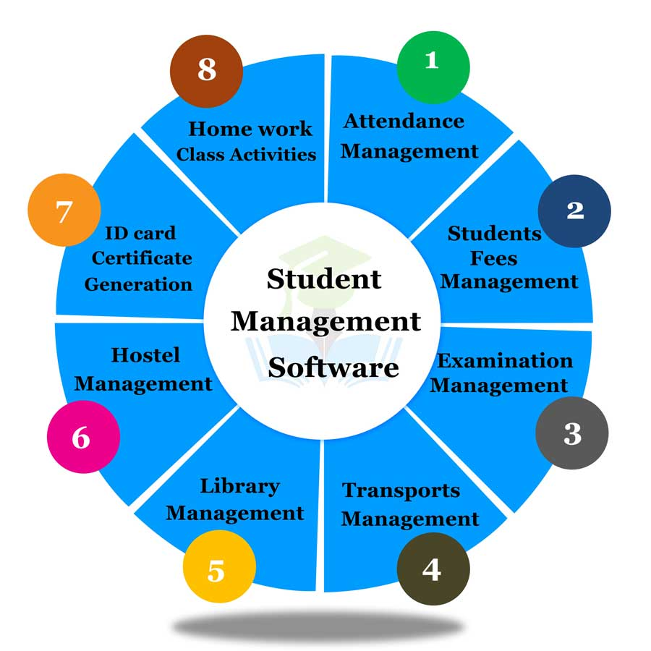

shows how any user-type i.e Student/Teacher/Parents will upload their notes in the app. The user-type will click on menu then dropdown to login or register in any time after the data is inserted then edit/view/delete any data from the table as admin.

CODING

------------**Index.png------------**

<!DOCTYPE html>

<html>

<head>

<meta charset="utf-8">

<meta name="viewport" content="width=device-width, initial-scale=1">

<title>The_New_School</title>

</head>

<link rel="stylesheet" href="https://maxcdn.bootstrapcdn.com/bootstrap/3.4.1/css/bootstrap.min.css">

<script src="https://ajax.googleapis.com/ajax/libs/jquery/3.6.0/jquery.min.js"></script>

<script src="https://maxcdn.bootstrapcdn.com/bootstrap/3.4.1/js/bootstrap.min.js"></script>

<link href="css/style.css" rel="stylesheet" type="text/css"><!--css file-->

<script src="script.js"></script>

<!--for icons-->

<link href="https://cdnjs.cloudflare.com/ajax/libs/font-awesome/4.7.0/css/font-awesome.min.css" rel="stylesheet">

<!--link for the animation-->

<link href="css/animation.css" rel="stylesheet" type="text/css">

<link rel="stylesheet" href="https://cdnjs.cloudflare.com/ajax/libs/animate.css/4.1.1/animate.min.css"/>

<body>

<!-- first header section start -->

<div class="container-fluid">

<div class="row">

<div class="col-xs-12 col-sm-12 col-md-12 col-lg-12 col-xl-12 top-header-section">

<div class="col-xs-12 col-sm-12 col-md-4 col-lg-4 col-xl-4 top-left-section">

<div class="col-xs-12 col-sm-12 col-md-12 col-lg-12 col-xl-12 top-left-section1">

<strong><img src="images/homepage/toplogo.png" class="img-responsive"></strong>

</div> <!--close of left-section1-->

</div>

<div class="col-xs-12 col-sm-12 col-md-8 top-right-section">

<div class="col-xs-12 col-sm-12 col-md-12 top-right-section1">

<div class="col-xs-12 col-sm-12 col-md-8 top-tagline-section" >

<div class="col-xs-12 col-sm-12 col-sm-12 col-md-12 top-tagline-section1">

<marquee scrollamount="">

<p class=" animate_animated animate__zoomIn animate__infinite" data-wow-duration="2s" style="visibility: visible; animation-duration: 3s;">

"Investment in knowledge pays the best interest."

–Benjamin

</p>

</marquee>

</div>

</div>

<div class="col-xs-12 col-sm-12 col-md-4 top-social-media-section">

<div class="col-xs-12 col-sm-12 col-md-12 top-social-media-section1" >

<ul class="animate__animated animate__bounce" data-wow-duration="2s" style="visibility: visible; animation-duration: 2s;">

<li><a href="https://www.facebook.com/" target="_blank"><i class="fa fa-facebook" aria-hidden="true"></i></a></li>

<li><a href="https://twitter.com/" target="_blank"><i class="fa fa-twitter" aria-hidden="true"></i></a></li>

<li><a href="https://www.instagram.com/" target="_blank"><i class="fa fa-instagram" aria-hidden="true"></i></a></li>

<li><a href="https://mail.google.com/" target="_blank"><i class="fa fa-google-plus" aria-hidden="true"></i></a></li>

</ul>

</div>

</div>

</div>

</div>

</div>

</div>

</div>

<!-- top header section end -->

<!-- Static navbar -->

<nav class="navbar navbar-inverse">

<div class="navbar-header">

<button type="button" class="navbar-toggle" data-toggle="collapse" data-target="#myNavbar">

<span class="icon-bar"></span>

<span class="icon-bar"></span>

<span class="icon-bar"></span>

</button>

<a href="schoolbus.php" target="_blank" class="navbar-brand">

<marquee scrollamount="5" direction="left">

<img src="images/homepage/onlinebus1.gif" style="height:40px;">

</marquee>

</a>

</div>

<div class="collapse navbar-collapse" id="myNavbar">

<ul class="nav navbar-nav navbar-right animate__animated animate__backInRight" style="visibility:visible; animation-duration:2s;">

<li class="active dropdown"> <!--dropdown for About-->

<a class="dropdown-toggle" data-toggle="dropdown"><i class="fa fa-home"> Home</i><span class="caret"></span></a>

<ul class="dropdown-menu">

<li class="disabled"><a href="#">About School</a></li><hr style="margin: 10px;">

<li><a href="aboutaffiliation.php" target="_blank">About Affiliation</a></li><hr style="margin: 10px;">

<li><a href="abouthostel.php" target="_blank">About Hostel</a></li><hr style="margin: 10px;">

</ul>

</li><!--Close dropdown for About-->

<li class="dropdown"> <!--Dropdown for Gallary-->

<a class="dropdown-toggle" data-toggle="dropdown">Gallary<span class="caret"></span></a>

<ul class="dropdown-menu">

<li><a href="annualfunction.php" target="_blank">Annual Function</a></li><hr style="margin: 10px;">

<li><a href="sportsmeet.php" target="_blank">Sports Meet</a></li><hr style="margin: 10px;">

<li><a href="shimlatrip.php" target="_blank">Shimla Trip</a></li><hr style="margin: 10px;">

<li><a href="socialexibition.php" target="_blank">Social Exibition</a></li><hr style="margin: 10px;">

<li><a href="zootrip.php" target="_blank">Zoo Trip</a></li><hr style="margin: 10px;">

</ul>

</li><!--Close dropdown for Gallary-->

<li class="dropdown"> <!--dropdown for About Admission-->

<a href="#" class="dropdown-toggle" data-toggle="dropdown"><i class="fa fa-search"> Admission</i><span class="caret"></span></a>

<ul class="dropdown-menu">

<li><a href="entrance.php" target="_blank">Entrance Exam</a></li><hr style="margin: 10px;">

<li><a href="tcadmission.php" target="_blank">Transfered Admission</a></li><hr style="margin: 10px;">

</ul>

</li><!--Close dropdown for Admission-->

<li class="dropdown"><!--dropdown for Notice-->

<a href="#" class="dropdown-toggle" data-toggle="dropdown" role="button" aria-haspopup="true" aria-expanded="false"> <i class="fa fa-comment"> Notice</i><span class="caret"></span></a>

<ul class="dropdown-menu">

<li><a href="notice.php" target="_blank">June 2022</a></li><hr style="margin: 10px;">

<li><a href="oldnotice.php" target="_blank">May 2022</a></li><hr style="margin: 10px;">

</ul>

</li><!--end for Notice-->

<li class="dropdown"> <!--dropdown for contact us-->

<a href="#" class="dropdown-toggle" data-toggle="dropdown"><i class="fa fa-envelope"> Contact</i><span class="caret"></span></a>

<ul class="dropdown-menu">

<li><a href="contactnumber.php" target="_blank"><i class="fa fa-phone"> Contact Numbers</i></a></li><hr style="margin: 10px;">

<li><a href="contactus.php" target="_blank">How To Get There</a></li><hr style="margin: 10px;">

</ul>

</li><!--Close dropdown for contact-->

<li class="dropdown"> <!--dropdown for Log_in-->

<a class="dropdown-toggle" data-toggle="dropdown"><span class="glyphicon glyphicon-log-in"></span> Login<span class="caret"></span></a>

<ul class="dropdown-menu">

<li><a href="teachers_login.php" target="_blank">Teacher</a></li><hr style="margin: 10px;">

<li><a href="students_login.php" target="_blank">Student</a></li><hr style="margin: 10px;">

<li><a href="parents_login.php" target="_blank">Parent</a></li><hr style="margin: 10px;">

<li><a href="registration.php" target="_blank"><button type="button" class="btn btn-danger" style="border-radius: 10px;">Register</button></a></li>

</ul>

</li><!--Close dropdown for Log_in-->

<!--dropdown for Register-->

<li class="dropdown">

<a class="dropdown-toggle" data-toggle="dropdown"><span class="glyphicon glyphicon-user"></span> Registration <span class="caret"></span>

</a>

<ul class="dropdown-menu">

<li><a href="teachers-registration.php" target="_blank">Create Teachers Account</a></li><hr style="margin: 10px;">

<li><a href="students-registration.php" target="_blank">Create Students Account</a></li><hr style="margin: 10px;">

<li><a href="parents-registration.php" target="_blank">Create Parents Account</a></li><hr style="margin: 10px;">

<li><a href="teachers_login.php" target="_blank"><button type="button" class="btn btn-danger" style="border-radius: 10px;">Log in</button></a></li>

</ul>

</li><!--Close dropdown for Register-->

</ul>

</div><!--collapse-navbar-collapse -->

</nav>

<!--end of static navbar-->

<!--start of carosuel-->

<div class="container-fluid">

<div class="row">

<div id="myCarousel" class="carousel slide animate__animated animate__backInLeft" data-ride="carousel" data-interval="2000">

<!-- Indicators -->

<ol class="carousel-indicators">

<li data-target="#myCarousel" data-slide-to="0" class="active"></li>

<li data-target="#myCarousel" data-slide-to="1"></li>

<li data-target="#myCarousel" data-slide-to="2"></li>

<li data-target="#myCarousel" data-slide-to="3"></li>

<li data-target="#myCarousel" data-slide-to="4"></li>

<li data-target="#myCarousel" data-slide-to="5"></li>

<li data-target="#myCarousel" data-slide-to="6"></li>

</ol>

<!-- images for slides -->

<div class="carousel-inner">

<div class="item active">

<img src="images/homepage/twogirls.jpg" alt="twogirls">

<div class="carousel-caption">

<h1 class="home-title">

<span>Learning is Fun</span>

<span>We give you opportunity to learn</span>

</h1>

</div>

</div>

<div class="item">

<img src="images/homepage/imagination.jpg" alt="imagination">

<div class="carousel-caption">

<h1 class="home-title">

<span>Think out of Box</span>

<span>Imagination can make you more creative</span>

</h1>

</div>

</div>

<div class="item">

<img src="images/homepage/smallgirls.jpg" alt="small kids Learning">

<div class="carousel-caption">

<h1 class="home-title">

<span>Best School</span>

<span>Learn and grow with your friends</span>

</h1>

</div>

</div>

<div class="item">

<img src="images/homepage/dreams.jpg" alt="dreams">

<div class="carousel-caption">

<h1 class="home-title">

<span>Dream Big</span>

<span>Move Out of your Comfort Zone</span>

</h1>

</div>

</div>

<div class="item">

<img src="images/homepage/mini.jpg" alt="New York">

<div class="carousel-caption">

<h1 class="home-title">

<span>Brilliant Students</span>

<span>Learn in positive environment</span>

</h1>

</div>

</div>

<div class="item">

<img src="images/homepage/technology.jpg" alt="Chicago">

<div class="carousel-caption">

<h1 class="home-title">

<span>New Technology</span>

<span>Learn the emerging technology</span>

</h1>

</div>

</div>

<div class="item">

<img src="images/homepage/danceingkids.jpg" alt="dancing kids">

<div class="carousel-caption">

<h1 class="home-title">

<span>Annual Function Dance</span>

<span>Explore Every Form of Dance</span>

</h1>

</div>

</div>

<div class="item">

<img src="images/homepage/footballplay.jpg" alt="Chicago">

<div class="carousel-caption">

<h1 class="home-title">

<span>Football Team</span>

<span class="span1">Learn Sports From Best Coach in School </span>

</h1>

</div>

</div>

</div>

<!-- Left and right controls -->

<a class="left carousel-control" href="#myCarousel" data-slide="prev">

<span class="glyphicon glyphicon-chevron-left"></span>

<span class="sr-only">Previous</span>

</a>

<a class="right carousel-control" href="#myCarousel" data-slide="next">

<span class="glyphicon glyphicon-chevron-right"></span>

<span class="sr-only">Next</span>

</a>

</div>

</div>

</div><!--end of carosuel-->

<!--Start of About with form Section-->

<div class="container-fluid">

<div class="row">

<div class="container">

<div class="col-xs-12 col-sm-12 col-md-12 col-lg-12 col-xl-12 bigforboth nextgap">

<div class="col-xs-12 col-sm-12 col-md-12 col-lg-8 col-xl-8 aboutschool"> <h1 class="text-center">About New School</h1>

<div class="col-xs-12 col-sm-12 col-md-12 col-lg-12 col-xl-12 blockquotepara

animate__animated animate__bounceInUp" style="visibility: visible; animation-duration:8s;">

<blockquote class="bl">

<h3> “Education is our passport to the future, for tomorrow belongs to the people who prepare for it today.” – Malcolm X</h3>

<span>The New School is a boarding school located in Chandigarh, India. It lies on the heart of Chandigarh The City Beautiful. General RK Beniwal and Cap. V Batra established this school in 1990 under HQ Western Command. The school is ranked 9th among top boarding schools in India.</span>

</blockquote>

</div>

<div class="col-xs-12 col-sm-12 col-md-12 col-lg-6 col-xl-6 mainimage

animate__backInRight" style="visibility: visible; animation-duration:8s;">

<img src="images/homepage/schoolmain.jpg" class="img-thumbnail" style="border-radius: 10px;

box-shadow: 0px 10px 15px rgba(0, 0, 0, 0.1);">

</div>

<div class="col-xs-12 col-sm-12 col-md-12 col-lg-6 col-xl-6 miniaboutschool">

<div class="col-xs-12 col-sm-12 col-md-12 col-lg-12 col-xl-12 onlytext">

<span class="animate_animated animate__backInRight" style="visibility: visible; animation-duration:8s;">

The School is affiliated to the CBSE(Central Board of Secondary Education). It is also accredited by International Education Board.

</span>

</div>

<div class="col-xs-12 col-sm-12 col-md-12 col-lg-12 col-xl-12 btn-group animate__bounceInUp" style="margin-top:10px; visibility: visible; animation-duration:8s;">

<button type="button" class="aboutbtn btn btn-primary" style="border-radius: 10px"> About Principal

</button>

<button type="button" class="btn btn-danger" style="border-radius: 10px; margin-left:15px; margin-bottom:15px ">Contact Us</button>

</div>

</div> <!---close of miniaboutschool--->

</div>

<!---form section--->

<div class="col-xs-12 col-sm-12 col-md-12 col-lg-4 col-xl-4 formfill" style="background-color: mintcream;">

<div class="col-xs-12 col-sm-12 col-md-12 col-lg-12 col-xl-12 animate__animated animate__backInRight"

style="visibility: visible; animation-duration:5s;">

<h3 class="text-center">Enrollment of students</h3>

</div>

<form class="form animate__animated animate__backInRight" action="action-for-enquiryformdetails.php" method="post"

style="visibility: visible; animation-duration:5s;" >

<div class="form-group">

<label class="control-label">Child Name</label>

<input id="yourname" name="name" type="text" placeholder="Child Name" class="form-control" required="">

</div>

<div class="form-group">

<label class="control-label">Mobile Number</label>

<input type="text" class="form-control" name="phone" placeholder="valid number" maxlength="10" >

</div>

<div class="form-group">

<label class="control-label">Email</label>

<input name="email" class="form-control" type="email"

placeholder="Email" required="">

</div>

<div class="form-group">

<label class="control-label">Date Of Birth</label>

<input name="dob" class="form-control" type="date"

required="">

</div>

<div class="form-group">

<label class="control-label">Admitting class

</label>

<select name="class" class="form-control">

<option>Nursery-UKg</option>

<option>1</option>

<option>2</option>

<option>3</option>

<option>4</option>

<option>5</option>

<option>6</option>

<option>7</option>

<option>8</option>

<option>9</option>

<option>10</option>

<option>11</option>

<option>12</option>

</select>

</div>

<button type="submit" name="submit" onclick="enrolresponse()" class="btn btn-info animate__animated animate__backInUp subbtn" style="visibility: visible; animation-duration:5s;">Submit</button>

<p> </p>

<span class="disabled">We will response within 2-3 days</span>

</form>

</div> <!---end of the formfill section--->

</div> <!--close for both-->

</div> <!--close of container-->

</div> <!--close of row-->

</div><!--close of fluid header-->

<!--end of About with form Section-->

<!--Start of Life at New_School-->

<div class="container-fluid">

<div class="row">

<div class="container">

<div class="col-xs-12 col-md-12 col-sm-12 col-lg-12 flipcards nextgap" style="padding: 0px;">

<h1 class="text-center animate__animated animate__backInRight"

style="visibility: visible; animation-duration:5s;">Life at New School</h1>

<div class="pager">

<div class="animate__animated animate__backInRight wrapper"

style="visibility: visible; animation-duration:5s;">

<div class="card front-face">

<img src="images/homepage/lib1.jpg">

</div>

<div class="card back-face">

<img src="images/homepage/library.jpg">

<div class="info">

<div class="title">Library</div>

<p>Place to remove your doubts<br>improve your self</p>

</div>

<ul class="socialmedia">

<a href="https://www.facebook.com/" target="_blank"><i class="fa fa-facebook-f"></i></a>

<a href="https://twitter.com/" target="_blank"><i class="fa fa-twitter"></i></a>

<a href="https://www.instagram.com/" target="_blank"><i class="fa fa-instagram"></i></a>

<a href="https://www.youtube.com/" target="_blank"><i class="fa fa-youtube"></i></a>

</ul>

</div>

</div><!--close of wrapper1-->

<div class="wrapper animate__animated animate__backInUp"

style="visibility: visible; animation-duration:5s;">

<div class="card front-face">

<img src="images/homepage/run.jpg">

</div>

<div class="card back-face">

<img src="images/homepage/sports.jpg">

<div class="info">

<div class="title">Sports</div>

<p>Healthy Growth<br>With Sports Activity</p>

</div>

<ul class="socialmedia">

<a href="https://www.facebook.com/" target="_blank"><i class="fa fa-facebook-f"></i></a>

<a href="https://twitter.com/" target="_blank"><i class="fa fa-twitter"></i></a>

<a href="https://www.instagram.com/" target="_blank"><i class="fa fa-instagram"></i></a>

<a href="https://www.youtube.com/" target="_blank"><i class="fa fa-youtube"></i></a>

</ul>

</div>

</div><!--close of wrapper2-->

<div class="wrapper animate__animated animate__backInLeft"

style="visibility: visible; animation-duration:5s;">

<div class="card front-face">

<img src="images/homepage/trip.jpg">

</div>

<div class="card back-face">

<img src="images/homepage/tour.jpg">

<div class="info">

<div class="title">Field Trip</div>

<p>Great Learning Experiences<br>with young professional</p>

</div>

<ul class="socialmedia">

<a href="https://www.facebook.com/" target="_blank"><i class="fa fa-facebook-f"></i></a>

<a href="https://twitter.com/" target="_blank"><i class="fa fa-twitter"></i></a>

<a href="https://www.instagram.com/" target="_blank"><i class="fa fa-instagram"></i></a>

<a href="https://www.youtube.com/" target="_blank"><i class="fa fa-youtube"></i></a>

</ul>

</div>

</div><!--close of wrapper3-->

</div><!--close of pager-->

</div> <!--close of flipcards-->

</div> <!--close container-->

</div> <!--close row-->

</div><!--close container-fluid-->

<!--end of Life at New_School-->

<!--Start of the Principal message-->

<div class="container-fluid">

<div class="row">

<div class="container">

<div class="col-xs-12 col-sm-12 col-md-12 col-lg-12 col-xl-12 nextgap">

<h1 class="text-center animate__animated animate__bounceInUp" style="visibility: visible; animation-duration:5s;" >From The Desk of Principal</h1>

<div class="col-xs-12 col-sm-12 col-md-12 col-lg-12 col-xl-12 principal_desk">

<!--start of map-->

<div class="col-xs-12 col-sm-12 col-md-12 col-lg-6 col-xl-6 mam animate__animated

animate__backInLeft" style="visibility: visible; animation-duration:3s;">

<img src="images/homepage/princi.jpg" class="img-responsive">

</div> <!---end of principalimage--->

<!--start of principalmessage-->

<div class="col-xs-12 col-sm-12 col-md-12 col-xl-6 col-lg-6 principalmessage animate__animated animate__backInRight" style="visibility: visible; animation-duration:3s;">

<div class="pager">

<h3>Mrs. Ruth Thomas</h3><hr>

<span class="penmessage">The New School is a boarding school located in Chandigarh, India. It lies on the heart of Chandigarh The City Beautiful. General RK Beniwal and Col Bikram Batra established this school in 1990 under HQ Western Command. It is a coeducational residential School affiliated to the CBSE, New Delhi. The school is ranked 9th among top boarding schools in India.

</span>

<ul class="social-media-list-princi">

<li><a href="https://www.facebook.com/"><i class="fa fa-facebook-square" aria-hidden="true"></i></a></li>

<li><a href=""> <i class="fa fa-instagram" aria-hidden="true"></i></a></li>

<li><a href="https://www.linkedin.com/"><i class="fa fa-linkedin-square" aria-hidden="true"></i></a></li>

<li><a href="https://www.whatsapp.com/"><i class="fa fa-whatsapp" aria-hidden="true"></i></a></li>

<li><a href="https://twitter.com/" target="_blank"><i class="fa fa-twitter-square" aria-hidden="true"></i></a></li>

</ul>

<button type="button" class="btn btn-primary readmore" style="border-radius:10px; box-shadow: 0 1px 3px 0 rgba(1, 0, 0, 50);" >Read More</button>

</div> <!--end of pager-->

</div> <!---end of principalmessage--->

</div> <!--end of principal-desk-->

</div>

</div> <!--container close-->

</div> <!--close of the row-->

</div> <!--container-fluid close-->

<!--end of Principal message-->

<!--start of news and events--->

<div class="container-fluid">

<div class="row">

<div class="container">

<div class="col-xs-12 col-sm-12 col-md-12 col-lg-12 col-xl-12 nextgap">

<h1 class="text-center animate__animated animate__backInUp newsandeventsh1"

style="visibility: visible; animation-duration:5s;">News and Events of New_School</h1>

<!---Three Layers Together--->

<div class="col-xs-12 col-sm-12 col-md-12 col-lg-12 col-xl-12 firstlayer animate__animated animate__backInLeft"

style="visibility: visible; animation-duration:5s;">

<!--Start of first newsimgbox1-->

<div class="col-xs-12 col-sm-6 col-md-6 col-lg-3 col-xl-3 newsimgbox1">

<img src="images/homepage/one.jpg" alt="Image is loading" class="image1">

<div class="overlay1">

<div class="insidetext">Life is full of development at New_School</div>

</div>

</div> <!--End of newsimgbox1-->

<!--Start of newsimgbox2-->

<div class="col-xs-12 col-sm-6 col-md-6 col-lg-3 col-xl-3 newsimgbox2">

<img src="images/homepage/two.jpg" alt="Image is loading" class="image2">

<div class="overlay2">

<div class="insidetext">Explore the World</div>

</div>

</div> <!--End of newsimgbox2-->

<!--Start of newsimgbox3-->

<div class="col-xs-12 col-sm-6 col-md-6 col-lg-3 col-xl-3 newsimgbox3">

<img src="images/homepage/three.jpg" alt="Image is loading" class="image3">

<div class="overlay3">

<div class="insidetext">Life with best buddies</div>

</div>

</div> <!--End of newsimgbox3-->

<!--Start of newsimgbox4-->

<div class="col-xs-12 col-sm-6 col-md-6 col-lg-3 col-xl-3 newsimgbox4">

<img src="images/homepage/four.jpg" alt="Image is loading" class="image4">

<div class="overlay4">

<p class="insidetext">Learning Digital</p>

</div>

</div> <!--End of newsimgbox4-->

</div> <!--End of firstlayer-->

<div class="col-xs-12 col-sm-12 col-md-12 col-lg-12 col-xl-12 secondlayer animate__animated animate__backInRight"

style="visibility: visible; animation-duration:5s;">

<!--Start of newsimgbox5-->

<div class="col-xs-12 col-sm-6 col-md-6 col-lg-3 col-xl-3 newsimgbox5">

<img src="images/homepage/five.jpg" alt="Image is loading" class="image5">

<div class="overlay5">

<div class="insidetext">Explore every little things</div>

</div>

</div> <!--End of newsimgbox5-->

<!--Start of newsimgbox6-->

<div class="col-xs-12 col-sm-6 col-md-6 col-lg-3 col-xl-3 newsimgbox6">

<img src="images/homepage/six.jpg" alt="Image is loading" class="image6">

<div class="overlay6">

<div class="insidetext">Learning environment</div>

</div>

</div> <!--End of newsimgbox6-->

<!--Start of newsimgbox7-->

<div class="col-xs-12 col-sm-6 col-md-6 col-lg-3 col-xl-3 newsimgbox7">

<img src="images/homepage/seven.jpg" alt="Image is loading" class="image7">

<div class="overlay7">

<div class="insidetext">Think Beyond</div>

</div>

</div> <!--End of newsimgbox7-->

<!--Start of newsimgbox8-->

<div class="col-xs-12 col-sm-6 col-md-6 col-lg-3 col-xl-3 newsimgbox8">

<img src="images/homepage/eight.jpg" alt="Image is loading" class="image8">

<div class="overlay8">

<p class="insidetext">Healthy Growth</p>

</div>

</div> <!--End of newsimgbox8-->

</div> <!--End of secondlayer-->

<div class="col-xs-12 col-sm-12 col-md-12 col-lg-12 col-xl-12 thirdlayer animate__animated animate__backInLeft"

style="visibility: visible; animation-duration:10s;">

<!--Start of first newsimgbox9-->

<div class="col-xs-12 col-sm-6 col-md-6 col-lg-3 col-xl-3 newsimgbox9">

<img src="images/homepage/nine.jpg" alt="Image is loading" class="image9">

<div class="overlay9">

<div class="insidetext">Fun Activities</div>

</div>

</div> <!--End of newsimgbox9-->

<!--Start of first newsimgbox10-->

<div class="col-xs-12 col-sm-6 col-md-6 col-lg-3 col-xl-3 newsimgbox10">

<img src="images/homepage/ten.jpg" alt="Image is loading" class="img-responsive image10">

<div class="overlay10">

<div class="insidetext">Physical and Mental Growth</div>

</div>

</div> <!--End of newsimgbox10-->

<!--Start of first newsimgbox11-->

<div class="col-xs-12 col-sm-6 col-md-6 col-lg-3 col-xl-3 newsimgbox11">

<img src="images/homepage/eleven.jpg" alt="Image is loading" class="img-responsive image11">

<div class="overlay11">

<div class="insidetext">Sports Meet</div>

</div>

</div> <!--End of newsimgbox11-->

<!--Start of first newsimgbox12-->

<div class="col-xs-12 col-sm-6 col-md-6 col-lg-3 col-xl-3 newsimgbox12">

<img src="images/homepage/twelve.jpg" alt="Image is loading" class="img-responsive image12">

<div class="overlay12">

<div class="insidetext">Love for the Country</div>

</div>

</div> <!--End of newsimgbox12-->

</div> <!--end of thirdlayer-->

</div> <!--end of nextgap-->

</div> <!--end of container-->

</div> <!--end of row-->

</div> <!--closing of news and events-->

<!--start of the mapping-->

<div class="container-fluid">

<div class="row">

<div class="container">

<div class="col-xs-12 col-sm-12 col-md-12 col-lg-12 col-xl-12 map_address nextgap">

<!--start of map-->

<h1 class="text-center animate__animated animate__backInLeft" style=" visibility: visible;

animation-duration:10s;">Find Us Here!</h1>

<div class="col-xs-12 col-sm-12 col-md-12 col-lg-6 col-xl-6 map animate__animated animate__backInLeft" style="visibility: visible; animation-duration:10s;">

<iframe src="https://www.google.com/maps/embed?pb=!1m18!1m12!1m3!1d3429.752631634512!2d76.7364071151313!3d30.725353881639816!2m3!1f0!2f0!3f0!3m2!1i1024!2i768!4f13.1!3m3!1m2!1s0x390fedd73a4c8575%3A0xb15d688a2085d373!2sPost%20Graduate%20Government%20College%20for%20Girls!5e0!3m2!1sen!2sin!4v1652161108224!5m2!1sen!2sin" width=100%; height="450" style="border:0;" allowfullscreen="" loading="lazy" referrerpolicy="no-referrer-when-downgrade"></iframe>

</div> <!---end of map--->

<!--start of address-->

<div class="col-xs-12 col-sm-12 col-md-12 col-xl-6 col-lg-6 address animate__animated animate__backInRight" style="visibility: visible; animation-duration:10s;">

<div class="pager">

<h2>We Are Locatted Here</h2><hr>

<div class="addressgiven">

<span>The New School</span> <br>

<span> Chandigarh Road </span><br>

<span> Near Church Of God</span><br>

<span> Sector 41-B</span><br>

<span>Chandigarh 160036</span><br>

<h2>Contact Numbers</h2>

<i class="fa fa-phone"> 1234567890</i><br><i class="fa fa-phone"> 9876543210</i>

</div>

<ul class="social-media-list-map animate__animated animate__backInRight" style="visibility: visible; animation-duration:10s;">

<li><a href="https://www.facebook.com/" target="_blank"><i class="fa fa-facebook-square" aria-hidden="true"></i>

</a></li>

<li><a href="https://www.instagram.com/" target="_blank"><i class="fa fa-instagram" ></i></a></li>

<li><a href="https://www.linkedin.com/" target="_blank"><i class="fa fa-linkedin-square" aria-hidden="true"></i></a></li>

<li><a href="https://www.whatsapp.com/" target="_blank"><i class="fa fa-whatsapp" aria-hidden="true"></i></a></li>

<li><a href="" target="_blank"><i class="fa fa-twitter-square" aria-hidden="true"></i></a></li>

</ul>

</div> <!--end of pager-->

</div> <!---end of address--->

</div> <!--end of map_address-->

</div> <!--container close-->

</div><!-- close of row -->

</div> <!--container-fluid close-->

<!--end of the mapping-->

<div class="container-fluid">

<div class="row">

<div class="container">

<h2 class="text-center animate__animated animate__backInUp h2nextgap"

style="visibility: visible; animation-duration:10s;">Hoping to see you Soon</h2>

</div>

</div>

</div>

<!--start of the footer-->

<div class="container-fluid animate__animated animate__backInRight" style=" background-color:black; visibility: visible; animation-duration:5s;">

<div class="row">

<div class="container">

<div class="col-xs-12 col-sm-12 col-md-12 col-lg-12 col-xl-12 footer-section">

<!--Start of subscribe section-->

<div class="col-xs-12 col-sm-12 col-md-12 col-lg-12 col-xl-12 subscribe-section">

<div class="col-xs-12 col-sm-12 col-md-12 col-lg-12 col-xl-12 subscribe animate__animated animate__backInLeft" style="visibility: visible;

animation-duration:5s;">

<h4 class="text-center">Enter Your email for Subscription</h4>

</div>

<div class="col-xs-12 col-sm-8 col-md-12 subscribe animate__animated animate__backInRight" style="visibility: visible;

animation-duration:5s;">

<div class="col-xs-12 col-sm-12 col-md-12 subscribebtn">

<form>

<input type="text" placeholder="Enter your email">

<a href="#

">Subscribe</a>

</form>

</div>

</div>

</div> <!--Close of subscribe section-->

<!--Start of lower footer section-->

<div class="col-xs-12 col-sm-12 col-md-12 col-lg-12 col-xl-12 lower-footer-section">

<!--start of footer1-->

<div class="col-xs-12 col-sm-12 col-md-6 col-lg-3 col-xl-3 footer1 sanimate__animated animate__zoomIn" style="text-align: center;visibility: visible; animation-duration:2s;">

<div class="footer-logo">

<img src="images/homepage/logo.png">

</div>

<div class="logo-content">

<p class="addtext">We welcome you in the <br>new_school. Here we are <br>available to provide you<br> the best education</p>

<h4 class="footer-heading">Reach us in Social</h4>

<ul class="footer_list">

<li><a href="https://www.facebook.com/" target="_blank"><i class="fa fa-facebook-square" aria-hidden="true"></i></a></li>

<li><a href="https://www.instagram.com/"><i class="fa fa-instagram" aria-hidden="true"></i></a></li>

<li><a href="https://www.linkedin.com/" target="_blank"><i class="fa fa-linkedin-square" aria-hidden="true"></i></a></li>

<li><a href="https://www.whatsapp.com/" target="_blank"><i class="fa fa-whatsapp" aria-hidden="true"></i></a></li>

<li><a href="https://twitter.com/" target="_blank"><i class="fa fa-twitter-square" aria-hidden="true"></i></a>

</li>

</ul>

<span class="addtext">Make sure to follow<br>

<marquee direction="right" behavior="alternate"> <p style="color:#e0b36e">@new_school</p></marquee></span>

</div><!--end of footer1 logo-content-->

</div><!--end of footer1-->

<!--start of footer2-->

<div class="col-xs-12 col-sm-12 col-md-6 col-lg-5 col-xl-5 footer2 animate__animated animate__bounceInUp" style="text-align: center; visibility: visible; animation-duration:2s;">

<h2 class="footer-heading">Quik Navigation</h2>

<div class="menu-list addtext">

<ul>

<li><a href="#"><i class="fa fa-angle-right" aria-hidden="true"></i><i class="fa fa-home"></i>Home</a></li>

<li><a href="#"><i class="fa fa-angle-right" aria-hidden="true"></i><i class="fa fa-search"></i>Enquery</a></li>

<li><a href="#"><i class="fa fa-angle-right" aria-hidden="true"></i><i class="fa fa-file"></i>Notice</a></li>

<li><a href="#"><i class="fa fa-angle-right" aria-hidden="true"></i><i class="fa fa-envelope"></i>Home</a></li>

<li><a href="#"><i class="fa fa-angle-right" aria-hidden="true"></i><i class="fa fa-user"></i>Log in</a></li>

</ul>

</div>

</div> <!--close of footer2-->

<!--start of footer3-->

<div class="col-xs-12 col-sm-12 col-md-12 col-lg-4 col-xl-4 animate__animated animate__zoomIn footer3 addtext" style="visibility: visible; animation-duration:2s; ">

<div class="footer-heading">

<h2>Get In Touch</h2>

</div>

<!--footer3 address-->

<div class="footer3address">

<i class="fa fa-map-marker icon" aria-hidden="true"></i>

<span >The New School</span><br>

<span class="map-marker-address"> Chandigarh Road </span><br>

<span class="map-marker-address"> Near Church Of God</span><br>

<span class="map-marker-address"> Sector 41-B</span><br>

<span class="map-marker-address">Chandigarh 160036</span><br>

</div><!--end of footer3-address-->

<!--footer3 email-->

<div class="footer3email">

<i class="fa fa-envelope icon" aria-hidden="true">

</i> <span class="email1"> school@gmail.com</span> <br>

<span class="email2">principal@gmail.com</span>

</div>

<!--footer3 phone-->

<div class="footer3phone">

<i class="fa fa-phone icon" aria-hidden="true">

</i><span class="email1"> +91-1234567890</span> <br>

<span class="email2">+91-9987654321 </span>

</div><!--end of phone-->

<div class="footer3hours">

<i class="fa fa-clock-o icon" aria-hidden="true">

</i>

<span class="cl1">Mon-Friday</span><br>

<span class="cl2">Saturday(Half-day)</span><br>

<span class="cl3">8AM-2PM</span><br>

</div><!--end of clock-->

</div> <!--end of lower-footer3-->

</div><!--end of lower-footer-section -->

</div><!--end of footer-section-->

</div> <!--end of container-->

</div><!--row close-->

<!--Tiny footer-->

<div class=" col-xl-12 col-lg-12 col-md-12 col-sm-12 col-12 mini-footer">

<span class="addtext"><marquee>Copyright © 2022 <a href="index.php">The_New_School

</a> All Rights Reserved.</marquee></span>

</div><!--end of Tiny footer-->

</div> <!--end of container-fluid-->

<!--close of the footer-->

</body>

</html>

------------schoolbus.php--------------

<!DOCTYPE html>

<html>

<head>

<meta charset="utf-8">

<meta name="viewport" content="width=device-width, initial-scale=1">

<title>School_Bus</title>

<link rel="stylesheet" href="https://maxcdn.bootstrapcdn.com/bootstrap/3.4.1/css/bootstrap.min.css">

<script src="https://ajax.googleapis.com/ajax/libs/jquery/3.6.0/jquery.min.js"></script>

<script src="https://maxcdn.bootstrapcdn.com/bootstrap/3.4.1/js/bootstrap.min.js">

</script>

<!--for icons-->

<link href="https://cdnjs.cloudflare.com/ajax/libs/font-awesome/4.7.0/css/font-awesome.min.css" rel="stylesheet">

</head>

<body>

<div class="container-fluid" id="header">

<h3 class="portal">THE NEW SCHOOL TRANSPORT SYSTEM</h3>

<div class="text-center" style="padding: 4px 2px;">

<button type="button" class="btn btn-warning togglebtn" data-toggle="collapse" data-target="#navigationbar">Click for menu</button>

</div>

<!-- Static navbar -->

<nav id="navigationbar" class="navbar navbar-inverse collapse">

<ul class="nav navbar-nav animate__animated animate__backInRight" style="visibility:visible; animation-duration:2s;">

<li> <!--dropdown for About-->

<a class="dropdown-toggle" data-toggle="dropdown">Home<span class="caret"></span></a>

<ul class="dropdown-menu">

<li><a href="index.php">About School</a></li><hr style="margin: 10px;">

<li><a href="aboutaffilition.php">About Affiliation</a></li><hr style="margin: 10px;">

<li class="disabled"><a href="#">About Hostel</a></li><hr style="margin: 10px;">

</ul>

</li><!--Close dropdown for About-->

<li class="dropdown"> <!--Dropdown for Gallary-->

<a class="dropdown-toggle" data-toggle="dropdown">Gallary<span class="caret"></span>

</a>

<ul class="dropdown-menu">

<li><a href="annualfunction.php" target="_blank">Annual Function</a></li><hr style="margin: 10px;">

<li><a href="sportsmeet.php" target="_blank">Sports Meet</a></li><hr style="margin: 10px;">

<li><a href="shimlatrip.php" target="_blank">Shimla Trip</a></li><hr style="margin: 10px;">

<li class="disabled"><a href="#" target="_blank">Social Exibition</a></li><hr style="margin: 10px;">

<li class="disabled"><a href="#" target="_blank">Zoo Trip</a></li><hr style="margin: 10px;">

</ul>

</li><!--Close dropdown for Gallary-->

<li class="dropdown"><!--dropdown for Notice-->

<a href="#" class="dropdown-toggle" data-toggle="dropdown" role="button" aria-haspopup="true" aria-expanded="false">Notice<span class="caret"></span></a>

<ul class="dropdown-menu">

<li class="disabled"><a href="#">June 2022</a></li><hr style="margin: 10px;">

<li><a href="oldnotice.php">May 2022</a></li><hr style="margin: 10px;">

</ul>

</li><!--end for Notice-->

<li class="dropdown"> <!--dropdown for About Admission-->

<a href="#" class="dropdown-toggle" data-toggle="dropdown"><i class="fa fa-search"> Admission</i><span class="caret"></span></a>

<ul class="dropdown-menu">

<li class="disabled"><a href="#" target="_blank">Entrance Exam</a></li><hr style="margin: 10px;">

<li><a href="tcadmission.php" target="_blank">Transfered Admission</a></li><hr style="margin: 10px;">

</ul>

</li><!--Close dropdown for Admission-->

<li class="dropdown"> <!--dropdown for contact us-->

<a href="#" class="dropdown-toggle" data-toggle="dropdown"><i class="fa fa-envelope"> Contact</i><span class="caret"></span></a>

<ul class="dropdown-menu">

<li><a href="contactnumber.php" target="_blank"><i class="fa fa-phone"> Contact Numbers</i></a></li><hr style="margin: 10px;">

<li><a href="contactus.php" target="_blank">How To Get There</a></li><hr style="margin: 10px;">

</ul>

</li><!--Close dropdown for contact-->

<li class="dropdown"> <!--dropdown for Log_in-->

<a class="dropdown-toggle" data-toggle="dropdown"><span class="glyphicon glyphicon-log-in"></span> Login<span class="caret"></span></a>

<ul class="dropdown-menu">

<li><a href="teachers_login.php" target="_blank">Teacher</a></li><hr style="margin: 10px;">

<li><a href="students_login.php" target="_blank">Student</a></li><hr style="margin: 10px;">

<li><a href="registration.php" target="_blank"><button type="button" class="btn btn-danger" style="border-radius: 10px;">Register</button></a></li>

</ul>

</li><!--Close dropdown for Log_in-->

<!--dropdown for Register-->

<li class="dropdown">

<a class="dropdown-toggle" data-toggle="dropdown"><span class="glyphicon glyphicon-user"></span> Admin<span class="caret"></span>

</a>

<ul class="dropdown-menu">

<li><a href="teachers-registration.php" target="_blank">Create Teachers Account</a></li><hr style="margin: 10px;">

<li><a href="students-registration.php" target="_blank">Create Students Account</a></li><hr style="margin: 10px;">

<li><a href="teachers_login.php" target="_blank"><button type="button" class="btn btn-danger" style="border-radius: 10px;">Log in</button></a></li>

</ul>

</li><!--Close dropdown for Register-->

</ul>

</nav>

</div><!--close of container-->

<!--end of static navbar-->

<div class="container-fluid">

<div class="row">

<div class="container">

<h3 class="enjoy">Your Child's Safety is Ours</h3>

<p>THE NEW SCHOOL provides safe and reliable air-conditioned bus transportation to students who wish to avail this facility. The school has a luxury & air-conditioned fleet of buses with the best of safety arrangements available for the neighbouring areas. The students in school buses are accompanied by well-trained attendants/ escorts to ensure their safety.</p>

</div><!--close of container-->

</div><!--close of row-->

</div><!--close of container-fluid-->

<div class="container-fluid">

<div class="row">

<div class="container">

<div id="myCarousel" class="carousel slide" data-ride="carousel">

<!-- Indicators -->

<ol class="carousel-indicators">

<li data-target="#myCarousel" data-slide-to="0" class="active"></li>

<li data-target="#myCarousel" data-slide-to="1"></li>

<li data-target="#myCarousel" data-slide-to="2"></li>

</ol>

<!-- Wrapper for slides -->

<div class="carousel-inner">

<div class="item active">

<img src="images/onlinebus/busparking1.jpg" alt="buspark1" style="width:100%;">

</div>

<div class="item">

<img src="images/onlinebus/busparking2.jpg" alt="buspark2" style="width:100%;">

</div>

<div class="item">

<img src="images/onlinebus/busparking3.jpg" alt="buspark3" style="width:100%;">

</div>

</div>

<!-- Left and right controls -->

<a class="left carousel-control" href="#myCarousel" data-slide="prev">

<span class="glyphicon glyphicon-chevron-left"></span>

<span class="sr-only">Previous</span>

</a>

<a class="right carousel-control" href="#myCarousel" data-slide="next">

<span class="glyphicon glyphicon-chevron-right"></span>

<span class="sr-only">Next</span>

</a>

</div>

</div>

</div>

</div>

<div class="container-fluid">

<div class="row">

<div class="container">

<h3>Free school transport</h3>

<p>

Entitlement to transport assistance is assessed by the school admissions and transport team. Our home to school transport policy is attached to this page.

Students who are entitled to receive free school transport are normally issued with a bus pass to travel on a dedicated school bus service or a public bus service. However, families who live in rural areas where transport options are sometimes limited may be entitled to receive a refund of travelling expenses for either the journey to the nearest bus stop, or direct to school if no suitable bus service is available.</p>

<h3>Children travelling without a free bus pass</h3>

<p>Students who are not entitled to any help with transport costs may still be able to travel and pay a fare to the driver for each journey they make. However, this is only available on school bus services that are registered to take paying passengers. Typically, services that are not available to fare paying pupils are those that operate to denominational (faith) schools and those that are operated by minibuses.

Families can apply to buy a pass for transport on these services. For more information,<a href="gmail.com"></a></p>

<h3>Bus timetables and routes</h3>

<p>Information for dedicated school bus services is currently not available online but we are looking to change this in the near future.</p>

</div>

</div>

</div>

<!--Tiny footer-->

<div class=" col-xl-12 col-lg-12 col-md-12 col-sm-12 col-12 mini-footer">

<span class="addtext"><marquee>Copyright © 2022 <a href="index.php">The_New_School

</a> All Rights Reserved.</marquee></span>

</div><!--end of Tiny footer-->

</body>

</html>

<style>

*{ margin: 0px;

padding: 0px;

}

#header

{background-color: black; color: white;padding: 1.5px 1px;}

@import url('https://fonts.googleapis.com/css2?family=Anton&family=Merriweather:ital@0;1&family=Montserrat&family=Mukta:wght@500&family=Playfair+Display&family=Ramabhadra&family=Roboto+Flex:opsz@8..144&family=Roboto:wght@400;500&family=Tiro+Bangla&family=Tiro+Devanagari+Marathi&family=Tiro+Gurmukhi&display=swap');

.portal{letter-spacing: 1.2vw;font-family: 'system-ui';text-transform: uppercase;text-align: center;}

.togglebtn

{margin-top: 10px;margin-bottom: 5px;text-align: center;text-transform: uppercase;}

.btn-warning

{ margin-top: 10px;margin-bottom: 0px; background-color: #d28d02;color: white;font-weight: 600; font-family: 'system-ui'; text-transform: uppercase;}

/*style for second inverse navigation*/

.navbar{ margin-bottom: 0px; z-index: 1; border-radius: 0px;}

.mini-footer

{ background-color: black; color: white;}

.navbar-nav

{ text-align: center;}

.navbar-inverse .navbar-nav>li>a

{text-transform: uppercase;color: white;padding: 20px;}

/*setting the image*/

.navbar-brand img {padding-left: 5px;margin-left: 200px; }

.dropdown-menu li a{text-align: center;}

.dropdown-header

{text-align: center;color: Black;font-weight: 600;}

/*enjoy heading*/

.enjoy

{ text-transform: uppercase; text-align: center; font-size: 40px;}

@import url('https://fonts.googleapis.com/css2?family=Montserrat&family=Playfair+Display:wght@400;800&family=Roboto+Flex:opsz@8..144&display=swap');

p

{font-family: 'Roboto Flex', sans-serif;}

</style>

------------aboutaffiliation.php------------

<!DOCTYPE html>

<html>

<head>

<meta charset="utf-8">

<meta name="viewport" content="width=device-width, initial-scale=1">

<title>CBSE Affiliation</title>

<link rel="stylesheet" href="https://maxcdn.bootstrapcdn.com/bootstrap/3.4.1/css/bootstrap.min.css">

<script src="https://ajax.googleapis.com/ajax/libs/jquery/3.6.0/jquery.min.js"></script>

<script src="https://maxcdn.bootstrapcdn.com/bootstrap/3.4.1/js/bootstrap.min.js"></script>

<!--for icons-->

<link href="https://cdnjs.cloudflare.com/ajax/libs/font-awesome/4.7.0/css/font-awesome.min.css" rel="stylesheet">

</head>

<body>

<div class="container-fluid" id="header">

<h3 class="portal">AFFILIATED TO CBSE BOARD</h3>

<div class="text-center" style="padding: 4px 2px;">

<button type="button" class="btn btn-warning togglebtn" data-toggle="collapse" data-target="#navigationbar">Click for menu</button>

</div>

<!-- Static navbar -->

<!-- Static navbar -->

<nav id="navigationbar" class="navbar navbar-inverse collapse">

<ul class="nav navbar-nav animate__animated animate__backInRight" style="visibility:visible; animation-duration:2s;">

<li> <!--dropdown for About-->

<a class="dropdown-toggle" data-toggle="dropdown">Home<span class="caret"></span></a>

<ul class="dropdown-menu">

<li><a href="index.php">About School</a></li><hr style="margin: 10px;">

<li class="disabled"><a href="aboutaffilition.php">About Affiliation</a></li><hr style="margin: 10px;">

<li><a href="#">About Hostel</a></li><hr style="margin: 10px;">

</ul>

</li><!--Close dropdown for About-->

<li class="dropdown"> <!--Dropdown for Gallary-->

<a class="dropdown-toggle" data-toggle="dropdown">Gallary<span class="caret"></span>

</a>

<ul class="dropdown-menu">

<li><a href="annualfunction.php" target="_blank">Annual Function</a></li><hr style="margin: 10px;">

<li><a href="sportsmeet.php" target="_blank">Sports Meet</a></li><hr style="margin: 10px;">

<li><a href="shimlatrip.php" target="_blank">Shimla Trip</a></li><hr style="margin: 10px;">

<li><a href="socialexibition.php" target="_blank">Social Exibition</a></li><hr style="margin: 10px;">

<li><a href="zootrip.php" target="_blank">Zoo Trip</a></li><hr style="margin: 10px;">

</ul>

</li><!--Close dropdown for Gallary-->

<li class="dropdown"><!--dropdown for Notice-->

<a href="#" class="dropdown-toggle" data-toggle="dropdown" role="button" aria-haspopup="true" aria-expanded="false">Notice<span class="caret"></span></a>

<ul class="dropdown-menu">

<li><a href="notice.php">June 2022</a></li><hr style="margin: 10px;">

<li><a href="oldnotice.php">May 2022</a></li><hr style="margin: 10px;">

</ul>

</li><!--end for Notice-->

<li class="dropdown"> <!--dropdown for About Admission-->

<a href="#" class="dropdown-toggle" data-toggle="dropdown"><i class="fa fa-search"> Admission</i><span class="caret"></span></a>

<ul class="dropdown-menu">

<li><a href="entrance.php" target="_blank">Entrance Exam</a></li><hr style="margin: 10px;">

<li><a href="tcadmission.php" target="_blank">Transfered Admission</a></li><hr style="margin: 10px;">

</ul>

</li><!--Close dropdown for Admission-->

<li class="dropdown"> <!--dropdown for contact us-->

<a href="#" class="dropdown-toggle" data-toggle="dropdown"><i class="fa fa-envelope"> Contact</i><span class="caret"></span></a>

<ul class="dropdown-menu">

<li><a href="contactnumber.php" target="_blank"><i class="fa fa-phone"> Contact Numbers</i></a></li><hr style="margin: 10px;">

<li><a href="contactus.php" target="_blank">How To Get There</a></li><hr style="margin: 10px;">

</ul>

</li><!--Close dropdown for contact-->

<li class="dropdown"> <!--dropdown for Log_in-->

<a class="dropdown-toggle" data-toggle="dropdown"><span class="glyphicon glyphicon-log-in"></span> Login<span class="caret"></span></a>

<ul class="dropdown-menu">

<li><a href="teachers_login.php" target="_blank">Teacher</a></li><hr style="margin: 10px;">

<li><a href="students_login.php" target="_blank">Student</a></li><hr style="margin: 10px;">

<li><a href="registration.php" target="_blank"><button type="button" class="btn btn-danger" style="border-radius: 10px;">Register</button></a></li>

</ul>

</li><!--Close dropdown for Log_in-->

<!--dropdown for Register-->

<li class="dropdown">

<a class="dropdown-toggle" data-toggle="dropdown"><span class="glyphicon glyphicon-user"></span> Admin<span class="caret"></span>

</a>

<ul class="dropdown-menu">

<li><a href="teachers-registration.php" target="_blank">Create Teachers Account</a></li><hr style="margin: 10px;">

<li><a href="students-registration.php" target="_blank">Create Students Account</a></li><hr style="margin: 10px;">

<li><a href="teachers_login.php" target="_blank"><button type="button" class="btn btn-danger" style="border-radius: 10px;">Log in</button></a></li>

</ul>

</li><!--Close dropdown for Register-->

</ul>

</nav>

</div><!--close of container-->

<!--end of static navbar-->

<div class="container-fluid">

<div class="row">

<div class="container">

<h3 class="enjoy">Central Board of Secondary Education</h3>

<p class="text-center">The New School is affiliated to CBSE Board Delhi. Any school which has granted CBSE affiliation has to run according to CBSE guidelines. These schools have to follow the curriculum of study as suggested by the CBSE only. About 200 new schools acquire CBSE affiliation in each year.</p>

</div><!--close of container-->

</div><!--close of row-->

</div><!--close of container-fluid-->

<div class="container-fluid">

<div class="row">

<div class="container">

<p>The school is recognized by Education Department, Chandigarh Administration and affiliated till grade/class 10+2 with Central Board of Secondary Education (CBSE), New Delhi. The CBSE Affiliation No. is CBSE/Affl./EX-12345-1111/7777-21(2632277).</p>

<img src="images/affiliationpage/cbse.jpg" alt="cbse logo" style="width:100%;">

<span>The school has been awarded the Certificate of Accreditation in the category of platinum by Department of Education Chandigarh (U.T.) in association with PGIMER, Chandigarh and Indian Council of Medical Research under the School Health Accreditation Project (SHAP).</span>

<img src="images/affiliationpage/cbsebuilding.jpg" alt="cbse logo" style="width:100%;"> <p class="text-center">Our School Follow all the norms publishd by CBSE Board</p>

</div>

</div>

</div>

<!--Tiny footer-->

<div class=" col-xl-12 col-lg-12 col-md-12 col-sm-12 col-12 mini-footer">

<span class="addtext"><marquee>Copyright © 2022 <a href="index.php">The_New_School

</a> All Rights Reserved.</marquee></span>

</div><!--end of Tiny footer-->

</body>

</html>

<style>

*{ margin: 0px;

padding: 0px;

}

#header

{

background-color: black;

color: white;

padding: 1.5px 1px;

}

@import url('https://fonts.googleapis.com/css2?family=Anton&family=Merriweather:ital@0;1&family=Montserrat&family=Mukta:wght@500&family=Playfair+Display&family=Ramabhadra&family=Roboto+Flex:opsz@8..144&family=Roboto:wght@400;500&family=Tiro+Bangla&family=Tiro+Devanagari+Marathi&family=Tiro+Gurmukhi&display=swap');

.portal{

letter-spacing: 1.2vw;

font-family: 'system-ui';

text-transform: uppercase;

text-align: center;

}

.togglebtn

{

margin-top: 10px;

margin-bottom: 5px;

text-align: center;

text-transform: uppercase;

}

.btn-warning

{

margin-top: 10px;

margin-bottom: 0px;

background-color: #d28d02;

color: white;

font-weight: 600;

font-family: 'system-ui';

text-transform: uppercase;

}

/*style for second inverse navigation*/

.navbar{

margin-bottom: 0px;

z-index: 1;

border-radius: 0px;}

.footer-section

{

background-color: black;

}

.navbar-nav

{

text-align: center;

}

.navbar-inverse .navbar-nav>li>a

{

text-transform: uppercase;

color: white;

padding: 20px;

}

/*setting the image*/

.navbar-brand img {

padding-left: 5px;

margin-left: 200px;

}

.dropdown-menu li a{text-align: center;}

.dropdown-header

{text-align: center;

color: Black;

font-weight: 600;

}

/*enjoy heading*/

.enjoy

{

text-transform: uppercase;

text-align: center;

font-size: 40px;

}

@import url('https://fonts.googleapis.com/css2?family=Montserrat&family=Playfair+Display:wght@400;800&family=Roboto+Flex:opsz@8..144&display=swap');

p

{

font-family: 'Roboto Flex', sans-serif;

}

.mini-footer{background-color: black;color: white;}

</style>

------------abouthostel.php------------

<!DOCTYPE html>

<html>

<head>

<meta charset="utf-8">

<meta name="viewport" content="width=device-width, initial-scale=1">

<title>Hostel Life</title>

<link rel="stylesheet" href="https://maxcdn.bootstrapcdn.com/bootstrap/3.4.1/css/bootstrap.min.css">

<script src="https://ajax.googleapis.com/ajax/libs/jquery/3.6.0/jquery.min.js"></script>

<script src="https://maxcdn.bootstrapcdn.com/bootstrap/3.4.1/js/bootstrap.min.js"></script>

<!--for icons-->

<link href="https://cdnjs.cloudflare.com/ajax/libs/font-awesome/4.7.0/css/font-awesome.min.css" rel="stylesheet">

</head>

<body>

<div class="container-fluid" id="header">

<h3 class="portal">Hostel Life</h3>

<div class="text-center" style="padding: 4px 2px;">

<button type="button" class="btn btn-warning togglebtn" data-toggle="collapse" data-target="#navigationbar">Click for menu</button>

</div>

<!-- Static navbar -->

<nav id="navigationbar" class="navbar navbar-inverse collapse">

<ul class="nav navbar-nav animate__animated animate__backInRight" style="visibility:visible; animation-duration:2s;">

<li> <!--dropdown for About-->

<a class="dropdown-toggle" data-toggle="dropdown">Home<span class="caret"></span></a>

<ul class="dropdown-menu">

<li><a href="index.php">About School</a></li><hr style="margin: 10px;">

<li><a href="aboutaffilition.php">About Affiliation</a></li><hr style="margin: 10px;">

<li class="disabled"><a href="#">About Hostel</a></li><hr style="margin: 10px;">

</ul>

</li><!--Close dropdown for About-->

<li class="dropdown"> <!--Dropdown for Gallary-->

<a class="dropdown-toggle" data-toggle="dropdown">Gallary<span class="caret"></span>

</a>

<ul class="dropdown-menu">

<li><a href="annualfunction.php" target="_blank">Annual Function</a></li><hr style="margin: 10px;">

<li><a href="sportsmeet.php" target="_blank">Sports Meet</a></li><hr style="margin: 10px;">

<li><a href="shimlatrip.php" target="_blank">Shimla Trip</a></li><hr style="margin: 10px;">

<li><a href="socialexibition.php" target="_blank">Social Exibition</a></li><hr style="margin: 10px;">

<li><a href="zootrip.php" target="_blank">Zoo Trip</a></li><hr style="margin: 10px;">

</ul>

</li><!--Close dropdown for Gallary-->

<li class="dropdown"><!--dropdown for Notice-->

<a href="#" class="dropdown-toggle" data-toggle="dropdown" role="button" aria-haspopup="true" aria-expanded="false">Notice<span class="caret"></span></a>

<ul class="dropdown-menu">

<li><a href="notice.php">June 2022</a></li><hr style="margin: 10px;">

<li><a href="oldnotice.php">May 2022</a></li><hr style="margin: 10px;">

</ul>

</li><!--end for Notice-->

<li class="dropdown"> <!--dropdown for About Admission-->

<a href="#" class="dropdown-toggle" data-toggle="dropdown"><i class="fa fa-search"> Admission</i><span class="caret"></span></a>

<ul class="dropdown-menu">

<li><a href="entrance.php" target="_blank">Entrance Exam</a></li><hr style="margin: 10px;">

<li><a href="tcadmission.php" target="_blank">Transfered Admission</a></li><hr style="margin: 10px;">

</ul>

</li><!--Close dropdown for Admission-->

<li class="dropdown"> <!--dropdown for contact us-->

<a href="#" class="dropdown-toggle" data-toggle="dropdown"><i class="fa fa-envelope"> Contact</i><span class="caret"></span></a>

<ul class="dropdown-menu">

<li><a href="contactnumber.php" target="_blank"><i class="fa fa-phone"> Contact Numbers</i></a></li><hr style="margin: 10px;">

<li><a href="contactus.php" target="_blank">How To Get There</a></li><hr style="margin: 10px;">

</ul>

</li><!--Close dropdown for contact-->

<li class="dropdown"> <!--dropdown for Log_in-->

<a class="dropdown-toggle" data-toggle="dropdown"><span class="glyphicon glyphicon-log-in"></span> Login<span class="caret"></span></a>

<ul class="dropdown-menu">

<li><a href="teachers_login.php" target="_blank">Teacher</a></li><hr style="margin: 10px;">

<li><a href="students_login.php" target="_blank">Student</a></li><hr style="margin: 10px;">

<li><a href="parents_login.php" target="_blank">Parent</a></li><hr style="margin: 10px;">

<li><a href="registration.php" target="_blank"><button type="button" class="btn btn-danger" style="border-radius: 10px;">Register</button></a></li>

</ul>

</li><!--Close dropdown for Log_in-->

<!--dropdown for Register-->

<li class="dropdown">

<a class="dropdown-toggle" data-toggle="dropdown"><span class="glyphicon glyphicon-user"></span> Admin<span class="caret"></span>

</a>

<ul class="dropdown-menu">

<li><a href="teachers-registration.php" target="_blank">Create Teachers Account</a></li><hr style="margin: 10px;">

<li><a href="students-registration.php" target="_blank">Create Students Account</a></li><hr style="margin: 10px;">

<li><a href="parents-registration.php" target="_blank">Create Parents Account</a></li><hr style="margin: 10px;">

<li><a href="teachers_login.php" target="_blank"><button type="button" class="btn btn-danger" style="border-radius: 10px;">Log in</button></a></li>

</ul>

</li><!--Close dropdown for Register-->

</ul>

</nav>

</div><!--close of container-->

<!--end of static navbar-->

<div class="container-fluid">

<div class="row">

<div class="container">

<h3 class="enjoy">Home Away From Home</h3>

<p class="text-center">Hostel life gives you the opportunity to become independent. Hostel is the home away from home.</p>

</div><!--close of container-->

</div><!--close of row-->

</div><!--close of container-fluid-->

<div class="container-fluid">

<div class="row">

<div class="container">

<div id="myCarousel" class="carousel slide" data-ride="carousel">

<!-- Indicators -->

<ol class="carousel-indicators">

<li data-target="#myCarousel" data-slide-to="0" class="active"></li>

<li data-target="#myCarousel" data-slide-to="1"></li>

<li data-target="#myCarousel" data-slide-to="2"></li>

</ol>

<!-- Wrapper for slides -->

<div class="carousel-inner">

<div class="item active">

<img src="images/hostelpage/hostel1.jpg" class="img-responsive" alt="Hostel one" style="width:100%;">

</div>

<div class="item">

<img src="images/hostelpage/hostel2.jpg" class="img-responsive" alt="Hostel two" style="width:100%;">

</div>

<div class="item">

<img src="images/hostelpage/hostel3.jpg" class="img-responsive" alt="Hostel three" style="width:100%;">

</div>

</div>

<!-- Left and right controls -->

<a class="left carousel-control" href="#myCarousel" data-slide="prev">

<span class="glyphicon glyphicon-chevron-left"></span>

<span class="sr-only">Previous</span>

</a>

<a class="right carousel-control" href="#myCarousel" data-slide="next">

<span class="glyphicon glyphicon-chevron-right"></span>

<span class="sr-only">Next</span>

</a>

</div>

</div>

</div>

</div>

<div class="container-fluid">

<div class="row">

<div class="container">

<h3>Best Environment</h3>

<p>The School has created the facility of hostels for Boys and Girls separately in order to provide a good environment for them to continue their studies in a healthy and caring atmosphere.The hostels provide neat and beautiful garden with basketball and other sports facilities for the students to relax. The residents of SR Hostel always feel at home in the campus as it's not a hostel but a home away from home.</p>

<h3>Safe and Secure</h3>

<p>A well maintained, hygienic & well furnished mess with expert cooks serving children healthy sumptuous food is another attraction of the hostel.</p>

<h3>Mess</h3>

<p>We understands the importance of a secure & safe environment for girls, that is why we have high levels of security. All the entry & exit points are manned by well trained security guards. CCTVs are positioned at all entrances & exits, primarily to complement the non-invasive security system. No one can enter without proper authorization & prior permission from the Principal.</p>

<h3>Recreational facilities</h3>

<p>After school hours, students are encouraged to participate in recreational activities including hobby classes which provide a chance to the students to showcase their talents in dance, music, drama & in various aspects of stage management.</p>

<h3>Encouraging studies with special help</h3>

<p>The teaching staff , resident staff take a personal interest in each boarders progress by guiding, advising & encouraging them as required. Evening homework classes are conducted under the supervision of teachers who assist in completion of homework. The school has tied up with Lakshya Coaching Institute which will provide the facility of pre-recorded lectures titled Robomate to hostel students. During these classes experienced faculty members of the school take doubt removal sessions for boarders.</p>

</div>

</div>

</div>

<!--Tiny footer-->

<div class=" col-xl-12 col-lg-12 col-md-12 col-sm-12 col-12 mini-footer">

<span class="addtext"><marquee>Copyright © 2022 <a href="index.php">The_New_School

</a> All Rights Reserved.</marquee></span>

</div><!--end of Tiny footer-->

</body>

</html>

<style>

*{ margin: 0px;padding: 0px;}

#header{background-color: black; color: white;padding: 1.5px 1px;}

@import url('https://fonts.googleapis.com/css2?family=Anton&family=Merriweather:ital@0;1&family=Montserrat&family=Mukta:wght@500&family=Playfair+Display&family=Ramabhadra&family=Roboto+Flex:opsz@8..144&family=Roboto:wght@400;500&family=Tiro+Bangla&family=Tiro+Devanagari+Marathi&family=Tiro+Gurmukhi&display=swap');

.portal{letter-spacing: 1.2vw;font-family: 'system-ui';text-transform: uppercase;text-align: center;}

.togglebtn{margin-top: 10px;margin-bottom: 5px;text-align: center;text-transform: uppercase;}

.btn-warning{margin-top: 10px;margin-bottom: 0px;background-color: #d28d02;color: white;font-weight: 600;font-family: 'system-ui';text-transform: uppercase;}

/*style for second inverse navigation*/

.navbar{margin-bottom: 0px;z-index: 1;border-radius: 0px;}

.footer-section{background-color: black;}

.navbar-nav{text-align: center;}

.navbar-inverse .navbar-nav>li>a {text-transform: uppercase;color: white;padding: 20px;}

/*setting the image*/

.navbar-brand img {padding-left: 5px;margin-left: 200px; }

.dropdown-menu li a{text-align: center;}

.dropdown-header{text-align: center;color: Black;font-weight: 600;}

/*enjoy heading*/

.enjoy{text-transform: uppercase;text-align: center;font-size: 40px;}

@import url('https://fonts.googleapis.com/css2?family=Montserrat&family=Playfair+Display:wght@400;800&family=Roboto+Flex:opsz@8..144&display=swap');

p{font-family: 'Roboto Flex', sans-serif;}

</style>

------------annualfunction.php------------

<!DOCTYPE html>

<html>

<head>

<meta charset="utf-8">

<meta name="viewport" content="width=device-width, initial-scale=1">

<title>Annual Function</title>

<link rel="stylesheet" href="https://maxcdn.bootstrapcdn.com/bootstrap/3.4.1/css/bootstrap.min.css">

<script src="https://ajax.googleapis.com/ajax/libs/jquery/3.6.0/jquery.min.js"></script>

<script src="https://maxcdn.bootstrapcdn.com/bootstrap/3.4.1/js/bootstrap.min.js"></script>

<!--for icons-->

<link href="https://cdnjs.cloudflare.com/ajax/libs/font-awesome/4.7.0/css/font-awesome.min.css" rel="stylesheet">

</head>

<body>

<div class="container-fluid" id="header">

<h3 class="portal">Annual Function</h3>

<div class="text-center" style="padding: 4px 2px;">

<button type="button" class="btn btn-warning togglebtn" data-toggle="collapse" data-target="#navigationbar">Click for menu</button>

</div>

<!-- Static navbar -->

<nav id="navigationbar" class="navbar navbar-inverse collapse">

<ul class="nav navbar-nav animate__animated animate__backInRight" style="visibility:visible; animation-duration:2s;">

<li> <!--dropdown for About-->

<a class="dropdown-toggle" data-toggle="dropdown">Home<span class="caret"></span></a>

<ul class="dropdown-menu">

<li><a href="index.php">About School</a></li><hr style="margin: 10px;">

<li><a href="aboutaffilition.php">About Affiliation</a></li><hr style="margin: 10px;">

<li class="disabled"><a href="#">About Hostel</a></li><hr style="margin: 10px;">

</ul>

</li><!--Close dropdown for About-->

<li class="dropdown active"> <!--Dropdown for Gallary-->

<a class="dropdown-toggle" data-toggle="dropdown">Gallary<span class="caret"></span>

</a>

<ul class="dropdown-menu">

<li><a href="annualfunction.php" target="_blank">Annual Function</a></li><hr style="margin: 10px;">

<li><a href="sportsmeet.php" target="_blank">Sports Meet</a></li><hr style="margin: 10px;">

<li class="disabled"><a href="#" target="_blank">Annual Function</a></li><hr style="margin: 10px;">

<li><a href="socialexibition.php" target="_blank">Social Exibition</a></li><hr style="margin: 10px;">

<li><a href="gallary.php" target="_blank">Zoo Trip</a></li><hr style="margin: 10px;">

</ul>

</li><!--Close dropdown for Gallary-->

<li class="dropdown"><!--dropdown for Notice-->

<a href="#" class="dropdown-toggle" data-toggle="dropdown" role="button" aria-haspopup="true" aria-expanded="false">Notice<span class="caret"></span></a>

<ul class="dropdown-menu">

<li><a href="notice.php">June 2022</a></li><hr style="margin: 10px;">

<li><a href="oldnotice.php">May 2022</a></li><hr style="margin: 10px;">

</ul>

</li><!--end for Notice-->

<li class="dropdown"> <!--dropdown for About Admission-->

<a href="#" class="dropdown-toggle" data-toggle="dropdown"><i class="fa fa-search"> Admission</i><span class="caret"></span></a>

<ul class="dropdown-menu">

<li><a href="entrance.php" target="_blank">Entrance Exam</a></li><hr style="margin: 10px;">

<li><a href="tcadmission.php" target="_blank">Transfered Admission</a></li><hr style="margin: 10px;">

</ul>

</li><!--Close dropdown for Admission-->

<li class="dropdown"> <!--dropdown for contact us-->

<a href="#" class="dropdown-toggle" data-toggle="dropdown"><i class="fa fa-envelope"> Contact</i><span class="caret"></span></a>

<ul class="dropdown-menu">

<li><a href="contactnumber.php" target="_blank"><i class="fa fa-phone"> Contact Numbers</i></a></li><hr style="margin: 10px;">

<li><a href="contactus.php" target="_blank">How To Get There</a></li><hr style="margin: 10px;">

</ul>

</li><!--Close dropdown for contact-->

<li class="dropdown"> <!--dropdown for Log_in-->

<a class="dropdown-toggle" data-toggle="dropdown"><span class="glyphicon glyphicon-log-in"></span> Login<span class="caret"></span></a>

<ul class="dropdown-menu">

<li><a href="teachers_login.php" target="_blank">Teacher</a></li><hr style="margin: 10px;">

<li><a href="students_login.php" target="_blank">Student</a></li><hr style="margin: 10px;">

<li><a href="parents_login.php" target="_blank">Parent</a></li><hr style="margin: 10px;">

<li><a href="registration.php" target="_blank"><button type="button" class="btn btn-danger" style="border-radius: 10px;">Register</button></a></li>

</ul>

</li><!--Close dropdown for Log_in-->

<!--dropdown for Register-->

<li class="dropdown">

<a class="dropdown-toggle" data-toggle="dropdown"><span class="glyphicon glyphicon-user"></span> Admin<span class="caret"></span>

</a>

<ul class="dropdown-menu">

<li><a href="teachers-registration.php" target="_blank">Create Teachers Account</a></li><hr style="margin: 10px;">

<li><a href="students-registration.php" target="_blank">Create Students Account</a></li><hr style="margin: 10px;">

<li><a href="parents-registration.php" target="_blank">Create Parents Account</a></li><hr style="margin: 10px;">

<li><a href="teachers_login.php" target="_blank"><button type="button" class="btn btn-danger" style="border-radius: 10px;">Log in</button></a></li>

</ul>

</li><!--Close dropdown for Register-->

</ul>

</nav>

</div><!--close of container-->

<!--end of static navbar-->

<div class="container-fluid">

<div class="row">

<h3 class="text-center">Glimpse of Annual Function</h3>

<div class="col-xs-4 col-sm-4 col-md-4 col-lg-4 col-xl-4 box">

<img class="img-responsive" src="images/gallary/shimla/one.jpg" >

<h3 class="title">Class 5</h3>

<ul class="icon">

<li><a href="#"><i class="fa fa-search"></i></a></li>

<li><a href="#"><i class="fa fa-link"></i></a></li>

</ul>

</div>

<div class="col-xs-4 col-sm-4 col-md-4 col-lg-4 col-xl-4 box">

<img class="img-responsive" src="images/gallary/shimla/two.jpg">

<h3 class="title">Class two</h3>

<ul class="icon">

<li><a href="#"><i class="fa fa-search"></i></a></li>

<li><a href="#"><i class="fa fa-link"></i></a></li>

</ul>

</div>

<div class="col-xs-4 col-sm-4 col-md-4 col-lg-4 col-xl-4 box">

<img class="img-responsive" src="images/gallary/shimla/three.jpg">

<h3 class="title">Annual Function</h3>

<ul class="icon">

<li><a href="#"><i class="fa fa-search"></i></a></li>

<li><a href="#"><i class="fa fa-link"></i></a></li>

</ul>

</div>

<div class="col-xs-4 col-sm-4 col-md-4 col-lg-4 col-xl-4 box">

<img class="img-responsive" src="images/gallary/shimla/four.jpg">

<h3 class="title">Annual Function</h3>

<ul class="icon">

<li><a href="#"><i class="fa fa-search"></i></a></li>

<li><a href="#"><i class="fa fa-link"></i></a></li>

</ul>

</div>

<div class="col-xs-4 col-sm-4 col-md-4 col-lg-4 col-xl-4 box">

<img class="img-responsive" src="images/gallary/shimla/five.jpg">

<h3 class="title">Annual Function</h3>

<ul class="icon">

<li><a href="#"><i class="fa fa-search"></i></a></li>

<li><a href="#"><i class="fa fa-link"></i></a></li>

</ul>

</div>

<div class="col-xs-4 col-sm-4 col-md-4 col-lg-4 col-xl-4 box">

<img class="img-responsive" src="images/gallary/shimla/six.jpg">

<h3 class="title">Annual Function</h3>

<ul class="icon">

<li><a href="#"><i class="fa fa-search"></i></a></li>

<li><a href="#"><i class="fa fa-link"></i></a></li>

</ul>

</div>

<div class="col-xs-4 col-sm-4 col-md-4 col-lg-4 col-xl-4 box">

<img class="img-responsive" src="images/gallary/shimla/seven.jpg">

<h3 class="title">Annual Function</h3>

<ul class="icon">

<li><a href="#"><i class="fa fa-search"></i></a></li>

<li><a href="#"><i class="fa fa-link"></i></a></li>

</ul>

</div>

<div class="col-xs-4 col-sm-4 col-md-4 col-lg-4 col-xl-4 box">

<img class="img-responsive" src="images/gallary/shimla/eight.jpg">

<h3 class="title">Annual Function</h3>

<ul class="icon">

<li><a href="#"><i class="fa fa-search"></i></a></li>

<li><a href="#"><i class="fa fa-link"></i></a></li>

</ul>

</div>

<div class="col-xs-4 col-sm-4 col-md-4 col-lg-4 col-xl-4 box">

<img class="img-responsive" src="images/gallary/shimla/nine.jpg">

<h3 class="title">Annual Function</h3>

<ul class="icon">

<li><a href="#"><i class="fa fa-search"></i></a></li>

<li><a href="#"><i class="fa fa-link"></i></a></li>

</ul>

</div>

</div><!-- close of row -->

</div><!-- close of container-fluid -->

<!--Tiny footer-->

<div class=" col-xl-12 col-lg-12 col-md-12 col-sm-12 col-12 mini-footer">

<span class="addtext"><marquee>Copyright © 2022 <a href="index.php">The_New_School

</a> All Rights Reserved.</marquee></span>

</div><!--end of Tiny footer-->

</body>

</html>

<style>

*{ margin: 0px; padding: 0px;}

@import url('https://fonts.googleapis.com/css2?family=Anton&family=Merriweather:ital@0;1&family=Montserrat&family=Mukta:wght@500&family=Playfair+Display&family=Ramabhadra&family=Roboto+Flex:opsz@8..144&family=Roboto:wght@400;500&family=Tiro+Bangla&family=Tiro+Devanagari+Marathi&family=Tiro+Gurmukhi&display=swap');

body{

text-transform: capitalize;

}

#header

{

background-color: black;

color: white;

padding: 1.5px 1px;

}

.portal{

letter-spacing: 1.2vw;

font-family: 'system-ui';

text-transform: uppercase;

text-align: center;

}

.togglebtn

{

margin-top: 10px;

margin-bottom: 5px;

text-align: center;

text-transform: uppercase;

}

.btn-warning

{

margin-top: 10px;

margin-bottom: 0px;

background-color: #ca5c1f;

color: white;

font-family: 'system-ui';

text-transform: uppercase;

}

/*style for second inverse navigation*/

.navbar{

margin-bottom: 0px;

z-index: 1;

border-radius: 0px;}

.navbar-nav

{

text-align: center;

}

.navbar-inverse .navbar-nav>li>a

{

text-transform: uppercase;

color: white;

padding: 20px;

}

/*setting the image*/

.navbar-brand img {

padding-left: 5px;

padding-right: 282px;

}

.dropdown-menu li a{text-align: center;}

.dropdown-header

{text-align: center;

color: Black;

font-weight: 600;

}

.box,

{

margin: 2px 2px;

}

/*********************** Transition *******************/

.box img, .box:after,.box:before{width:100%;transition:all .3s ease 0s}

.box .icon li a{text-align:center}

.box:after,.box:before,.box:after,.box:before,.box .inner-content:after,

.box:after,.box:before,.box:before,.box:after,.box:before,.box:after,.box:after,.box:before{content:""}

.box, .box .icon li a{overflow:hidden}/*for li a links */

.box .icon,.box .title{margin:0;position:absolute}

.box{box-shadow:0 0 3px rgba(0,0,0,.3);position:relative}

.box:after,.box:before

{ height:50%;background:rgba(0,0,0,.5);

position:absolute;top:0;left:0;z-index:1;transform-origin:100% 0;

transform:rotateZ(90deg)

}

.box:after{top:auto;bottom:0;transform-origin:0 100%}

.box:hover:after, .box:hover:before{transform:rotateZ(0)}

.box img{height:auto;transform:scale(1) rotate(0)}

.box:hover img{filter:sepia(80%);transform:scale(1.3) rotate(10deg)}

.box .title

{

font-size:19px;font-weight:600;color:#fff;text-transform:uppercase;

text-shadow:0 0 1px #004cbf;bottom:10px;left:10px;opacity:0;

z-index:2;transform:scale(0);transition:all .5s ease .2s

}

.box:hover .title{opacity:1;transform:scale(1)}

.box .icon{padding:7px 5px;list-style:none;background:#004cbf;

border-radius:0 0 0 10px;top:-100%;right:0;z-index:2;

transition:all .3s ease .2s}

.box:hover .icon{top:0}

.box .icon li{display:block;margin:10px 0}

.box .icon li a{display:block;width:35px;height:35px;line-height:35px;border-radius:10px;font-size:18px;color:#fff;transition:all .3s ease 0s}

.box .icon li a,.box .icon a:hover{border-radius:50%}

.box .icon li a:hover{color:#fff;box-shadow:0 0 10px #000 inset,0 0 0 3px #fff}

@media only screen and (max-width:990px){.box{margin-bottom:30px}

}

.mini-footer{background-color:black;color:white;}

</style>

----------sportsmeet.php------------

<!DOCTYPE html>

<html>

<head>

<meta charset="utf-8">

<meta name="viewport" content="width=device-width, initial-scale=1">

<title>Sports Meet</title>

<link rel="stylesheet" href="https://maxcdn.bootstrapcdn.com/bootstrap/3.4.1/css/bootstrap.min.css">

<script src="https://ajax.googleapis.com/ajax/libs/jquery/3.6.0/jquery.min.js"></script>

<script src="https://maxcdn.bootstrapcdn.com/bootstrap/3.4.1/js/bootstrap.min.js"></script>

<!--for icons-->

<link href="https://cdnjs.cloudflare.com/ajax/libs/font-awesome/4.7.0/css/font-awesome.min.css" rel="stylesheet">

</head>

<body>

<div class="container-fluid" id="header">

<h3 class="portal">Sports Meet 2022</h3>

<div class="text-center" style="padding: 4px 2px;">

<button type="button" class="btn btn-warning togglebtn" data-toggle="collapse" data-target="#navigationbar">Click for menu</button>

</div>

<!-- Static navbar -->

<nav id="navigationbar" class="navbar navbar-inverse collapse">

<ul class="nav navbar-nav animate__animated animate__backInRight" style="visibility:visible; animation-duration:2s;">

<li> <!--dropdown for About-->

<a class="dropdown-toggle" data-toggle="dropdown">Home<span class="caret"></span></a>

<ul class="dropdown-menu">

<li><a href="index.php">About School</a></li><hr style="margin: 10px;">

<li><a href="aboutaffilition.php">About Affiliation</a></li><hr style="margin: 10px;">

<li><a href="abouthostel.php">About Hostel</a></li><hr style="margin: 10px;">

</ul>

</li><!--Close dropdown for About-->

<li class="dropdown active"> <!--Dropdown for Gallary-->

<a class="dropdown-toggle" data-toggle="dropdown">Gallary<span class="caret"></span>

</a>

<ul class="dropdown-menu">

<li><a href="annualfunction.php" target="_blank">Annual Function</a></li><hr style="margin: 10px;">

<li class="disabled"><a href="#" target="_blank">Sports Meet</a></li><hr style="margin: 10px;">

<li><a href="shimlatrip.php" target="_blank">Shimla Trip</a></li><hr style="margin: 10px;">

<li><a href="socialexibition.php" target="_blank">Social Exibition</a></li><hr style="margin: 10px;">

<li><a href="zootrip.php" target="_blank">Zoo Trip</a></li><hr style="margin: 10px;">

</ul>

</li><!--Close dropdown for Gallary-->

<li class="dropdown"><!--dropdown for Notice-->

<a href="#" class="dropdown-toggle" data-toggle="dropdown" role="button" aria-haspopup="true" aria-expanded="false">Notice<span class="caret"></span></a>

<ul class="dropdown-menu">

<li><a href="notice.php">June 2022</a></li><hr style="margin: 10px;">

<li><a href="oldnotice.php">May 2022</a></li><hr style="margin: 10px;">

</ul>

</li><!--end for Notice-->

<li class="dropdown"> <!--dropdown for About Admission-->

<a href="#" class="dropdown-toggle" data-toggle="dropdown"><i class="fa fa-search"> Admission</i><span class="caret"></span></a>

<ul class="dropdown-menu">

<li><a href="entrance.php" target="_blank">Entrance Exam</a></li><hr style="margin: 10px;">

<li><a href="tcadmission.php" target="_blank">Transfered Admission</a></li><hr style="margin: 10px;">

</ul>

</li><!--Close dropdown for Admission-->

<li class="dropdown"> <!--dropdown for contact us-->

<a href="#" class="dropdown-toggle" data-toggle="dropdown"><i class="fa fa-envelope"> Contact</i><span class="caret"></span></a>

<ul class="dropdown-menu">

<li><a href="contactnumber.php" target="_blank"><i class="fa fa-phone"> Contact Numbers</i></a></li><hr style="margin: 10px;">

<li><a href="contactus.php" target="_blank">How To Get There</a></li><hr style="margin: 10px;">

</ul>

</li><!--Close dropdown for contact-->

<li class="dropdown"> <!--dropdown for Log_in-->

<a class="dropdown-toggle" data-toggle="dropdown"><span class="glyphicon glyphicon-log-in"></span> Login<span class="caret"></span></a>

<ul class="dropdown-menu">

<li><a href="teachers_login.php" target="_blank">Teacher</a></li><hr style="margin: 10px;">

<li><a href="students_login.php" target="_blank">Student</a></li><hr style="margin: 10px;">

<li><a href="parents_login.php" target="_blank">Parent</a></li><hr style="margin: 10px;">

<li><a href="registration.php" target="_blank"><button type="button" class="btn btn-danger" style="border-radius: 10px;">Register</button></a></li>

</ul>

</li><!--Close dropdown for Log_in-->

<!--dropdown for Register-->

<li class="dropdown">

<a class="dropdown-toggle" data-toggle="dropdown"><span class="glyphicon glyphicon-user"></span> Admin<span class="caret"></span>

</a>

<ul class="dropdown-menu">

<li><a href="teachers-registration.php" target="_blank">Create Teachers Account</a></li><hr style="margin: 10px;">

<li><a href="students-registration.php" target="_blank">Create Students Account</a></li><hr style="margin: 10px;">

<li><a href="parents-registration.php" target="_blank">Create Parents Account</a></li><hr style="margin: 10px;">

<li><a href="teachers_login.php" target="_blank"><button type="button" class="btn btn-danger" style="border-radius: 10px;">Log in</button></a></li>

</ul>

</li><!--Close dropdown for Register-->

</ul>

</nav>

</div><!--close of container-->

<!--end of static navbar-->

<div class="container-fluid">

<div class="row">

<h3 class="text-center">All the Events of Sports Meet</h3>

<div class="col-xs-4 col-sm-4 col-md-4 col-lg-4 col-xl-4 box">

<img class="img-responsive" src="images/gallary/sports/one.jpg" >

<h3 class="title">Class 5</h3>

<ul class="icon">

<li><a href="#"><i class="fa fa-search"></i></a></li>

<li><a href="#"><i class="fa fa-link"></i></a></li>

</ul>

</div>

<div class="col-xs-4 col-sm-4 col-md-4 col-lg-4 col-xl-4 box">

<img class="img-responsive" src="images/gallary/sports/two.jpg" >

<h3 class="title">Class two</h3>

<ul class="icon">

<li><a href="#"><i class="fa fa-search"></i></a></li>

<li><a href="#"><i class="fa fa-link"></i></a></li>

</ul>

</div>

<div class="col-xs-4 col-sm-4 col-md-4 col-lg-4 col-xl-4 box">

<img class="img-responsive" src="images/gallary/sports/three.jpg" >

<h3 class="title">Sports</h3>

<ul class="icon">

<li><a href="#"><i class="fa fa-search"></i></a></li>

<li><a href="#"><i class="fa fa-link"></i></a></li>

</ul>

</div>

<div class="col-xs-4 col-sm-4 col-md-4 col-lg-4 col-xl-4 box">

<img class="img-responsive" src="images/gallary/sports/four.jpg" >

<h3 class="title">Sports</h3>

<ul class="icon">

<li><a href="#"><i class="fa fa-search"></i></a></li>

<li><a href="#"><i class="fa fa-link"></i></a></li>

</ul>

</div>

<div class="col-xs-4 col-sm-4 col-md-4 col-lg-4 col-xl-4 box">

<img class="img-responsive" src="images/gallary/sports/five.jpg" >

<h3 class="title">Sports</h3>

<ul class="icon">

<li><a href="#"><i class="fa fa-search"></i></a></li>

<li><a href="#"><i class="fa fa-link"></i></a></li>

</ul>

</div>

<div class="col-xs-4 col-sm-4 col-md-4 col-lg-4 col-xl-4 box">

<img class="img-responsive" src="images/gallary/sports/six.jpg" >

<h3 class="title">Sports</h3>

<ul class="icon">

<li><a href="#"><i class="fa fa-search"></i></a></li>

<li><a href="#"><i class="fa fa-link"></i></a></li>

</ul>

</div>

<div class="col-xs-4 col-sm-4 col-md-4 col-lg-4 col-xl-4 box">

<img class="img-responsive" src="images/gallary/sports/seven.jpg" >

<h3 class="title">Sports</h3>

<ul class="icon">

<li><a href="#"><i class="fa fa-search"></i></a></li>

<li><a href="#"><i class="fa fa-link"></i></a></li>

</ul>

</div>

<div class="col-xs-4 col-sm-4 col-md-4 col-lg-4 col-xl-4 box">

<img class="img-responsive" src="images/gallary/sports/eight.jpg" >

<h3 class="title">Sports</h3>

<ul class="icon">

<li><a href="#"><i class="fa fa-search"></i></a></li>

<li><a href="#"><i class="fa fa-link"></i></a></li>

</ul>

</div>

<div class="col-xs-4 col-sm-4 col-md-4 col-lg-4 col-xl-4 box">

<img class="img-responsive" src="images/gallary/sports/nine.jpg" >

<h3 class="title">Sports</h3>

<ul class="icon">

<li><a href="#"><i class="fa fa-search"></i></a></li>

<li><a href="#"><i class="fa fa-link"></i></a></li>

</ul>

</div>

</div><!-- close of row -->

</div><!-- close of container-fluid -->

<!--Tiny footer-->

<div class=" col-xl-12 col-lg-12 col-md-12 col-sm-12 col-12 mini-footer">

<span class="addtext"><marquee>Copyright © 2022 <a href="index.php">The_New_School

</a> All Rights Reserved.</marquee></span>

</div><!--end of Tiny footer-->

</body>

</html>

<style>

*{ margin: 0px;

padding: 0px;

}

@import url('https://fonts.googleapis.com/css2?family=Anton&family=Merriweather:ital@0;1&family=Montserrat&family=Mukta:wght@500&family=Playfair+Display&family=Ramabhadra&family=Roboto+Flex:opsz@8..144&family=Roboto:wght@400;500&family=Tiro+Bangla&family=Tiro+Devanagari+Marathi&family=Tiro+Gurmukhi&display=swap');

body{

text-transform: capitalize;

}

#header

{

background-color: black;

color: white;

padding: 1.5px 1px;

}

.portal{

letter-spacing: 1.2vw;

font-family: 'system-ui';

text-transform: uppercase;

text-align: center;

}

.togglebtn

{

margin-top: 10px;

margin-bottom: 5px;

text-align: center;

text-transform: uppercase;

}

.btn-warning

{

margin-top: 10px;

margin-bottom: 0px;

background-color: #ca5c1f;

color: white;

font-family: 'system-ui';

text-transform: uppercase;

}

/*style for second inverse navigation*/

.navbar{

margin-bottom: 0px;

z-index: 1;

border-radius: 0px;}

.footer-section

{

background-color: black;

}

.navbar-nav

{

text-align: center;

}

.navbar-inverse .navbar-nav>li>a

{

text-transform: uppercase;

color: white;

padding: 20px;

}

/*setting the image*/

.navbar-brand img {

padding-left: 5px;

padding-right: 282px;

}

.dropdown-menu li a{text-align: center;}

.dropdown-header

{text-align: center;

color: Black;

font-weight: 600;

}

.box,

{

margin: 2px 2px;

}

/*********************** Transition *******************/

.box img, .box:after,.box:before{width:100%;transition:all .3s ease 0s}

.box .icon li a{text-align:center}

.box:after,.box:before,.box:after,.box:before,.box .inner-content:after,

.box:after,.box:before,.box:before,.box:after,.box:before,.box:after,.box:after,.box:before{content:""}

.box, .box .icon li a{overflow:hidden}/*for li a links */

.box .icon,.box .title{margin:0;position:absolute}

.box{box-shadow:0 0 3px rgba(0,0,0,.3);position:relative}

.box:after,.box:before

{ height:50%;background:rgba(0,0,0,.5);

position:absolute;top:0;left:0;z-index:1;transform-origin:100% 0;

transform:rotateZ(90deg)

}

.box:after{top:auto;bottom:0;transform-origin:0 100%}

.box:hover:after, .box:hover:before{transform:rotateZ(0)}

.box img{height:auto;transform:scale(1) rotate(0)}

.box:hover img{filter:sepia(80%);transform:scale(1.3) rotate(10deg)}

.box .title

{

font-size:19px;font-weight:600;color:#fff;text-transform:uppercase;

text-shadow:0 0 1px #004cbf;bottom:10px;left:10px;opacity:0;

z-index:2;transform:scale(0);transition:all .5s ease .2s

}

.box:hover .title{opacity:1;transform:scale(1)}

.box .icon{padding:7px 5px;list-style:none;background:#004cbf;

border-radius:0 0 0 10px;top:-100%;right:0;z-index:2;

transition:all .3s ease .2s}

.box:hover .icon{top:0}

.box .icon li{display:block;margin:10px 0}

.box .icon li a{display:block;width:35px;height:35px;line-height:35px;border-radius:10px;font-size:18px;color:#fff;transition:all .3s ease 0s}

.box .icon li a,.box .icon a:hover{border-radius:50%}

.box .icon li a:hover{color:#fff;box-shadow:0 0 10px #000 inset,0 0 0 3px #fff}

@media only screen and (max-width:990px){.box{margin-bottom:30px}

}

.mini-footer{background-color: black;color: white;}

</style>

----------shimlatrip.php------------

<!DOCTYPE html>

<html>

<head>

<meta charset="utf-8">

<meta name="viewport" content="width=device-width, initial-scale=1">

<title>Shimla Trip</title>

<link rel="stylesheet" href="https://maxcdn.bootstrapcdn.com/bootstrap/3.4.1/css/bootstrap.min.css">

<script src="https://ajax.googleapis.com/ajax/libs/jquery/3.6.0/jquery.min.js"></script>

<script src="https://maxcdn.bootstrapcdn.com/bootstrap/3.4.1/js/bootstrap.min.js"></script>

<!--for icons-->

<link href="https://cdnjs.cloudflare.com/ajax/libs/font-awesome/4.7.0/css/font-awesome.min.css" rel="stylesheet">

</head>

<body>

<div class="container-fluid" id="header">

<h3 class="portal">Shimla Trip</h3>

<div class="text-center" style="padding: 4px 2px;">

<button type="button" class="btn btn-warning togglebtn" data-toggle="collapse" data-target="#navigationbar">Click for menu</button>

</div>

<!-- Static navbar -->

<nav id="navigationbar" class="navbar navbar-inverse collapse">

<ul class="nav navbar-nav animate__animated animate__backInRight" style="visibility:visible; animation-duration:2s;">

<li> <!--dropdown for About-->

<a class="dropdown-toggle" data-toggle="dropdown">Home<span class="caret"></span></a>

<ul class="dropdown-menu">

<li><a href="index.php">About School</a></li><hr style="margin: 10px;">

<li><a href="aboutaffilition.php">About Affiliation</a></li><hr style="margin: 10px;">

<li class="disabled"><a href="#">About Hostel</a></li><hr style="margin: 10px;">

</ul>

</li><!--Close dropdown for About-->

<li class="dropdown active"> <!--Dropdown for Gallary-->

<a class="dropdown-toggle" data-toggle="dropdown">Gallary<span class="caret"></span>

</a>

<ul class="dropdown-menu">

<li><a href="annualfunction.php" target="_blank">Annual Function</a></li><hr style="margin: 10px;">

<li><a href="sportsmeet.php" target="_blank">Sports Meet</a></li><hr style="margin: 10px;">

<li class="disabled"><a href="#" target="_blank">Shimla Trip</a></li><hr style="margin: 10px;">

<li><a href="socialexibition.php" target="_blank">Social Exibition</a></li><hr style="margin: 10px;">

<li><a href="gallary.php" target="_blank">Zoo Trip</a></li><hr style="margin: 10px;">

</ul>

</li><!--Close dropdown for Gallary-->

<li class="dropdown"><!--dropdown for Notice-->

<a href="#" class="dropdown-toggle" data-toggle="dropdown" role="button" aria-haspopup="true" aria-expanded="false">Notice<span class="caret"></span></a>

<ul class="dropdown-menu">

<li><a href="notice.php">June 2022</a></li><hr style="margin: 10px;">

<li><a href="oldnotice.php">May 2022</a></li><hr style="margin: 10px;">

</ul>

</li><!--end for Notice-->

<li class="dropdown"> <!--dropdown for About Admission-->

<a href="#" class="dropdown-toggle" data-toggle="dropdown"><i class="fa fa-search"> Admission</i><span class="caret"></span></a>

<ul class="dropdown-menu">

<li><a href="entrance.php" target="_blank">Entrance Exam</a></li><hr style="margin: 10px;">

<li><a href="tcadmission.php" target="_blank">Transfered Admission</a></li><hr style="margin: 10px;">

</ul>

</li><!--Close dropdown for Admission-->

<li class="dropdown"> <!--dropdown for contact us-->

<a href="#" class="dropdown-toggle" data-toggle="dropdown"><i class="fa fa-envelope"> Contact</i><span class="caret"></span></a>

<ul class="dropdown-menu">

<li><a href="contactnumber.php" target="_blank"><i class="fa fa-phone"> Contact Numbers</i></a></li><hr style="margin: 10px;">

<li><a href="contactus.php" target="_blank">How To Get There</a></li><hr style="margin: 10px;">

</ul>

</li><!--Close dropdown for contact-->

<li class="dropdown"> <!--dropdown for Log_in-->

<a class="dropdown-toggle" data-toggle="dropdown"><span class="glyphicon glyphicon-log-in"></span> Login<span class="caret"></span></a>

<ul class="dropdown-menu">

<li><a href="teachers_login.php" target="_blank">Teacher</a></li><hr style="margin: 10px;">

<li><a href="students_login.php" target="_blank">Student</a></li><hr style="margin: 10px;">

<li><a href="parents_login.php" target="_blank">Parent</a></li><hr style="margin: 10px;">

<li><a href="registration.php" target="_blank"><button type="button" class="btn btn-danger" style="border-radius: 10px;">Register</button></a></li>

</ul>

</li><!--Close dropdown for Log_in-->

<!--dropdown for Register-->

<li class="dropdown">

<a class="dropdown-toggle" data-toggle="dropdown"><span class="glyphicon glyphicon-user"></span> Admin<span class="caret"></span>

</a>

<ul class="dropdown-menu">

<li><a href="teachers-registration.php" target="_blank">Create Teachers Account</a></li><hr style="margin: 10px;">

<li><a href="students-registration.php" target="_blank">Create Students Account</a></li><hr style="margin: 10px;">

<li><a href="parents-registration.php" target="_blank">Create Parents Account</a></li><hr style="margin: 10px;">

<li><a href="teachers_login.php" target="_blank"><button type="button" class="btn btn-danger" style="border-radius: 10px;">Log in</button></a></li>

</ul>

</li><!--Close dropdown for Register-->

</ul>

</nav>

</div><!--close of container-->

<!--end of static navbar-->

<div class="container-fluid">

<div class="row">

<h3 class="text-center">Collection of Shimla-Trip</h3>

<div class="col-xs-4 col-sm-4 col-md-4 col-lg-4 col-xl-4 box">

<img class="img-responsive" src="images/gallary/shimla/one.jpg" >

<h3 class="title">Class 5</h3>

<ul class="icon">

<li><a href="#"><i class="fa fa-search"></i></a></li>

<li><a href="#"><i class="fa fa-link"></i></a></li>

</ul>

</div>

<div class="col-xs-4 col-sm-4 col-md-4 col-lg-4 col-xl-4 box">

<img class="img-responsive" src="images/gallary/shimla/two.jpg">

<h3 class="title">Class two</h3>

<ul class="icon">

<li><a href="#"><i class="fa fa-search"></i></a></li>

<li><a href="#"><i class="fa fa-link"></i></a></li>

</ul>

</div>

<div class="col-xs-4 col-sm-4 col-md-4 col-lg-4 col-xl-4 box">

<img class="img-responsive" src="images/gallary/shimla/three.jpg">

<h3 class="title">shimla Trip</h3>

<ul class="icon">

<li><a href="#"><i class="fa fa-search"></i></a></li>

<li><a href="#"><i class="fa fa-link"></i></a></li>

</ul>

</div>

<div class="col-xs-4 col-sm-4 col-md-4 col-lg-4 col-xl-4 box">

<img class="img-responsive" src="images/gallary/shimla/four.jpg">

<h3 class="title">shimla Trip</h3>

<ul class="icon">

<li><a href="#"><i class="fa fa-search"></i></a></li>

<li><a href="#"><i class="fa fa-link"></i></a></li>

</ul>

</div>

<div class="col-xs-4 col-sm-4 col-md-4 col-lg-4 col-xl-4 box">

<img class="img-responsive" src="images/gallary/shimla/five.jpg">

<h3 class="title">shimla Trip</h3>

<ul class="icon">

<li><a href="#"><i class="fa fa-search"></i></a></li>

<li><a href="#"><i class="fa fa-link"></i></a></li>

</ul>

</div>

<div class="col-xs-4 col-sm-4 col-md-4 col-lg-4 col-xl-4 box">

<img class="img-responsive" src="images/gallary/shimla/six.jpg">

<h3 class="title">shimla Trip</h3>

<ul class="icon">

<li><a href="#"><i class="fa fa-search"></i></a></li>

<li><a href="#"><i class="fa fa-link"></i></a></li>

</ul>

</div>

<div class="col-xs-4 col-sm-4 col-md-4 col-lg-4 col-xl-4 box">

<img class="img-responsive" src="images/gallary/shimla/seven.jpg">

<h3 class="title">shimla Trip</h3>

<ul class="icon">

<li><a href="#"><i class="fa fa-search"></i></a></li>

<li><a href="#"><i class="fa fa-link"></i></a></li>

</ul>

</div>

<div class="col-xs-4 col-sm-4 col-md-4 col-lg-4 col-xl-4 box">

<img class="img-responsive" src="images/gallary/shimla/eight.jpg">

<h3 class="title">shimla Trip</h3>

<ul class="icon">

<li><a href="#"><i class="fa fa-search"></i></a></li>

<li><a href="#"><i class="fa fa-link"></i></a></li>

</ul>

</div>

<div class="col-xs-4 col-sm-4 col-md-4 col-lg-4 col-xl-4 box">

<img class="img-responsive" src="images/gallary/shimla/nine.jpg">

<h3 class="title">shimla Trip</h3>

<ul class="icon">

<li><a href="#"><i class="fa fa-search"></i></a></li>

<li><a href="#"><i class="fa fa-link"></i></a></li>

</ul>

</div>

</div><!-- close of row -->

</div><!-- close of container-fluid -->

<!--Tiny footer-->

<div class=" col-xl-12 col-lg-12 col-md-12 col-sm-12 col-12 mini-footer">

<span class="addtext"><marquee>Copyright © 2022 <a href="index.php">The_New_School

</a> All Rights Reserved.</marquee></span>

</div><!--end of Tiny footer-->

</body>

</html>

<style>

*{ margin: 0px; padding: 0px;}

@import url('https://fonts.googleapis.com/css2?family=Anton&family=Merriweather:ital@0;1&family=Montserrat&family=Mukta:wght@500&family=Playfair+Display&family=Ramabhadra&family=Roboto+Flex:opsz@8..144&family=Roboto:wght@400;500&family=Tiro+Bangla&family=Tiro+Devanagari+Marathi&family=Tiro+Gurmukhi&display=swap');

body{

text-transform: capitalize;

}

#header

{

background-color: black;

color: white;

padding: 1.5px 1px;

}

.portal{

letter-spacing: 1.2vw;

font-family: 'system-ui';

text-transform: uppercase;

text-align: center;

}

.togglebtn

{

margin-top: 10px;

margin-bottom: 5px;

text-align: center;

text-transform: uppercase;

}

.btn-warning

{

margin-top: 10px;

margin-bottom: 0px;

background-color: #ca5c1f;

color: white;

font-family: 'system-ui';

text-transform: uppercase;

}

/*style for second inverse navigation*/

.navbar{

margin-bottom: 0px;

z-index: 1;

border-radius: 0px;}

.footer-section

{

background-color: black;

}

.navbar-nav

{

text-align: center;

}

.navbar-inverse .navbar-nav>li>a

{

text-transform: uppercase;

color: white;

padding: 20px;

}

/*setting the image*/

.navbar-brand img {

padding-left: 5px;

padding-right: 282px;

}

.dropdown-menu li a{text-align: center;}

.dropdown-header

{text-align: center;

color: Black;

font-weight: 600;

}

.box,

{

margin: 2px 2px;

}

/*********************** Transition *******************/

.box img, .box:after,.box:before{width:100%;transition:all .3s ease 0s}

.box .icon li a{text-align:center}

.box:after,.box:before,.box:after,.box:before,.box .inner-content:after,

.box:after,.box:before,.box:before,.box:after,.box:before,.box:after,.box:after,.box:before{content:""}

.box, .box .icon li a{overflow:hidden}/*for li a links */

.box .icon,.box .title{margin:0;position:absolute}

.box{box-shadow:0 0 3px rgba(0,0,0,.3);position:relative}

.box:after,.box:before

{ height:50%;background:rgba(0,0,0,.5);

position:absolute;top:0;left:0;z-index:1;transform-origin:100% 0;

transform:rotateZ(90deg)

}

.box:after{top:auto;bottom:0;transform-origin:0 100%}

.box:hover:after, .box:hover:before{transform:rotateZ(0)}

.box img{height:auto;transform:scale(1) rotate(0)}

.box:hover img{filter:sepia(80%);transform:scale(1.3) rotate(10deg)}

.box .title

{

font-size:19px;font-weight:600;color:#fff;text-transform:uppercase;

text-shadow:0 0 1px #004cbf;bottom:10px;left:10px;opacity:0;

z-index:2;transform:scale(0);transition:all .5s ease .2s

}

.box:hover .title{opacity:1;transform:scale(1)}

.box .icon{padding:7px 5px;list-style:none;background:#004cbf;

border-radius:0 0 0 10px;top:-100%;right:0;z-index:2;

transition:all .3s ease .2s}

.box:hover .icon{top:0}

.box .icon li{display:block;margin:10px 0}

.box .icon li a{display:block;width:35px;height:35px;line-height:35px;border-radius:10px;font-size:18px;color:#fff;transition:all .3s ease 0s}

.box .icon li a,.box .icon a:hover{border-radius:50%}

.box .icon li a:hover{color:#fff;box-shadow:0 0 10px #000 inset,0 0 0 3px #fff}

@media only screen and (max-width:990px){.box{margin-bottom:30px}

}

.mini-footer{background-color:black;color:white;}

</style>

------------socialexibition.php------------

<!DOCTYPE html>

<html>

<head>

<meta charset="utf-8">

<meta name="viewport" content="width=device-width, initial-scale=1">

<title>Social Exibition</title>

<link rel="stylesheet" href="https://maxcdn.bootstrapcdn.com/bootstrap/3.4.1/css/bootstrap.min.css">

<script src="https://ajax.googleapis.com/ajax/libs/jquery/3.6.0/jquery.min.js"></script>

<script src="https://maxcdn.bootstrapcdn.com/bootstrap/3.4.1/js/bootstrap.min.js"></script>

<!--for icons-->

<link href="https://cdnjs.cloudflare.com/ajax/libs/font-awesome/4.7.0/css/font-awesome.min.css" rel="stylesheet">

</head>

<body>

<div class="container-fluid" id="header">

<h3 class="portal">Social Science Exibition</h3>

<div class="text-center" style="padding: 4px 2px;">

<button type="button" class="btn btn-warning togglebtn" data-toggle="collapse" data-target="#navigationbar">Click for menu</button>

</div>

<!-- Static navbar -->

<nav id="navigationbar" class="navbar navbar-inverse collapse">

<ul class="nav navbar-nav animate__animated animate__backInRight" style="visibility:visible; animation-duration:2s;">

<li> <!--dropdown for About-->

<a class="dropdown-toggle" data-toggle="dropdown">Home<span class="caret"></span></a>

<ul class="dropdown-menu">

<li><a href="index.php">About School</a></li><hr style="margin: 10px;">

<li><a href="aboutaffilition.php">About Affiliation</a></li><hr style="margin: 10px;">

<li class="disabled"><a href="#">About Hostel</a></li><hr style="margin: 10px;">

</ul>

</li><!--Close dropdown for About-->

<li class="dropdown active"> <!--Dropdown for Gallary-->

<a class="dropdown-toggle" data-toggle="dropdown">Gallary<span class="caret"></span>

</a>

<ul class="dropdown-menu">

<li><a href="annualfunction.php" target="_blank">Annual Function</a></li><hr style="margin: 10px;">

<li><a href="sportsmeet.php" target="_blank">Sports Meet</a></li><hr style="margin: 10px;">

<li><a href="shimlatrip.php" target="_blank">Shimla Trip</a></li><hr style="margin: 10px;">

<li class="disabled"><a href="#" target="_blank">Social Exibition</a></li><hr style="margin: 10px;">

<li><a href="#" target="_blank">Zoo Trip</a></li><hr style="margin: 10px;">

</ul>

</li><!--Close dropdown for Gallary-->

<li class="dropdown"><!--dropdown for Notice-->

<a href="#" class="dropdown-toggle" data-toggle="dropdown" role="button" aria-haspopup="true" aria-expanded="false">Notice<span class="caret"></span></a>

<ul class="dropdown-menu">

<li><a href="notice.php">June 2022</a></li><hr style="margin: 10px;">

<li><a href="oldnotice.php">May 2022</a></li><hr style="margin: 10px;">

</ul>

</li><!--end for Notice-->

<li class="dropdown"> <!--dropdown for About Admission-->

<a href="#" class="dropdown-toggle" data-toggle="dropdown"><i class="fa fa-search"> Admission</i><span class="caret"></span></a>

<ul class="dropdown-menu">

<li><a href="entrance.php" target="_blank">Entrance Exam</a></li><hr style="margin: 10px;">

<li><a href="tcadmission.php" target="_blank">Transfered Admission</a></li><hr style="margin: 10px;">

</ul>

</li><!--Close dropdown for Admission-->

<li class="dropdown"> <!--dropdown for contact us-->

<a href="#" class="dropdown-toggle" data-toggle="dropdown"><i class="fa fa-envelope"> Contact</i><span class="caret"></span></a>

<ul class="dropdown-menu">

<li><a href="contactnumber.php" target="_blank"><i class="fa fa-phone"> Contact Numbers</i></a></li><hr style="margin: 10px;">

<li><a href="contactus.php" target="_blank">How To Get There</a></li><hr style="margin: 10px;">

</ul>

</li><!--Close dropdown for contact-->

<li class="dropdown"> <!--dropdown for Log_in-->

<a class="dropdown-toggle" data-toggle="dropdown"><span class="glyphicon glyphicon-log-in"></span> Login<span class="caret"></span></a>

<ul class="dropdown-menu">

<li><a href="teachers_login.php" target="_blank">Teacher</a></li><hr style="margin: 10px;">

<li><a href="students_login.php" target="_blank">Student</a></li><hr style="margin: 10px;">

<li><a href="parents_login.php" target="_blank">Parent</a></li><hr style="margin: 10px;">

<li><a href="registration.php" target="_blank"><button type="button" class="btn btn-danger" style="border-radius: 10px;">Register</button></a></li>

</ul>

</li><!--Close dropdown for Log_in-->

<!--dropdown for Register-->

<li class="dropdown">

<a class="dropdown-toggle" data-toggle="dropdown"><span class="glyphicon glyphicon-user"></span> Registration <span class="caret"></span>

</a>

<ul class="dropdown-menu">

<li><a href="teachers-registration.php" target="_blank">Create Teachers Account</a></li><hr style="margin: 10px;">

<li><a href="students-registration.php" target="_blank">Create Students Account</a></li><hr style="margin: 10px;">

<li><a href="parents-registration.php" target="_blank">Create Parents Account</a></li><hr style="margin: 10px;">

<li><a href="teachers_login.php" target="_blank"><button type="button" class="btn btn-danger" style="border-radius: 10px;">Log in</button></a></li>

</ul>

</li><!--Close dropdown for Register-->

</ul>

</nav>

</div><!--close of container-->

<!--end of static navbar-->

<div class="container-fluid">

<div class="row">

<h3 class="text-center">Our Brilliant Students</h3>

<div class="col-xs-4 col-sm-4 col-md-4 col-lg-4 col-xl-4 box">

<img class="img-responsive" src="images/gallary/exibition/one.jpg" >

<h3 class="title">Class 5</h3>

<ul class="icon">

<li><a href="#"><i class="fa fa-search"></i></a></li>

<li><a href="#"><i class="fa fa-link"></i></a></li>

</ul>

</div>

<div class="col-xs-4 col-sm-4 col-md-4 col-lg-4 col-xl-4 box">

<img class="img-responsive" src="images/gallary/exibition/two.jpg" >

<h3 class="title">Class two</h3>

<ul class="icon">

<li><a href="#"><i class="fa fa-search"></i></a></li>

<li><a href="#"><i class="fa fa-link"></i></a></li>

</ul>

</div>

<div class="col-xs-4 col-sm-4 col-md-4 col-lg-4 col-xl-4 box">

<img class="img-responsive" src="images/gallary/exibition/three.jpg" >

<h3 class="title">exibition</h3>

<ul class="icon">

<li><a href="#"><i class="fa fa-search"></i></a></li>

<li><a href="#"><i class="fa fa-link"></i></a></li>

</ul>

</div>

<div class="col-xs-4 col-sm-4 col-md-4 col-lg-4 col-xl-4 box">

<img class="img-responsive" src="images/gallary/exibition/four.jpg" >

<h3 class="title">exibition</h3>

<ul class="icon">

<li><a href="#"><i class="fa fa-search"></i></a></li>

<li><a href="#"><i class="fa fa-link"></i></a></li>

</ul>

</div>

<div class="col-xs-4 col-sm-4 col-md-4 col-lg-4 col-xl-4 box">

<img class="img-responsive" src="images/gallary/exibition/five.jpg" >

<h3 class="title">exibition</h3>

<ul class="icon">

<li><a href="#"><i class="fa fa-search"></i></a></li>

<li><a href="#"><i class="fa fa-link"></i></a></li>

</ul>

</div>

<div class="col-xs-4 col-sm-4 col-md-4 col-lg-4 col-xl-4 box">

<img class="img-responsive" src="images/gallary/exibition/six.jpg" >

<h3 class="title">exibition</h3>

<ul class="icon">

<li><a href="#"><i class="fa fa-search"></i></a></li>

<li><a href="#"><i class="fa fa-link"></i></a></li>

</ul>

</div>

<div class="col-xs-4 col-sm-4 col-md-4 col-lg-4 col-xl-4 box">

<img class="img-responsive" src="images/gallary/exibition/seven.jpg" >

<h3 class="title">exibition</h3>

<ul class="icon">

<li><a href="#"><i class="fa fa-search"></i></a></li>

<li><a href="#"><i class="fa fa-link"></i></a></li>

</ul>

</div>

<div class="col-xs-4 col-sm-4 col-md-4 col-lg-4 col-xl-4 box">

<img class="img-responsive" src="images/gallary/exibition/eight.jpg" >

<h3 class="title">exibition</h3>

<ul class="icon">

<li><a href="#"><i class="fa fa-search"></i></a></li>

<li><a href="#"><i class="fa fa-link"></i></a></li>

</ul>

</div>

<div class="col-xs-4 col-sm-4 col-md-4 col-lg-4 col-xl-4 box">

<img class="img-responsive" src="images/gallary/exibition/nine.jpg" >

<h3 class="title">exibition</h3>

<ul class="icon">

<li><a href="#"><i class="fa fa-search"></i></a></li>

<li><a href="#"><i class="fa fa-link"></i></a></li>

</ul>

</div>

</div><!-- close of row -->

</div><!-- close of container-fluid -->

<!--Tiny footer-->

<div class=" col-xl-12 col-lg-12 col-md-12 col-sm-12 col-12 mini-footer">

<span class="addtext"><marquee>Copyright © 2022 <a href="index.php">The_New_School

</a> All Rights Reserved.</marquee></span>

</div><!--end of Tiny footer-->

</body>

</html>

<style>

*{ margin: 0px; padding: 0px;}

@import url('https://fonts.googleapis.com/css2?family=Anton&family=Merriweather:ital@0;1&family=Montserrat&family=Mukta:wght@500&family=Playfair+Display&family=Ramabhadra&family=Roboto+Flex:opsz@8..144&family=Roboto:wght@400;500&family=Tiro+Bangla&family=Tiro+Devanagari+Marathi&family=Tiro+Gurmukhi&display=swap');

body{ text-transform: capitalize;}

#header

{

background-color: black;

color: white;

padding: 1.5px 1px;

}

.portal{

letter-spacing: 1.2vw;

font-family: 'system-ui';

text-transform: uppercase;

text-align: center;

}

.togglebtn

{

margin-top: 10px;

margin-bottom: 5px;

text-align: center;

text-transform: uppercase;

}

.btn-warning

{

margin-top: 10px;

margin-bottom: 0px;

background-color: #ca5c1f;

color: white;

font-family: 'system-ui';

text-transform: uppercase;

}

/*style for second inverse navigation*/

.navbar{

margin-bottom: 0px;

z-index: 1;

border-radius: 0px;}

.mini-footer

{

color: white;

background-color: black;

}

.navbar-nav

{

text-align: center;

}

.navbar-inverse .navbar-nav>li>a

{

text-transform: uppercase;

color: white;

padding: 20px;

}

/*setting the image*/

.navbar-brand img {

padding-left: 5px;

padding-right: 282px;

}

.dropdown-menu li a{text-align: center;}

.dropdown-header

{text-align: center;

color: Black;

font-weight: 600;

}

.box,

{

margin: 2px 2px;

}

/*********************** Transition *******************/

.box img, .box:after,.box:before{width:100%;transition:all .3s ease 0s}

.box .icon li a{text-align:center}

.box:after,.box:before,.box:after,.box:before,.box .inner-content:after,

.box:after,.box:before,.box:before,.box:after,.box:before,.box:after,.box:after,.box:before{content:""}

.box, .box .icon li a{overflow:hidden}/*for li a links */

.box .icon,.box .title{margin:0;position:absolute}

.box{box-shadow:0 0 3px rgba(0,0,0,.3);position:relative}

.box:after,.box:before

{ height:50%;background:rgba(0,0,0,.5);

position:absolute;top:0;left:0;z-index:1;transform-origin:100% 0;

transform:rotateZ(90deg)

}

.box:after{top:auto;bottom:0;transform-origin:0 100%}

.box:hover:after, .box:hover:before{transform:rotateZ(0)}

.box img{height:auto;transform:scale(1) rotate(0)}

.box:hover img{filter:sepia(80%);transform:scale(1.3) rotate(10deg)}

.box .title

{

font-size:19px;font-weight:600;color:#fff;text-transform:uppercase;

text-shadow:0 0 1px #004cbf;bottom:10px;left:10px;opacity:0;

z-index:2;transform:scale(0);transition:all .5s ease .2s

}

.box:hover .title{opacity:1;transform:scale(1)}

.box .icon{padding:7px 5px;list-style:none;background:#004cbf;

border-radius:0 0 0 10px;top:-100%;right:0;z-index:2;

transition:all .3s ease .2s}

.box:hover .icon{top:0}

.box .icon li{display:block;margin:10px 0}

.box .icon li a{display:block;width:35px;height:35px;line-height:35px;border-radius:10px;font-size:18px;color:#fff;transition:all .3s ease 0s}

.box .icon li a,.box .icon a:hover{border-radius:50%}

.box .icon li a:hover{color:#fff;box-shadow:0 0 10px #000 inset,0 0 0 3px #fff}

@media only screen and (max-width:990px){.box{margin-bottom:30px}

}

</style>

-------------zootrip.php------------

<!DOCTYPE html>

<html>

<head>

<meta charset="utf-8">

<meta name="viewport" content="width=device-width, initial-scale=1">

<title>Gallary</title>

<link rel="stylesheet" href="https://maxcdn.bootstrapcdn.com/bootstrap/3.4.1/css/bootstrap.min.css">

<script src="https://ajax.googleapis.com/ajax/libs/jquery/3.6.0/jquery.min.js"></script>

<script src="https://maxcdn.bootstrapcdn.com/bootstrap/3.4.1/js/bootstrap.min.js"></script>

<!--for icons-->

<link href="https://cdnjs.cloudflare.com/ajax/libs/font-awesome/4.7.0/css/font-awesome.min.css" rel="stylesheet">

</head>

<body>

<div class="container-fluid" id="header">

<h3 class="portal">Zoo Trip</h3>

<div class="text-center" style="padding: 4px 2px;">

<button type="button" class="btn btn-warning togglebtn" data-toggle="collapse" data-target="#navigationbar">Click for menu</button>

</div>

<!-- Static navbar -->

<nav id="navigationbar" class="navbar navbar-inverse collapse">

<ul class="nav navbar-nav animate__animated animate__backInRight" style="visibility:visible; animation-duration:2s;">

<li> <!--dropdown for About-->

<a class="dropdown-toggle" data-toggle="dropdown">Home<span class="caret"></span></a>

<ul class="dropdown-menu">

<li><a href="index.php">About School</a></li><hr style="margin: 10px;">

<li><a href="aboutaffilition.php">About Affiliation</a></li><hr style="margin: 10px;">

<li class="disabled"><a href="#">About Hostel</a></li><hr style="margin: 10px;">

</ul>

</li><!--Close dropdown for About-->

<li class="dropdown active"> <!--Dropdown for Gallary-->

<a class="dropdown-toggle" data-toggle="dropdown">Gallary<span class="caret"></span>

</a>

<ul class="dropdown-menu">

<li><a href="annualfunction.php" target="_blank">Annual Function</a></li><hr style="margin: 10px;">

<li><a href="sportsmeet.php" target="_blank">Sports Meet</a></li><hr style="margin: 10px;">

<li><a href="shimlatrip.php" target="_blank">Shimla Trip</a></li><hr style="margin: 10px;">

<li><a href="socialexibition.php" target="_blank">Social Exibition</a></li><hr style="margin: 10px;">

<li class="disabled"><a href="#" target="_blank">Zoo Trip</a></li><hr style="margin: 10px;">

</ul>

</li><!--Close dropdown for Gallary-->

<li class="dropdown"><!--dropdown for Notice-->

<a href="#" class="dropdown-toggle" data-toggle="dropdown" role="button" aria-haspopup="true" aria-expanded="false">Notice<span class="caret"></span></a>

<ul class="dropdown-menu">

<li><a href="notice.php">June 2022</a></li><hr style="margin: 10px;">

<li><a href="oldnotice.php">May 2022</a></li><hr style="margin: 10px;">

</ul>

</li><!--end for Notice-->

<li class="dropdown"> <!--dropdown for About Admission-->

<a href="#" class="dropdown-toggle" data-toggle="dropdown"><i class="fa fa-search"> Admission</i><span class="caret"></span></a>

<ul class="dropdown-menu">

<li><a href="entrance.php" target="_blank">Entrance Exam</a></li><hr style="margin: 10px;">

<li><a href="tcadmission.php" target="_blank">Transfered Admission</a></li><hr style="margin: 10px;">

</ul>

</li><!--Close dropdown for Admission-->

<li class="dropdown"> <!--dropdown for contact us-->

<a href="#" class="dropdown-toggle" data-toggle="dropdown"><i class="fa fa-envelope"> Contact</i><span class="caret"></span></a>

<ul class="dropdown-menu">

<li><a href="contactnumber.php" target="_blank"><i class="fa fa-phone"> Contact Numbers</i></a></li><hr style="margin: 10px;">

<li><a href="contactus.php" target="_blank">How To Get There</a></li><hr style="margin: 10px;">

</ul>

</li><!--Close dropdown for contact-->

<li class="dropdown"> <!--dropdown for Log_in-->

<a class="dropdown-toggle" data-toggle="dropdown"><span class="glyphicon glyphicon-log-in"></span> Login<span class="caret"></span></a>

<ul class="dropdown-menu">

<li><a href="teachers_login.php" target="_blank">Teacher</a></li><hr style="margin: 10px;">

<li><a href="students_login.php" target="_blank">Student</a></li><hr style="margin: 10px;">

<li><a href="parents_login.php" target="_blank">Parent</a></li><hr style="margin: 10px;">

<li><a href="registration.php" target="_blank"><button type="button" class="btn btn-danger" style="border-radius: 10px;">Register</button></a></li>

</ul>

</li><!--Close dropdown for Log_in-->

<!--dropdown for Register-->

<li class="dropdown">

<a class="dropdown-toggle" data-toggle="dropdown"><span class="glyphicon glyphicon-user"></span> Registration <span class="caret"></span>

</a>

<ul class="dropdown-menu">

<li><a href="teachers-registration.php" target="_blank">Create Teachers Account</a></li><hr style="margin: 10px;">

<li><a href="students-registration.php" target="_blank">Create Students Account</a></li><hr style="margin: 10px;">

<li><a href="parents-registration.php" target="_blank">Create Parents Account</a></li><hr style="margin: 10px;">

<li><a href="teachers_login.php" target="_blank"><button type="button" class="btn btn-danger" style="border-radius: 10px;">Log in</button></a></li>

</ul>

</li><!--Close dropdown for Register-->

</ul>

</nav>

</div><!--close of container-->

<!--end of static navbar-->

<div class="container-fluid">

<div class="row">

<h3 class="text-center">Collection of Zoo-Trip</h3>

<div class="col-xs-4 col-sm-4 col-md-4 col-lg-4 col-xl-4 box">

<img class="img-responsive" src="images/gallary/zoo/zoo.jpg" >

<h3 class="title">Class 5</h3>

<ul class="icon">

<li><a href="#"><i class="fa fa-search"></i></a></li>

<li><a href="#"><i class="fa fa-link"></i></a></li>

</ul>

</div>

<div class="col-xs-4 col-sm-4 col-md-4 col-lg-4 col-xl-4 box">

<img class="img-responsive" src="images/gallary/zoo/zoo1.jpg">

<h3 class="title">Class two</h3>

<ul class="icon">

<li><a href="#"><i class="fa fa-search"></i></a></li>

<li><a href="#"><i class="fa fa-link"></i></a></li>

</ul>

</div>

<div class="col-xs-4 col-sm-4 col-md-4 col-lg-4 col-xl-4 box">

<img class="img-responsive" src="images/gallary/zoo/zoo2.jpg">

<h3 class="title">Zoo Trip</h3>

<ul class="icon">

<li><a href="#"><i class="fa fa-search"></i></a></li>

<li><a href="#"><i class="fa fa-link"></i></a></li>

</ul>

</div>

<div class="col-xs-4 col-sm-4 col-md-4 col-lg-4 col-xl-4 box">

<img class="img-responsive" src="images/gallary/zoo/zoo3.jpg">

<h3 class="title">Zoo Trip</h3>

<ul class="icon">

<li><a href="#"><i class="fa fa-search"></i></a></li>

<li><a href="#"><i class="fa fa-link"></i></a></li>

</ul>

</div>

<div class="col-xs-4 col-sm-4 col-md-4 col-lg-4 col-xl-4 box">

<img class="img-responsive" src="images/gallary/zoo/zoo4.jpg">

<h3 class="title">Zoo Trip</h3>

<ul class="icon">

<li><a href="#"><i class="fa fa-search"></i></a></li>

<li><a href="#"><i class="fa fa-link"></i></a></li>

</ul>

</div>

<div class="col-xs-4 col-sm-4 col-md-4 col-lg-4 col-xl-4 box">

<img class="img-responsive" src="images/gallary/zoo/zoo5.jpg">

<h3 class="title">Zoo Trip</h3>

<ul class="icon">

<li><a href="#"><i class="fa fa-search"></i></a></li>

<li><a href="#"><i class="fa fa-link"></i></a></li>

</ul>

</div>

<div class="col-xs-4 col-sm-4 col-md-4 col-lg-4 col-xl-4 box">

<img class="img-responsive" src="images/gallary/zoo/zoo6.jpg">

<h3 class="title">Zoo Trip</h3>

<ul class="icon">

<li><a href="#"><i class="fa fa-search"></i></a></li>

<li><a href="#"><i class="fa fa-link"></i></a></li>

</ul>

</div>

<div class="col-xs-4 col-sm-4 col-md-4 col-lg-4 col-xl-4 box">

<img class="img-responsive" src="images/gallary/zoo/zoo7.jpg">

<h3 class="title">Zoo Trip</h3>

<ul class="icon">

<li><a href="#"><i class="fa fa-search"></i></a></li>

<li><a href="#"><i class="fa fa-link"></i></a></li>

</ul>

</div>

<div class="col-xs-4 col-sm-4 col-md-4 col-lg-4 col-xl-4 box">

<img class="img-responsive" src="images/gallary/zoo/zoo8.jpg">

<h3 class="title">Zoo Trip</h3>

<ul class="icon">

<li><a href="#"><i class="fa fa-search"></i></a></li>

<li><a href="#"><i class="fa fa-link"></i></a></li>

</ul>

</div>

</div><!-- close of row -->

</div><!-- close of container-fluid -->

<!--Tiny footer-->

<div class=" col-xl-12 col-lg-12 col-md-12 col-sm-12 col-12 mini-footer">

<span class="addtext"><marquee>Copyright © 2022 <a href="index.php">The_New_School

</a> All Rights Reserved.</marquee></span>

</div><!--end of Tiny footer-->

</body>

</html>

<style>

*{ margin: 0px;

padding: 0px;

}

@import url('https://fonts.googleapis.com/css2?family=Anton&family=Merriweather:ital@0;1&family=Montserrat&family=Mukta:wght@500&family=Playfair+Display&family=Ramabhadra&family=Roboto+Flex:opsz@8..144&family=Roboto:wght@400;500&family=Tiro+Bangla&family=Tiro+Devanagari+Marathi&family=Tiro+Gurmukhi&display=swap');

body{

text-transform: capitalize;

}

#header

{

background-color: black;

color: white;

padding: 1.5px 1px;

}

.portal{

letter-spacing: 1.2vw;

font-family: 'system-ui';

text-transform: uppercase;

text-align: center;

}

.togglebtn

{

margin-top: 10px;

margin-bottom: 5px;

text-align: center;

text-transform: uppercase;

}

.btn-warning

{

margin-top: 10px;

margin-bottom: 0px;

background-color: #ca5c1f;

color: white;

font-family: 'system-ui';

text-transform: uppercase;

}

/*style for second inverse navigation*/

.navbar{

margin-bottom: 0px;

z-index: 1;

border-radius: 0px;}

.mini-footer

{

color: white;

background-color: black;

}

.navbar-nav

{

text-align: center;

}

.navbar-inverse .navbar-nav>li>a

{

text-transform: uppercase;

color: white;

padding: 20px;

}

/*setting the image*/

.navbar-brand img {

padding-left: 5px;

padding-right: 282px;

}

.dropdown-menu li a{text-align: center;}

.dropdown-header

{text-align: center;

color: Black;

font-weight: 600;

}

.box,

{

margin: 2px 2px;

}

/*********************** Transition *******************/

.box img, .box:after,.box:before{width:100%;transition:all .3s ease 0s}

.box .icon li a{text-align:center}

.box:after,.box:before,.box:after,.box:before,.box .inner-content:after,

.box:after,.box:before,.box:before,.box:after,.box:before,.box:after,.box:after,.box:before{content:""}

.box, .box .icon li a{overflow:hidden}/*for li a links */

.box .icon,.box .title{margin:0;position:absolute}

.box{box-shadow:0 0 3px rgba(0,0,0,.3);position:relative}

.box:after,.box:before

{ height:50%;background:rgba(0,0,0,.5);

position:absolute;top:0;left:0;z-index:1;transform-origin:100% 0;

transform:rotateZ(90deg)

}

.box:after{top:auto;bottom:0;transform-origin:0 100%}

.box:hover:after, .box:hover:before{transform:rotateZ(0)}

.box img{height:auto;transform:scale(1) rotate(0)}

.box:hover img{filter:sepia(80%);transform:scale(1.3) rotate(10deg)}

.box .title

{

font-size:19px;font-weight:600;color:#fff;text-transform:uppercase;

text-shadow:0 0 1px #004cbf;bottom:10px;left:10px;opacity:0;

z-index:2;transform:scale(0);transition:all .5s ease .2s

}

.box:hover .title{opacity:1;transform:scale(1)}

.box .icon{padding:7px 5px;list-style:none;background:#004cbf;

border-radius:0 0 0 10px;top:-100%;right:0;z-index:2;

transition:all .3s ease .2s}

.box:hover .icon{top:0}

.box .icon li{display:block;margin:10px 0}

.box .icon li a{display:block;width:35px;height:35px;line-height:35px;border-radius:10px;font-size:18px;color:#fff;transition:all .3s ease 0s}

.box .icon li a,.box .icon a:hover{border-radius:50%}

.box .icon li a:hover{color:#fff;box-shadow:0 0 10px #000 inset,0 0 0 3px #fff}

@media only screen and (max-width:990px){.box{margin-bottom:30px}

}

</style>

------------entrance.php----------

<!DOCTYPE html>

<html>

<head>

<meta charset="utf-8">

<meta name="viewport" content="width=device-width, initial-scale=1">

<title>Entrance</title>

<link rel="stylesheet" href="https://maxcdn.bootstrapcdn.com/bootstrap/3.4.1/css/bootstrap.min.css">

<script src="https://ajax.googleapis.com/ajax/libs/jquery/3.6.0/jquery.min.js"></script>

<script src="https://maxcdn.bootstrapcdn.com/bootstrap/3.4.1/js/bootstrap.min.js"></script>

<!--for icons-->

<link href="https://cdnjs.cloudflare.com/ajax/libs/font-awesome/4.7.0/css/font-awesome.min.css" rel="stylesheet">

</head>

<body>

<div class="container-fluid" id="header">

<h3 class="portal">Entrance Exam</h3>

<div class="text-center" style="padding: 4px 2px;">

<button type="button" class="btn btn-warning togglebtn" data-toggle="collapse" data-target="#navigationbar">Click for menu</button>

</div>

<!-- Static navbar -->

<nav id="navigationbar" class="navbar navbar-inverse collapse">

<ul class="nav navbar-nav animate__animated animate__backInRight" style="visibility:visible; animation-duration:2s;">

<li> <!--dropdown for About-->

<a class="dropdown-toggle" data-toggle="dropdown">Home<span class="caret"></span></a>

<ul class="dropdown-menu">

<li><a href="index.php">About School</a></li><hr style="margin: 10px;">

<li><a href="aboutaffilition.php">About Affiliation</a></li><hr style="margin: 10px;">

<li class="disabled"><a href="#">About Hostel</a></li><hr style="margin: 10px;">

</ul>

</li><!--Close dropdown for About-->

<li class="dropdown"> <!--Dropdown for Gallary-->

<a class="dropdown-toggle" data-toggle="dropdown">Gallary<span class="caret"></span>

</a>

<ul class="dropdown-menu">

<li><a href="annualfunction.php" target="_blank">Annual Function</a></li><hr style="margin: 10px;">

<li><a href="sportsmeet.php" target="_blank">Sports Meet</a></li><hr style="margin: 10px;">

<li><a href="shimlatrip.php" target="_blank">Shimla Trip</a></li><hr style="margin: 10px;">

<li class="disabled"><a href="#" target="_blank">Social Exibition</a></li><hr style="margin: 10px;">

<li class="disabled"><a href="#" target="_blank">Zoo Trip</a></li><hr style="margin: 10px;">

</ul>

</li><!--Close dropdown for Gallary-->

<li class="dropdown"><!--dropdown for Notice-->

<a href="#" class="dropdown-toggle" data-toggle="dropdown" role="button" aria-haspopup="true" aria-expanded="false">Notice<span class="caret"></span></a>

<ul class="dropdown-menu">

<li><a href="notice.php">June 2022</a></li><hr style="margin: 10px;">

<li><a href="oldnotice.php">May 2022</a></li><hr style="margin: 10px;">

</ul>

</li><!--end for Notice-->

<li class="dropdown active"> <!--dropdown for About Admission-->

<a href="#" class="dropdown-toggle" data-toggle="dropdown"><i class="fa fa-search"> Admission</i><span class="caret"></span></a>

<ul class="dropdown-menu">

<li class="disabled"><a href="#" target="_blank">Entrance Exam</a></li><hr style="margin: 10px;">

<li><a href="tcadmission.php" target="_blank">Transfered Admission</a></li><hr style="margin: 10px;">

</ul>

</li><!--Close dropdown for Admission-->

<li class="dropdown"> <!--dropdown for contact us-->

<a href="#" class="dropdown-toggle" data-toggle="dropdown"><i class="fa fa-envelope"> Contact</i><span class="caret"></span></a>

<ul class="dropdown-menu">

<li><a href="contactnumber.php" target="_blank"><i class="fa fa-phone"> Contact Numbers</i></a></li><hr style="margin: 10px;">

<li><a href="contactus.php" target="_blank">How To Get There</a></li><hr style="margin: 10px;">

</ul>

</li><!--Close dropdown for contact-->

<li class="dropdown"> <!--dropdown for Log_in-->

<a class="dropdown-toggle" data-toggle="dropdown"><span class="glyphicon glyphicon-log-in"></span> Login<span class="caret"></span></a>

<ul class="dropdown-menu">

<li><a href="teachers_login.php" target="_blank">Teacher</a></li><hr style="margin: 10px;">

<li><a href="students_login.php" target="_blank">Student</a></li><hr style="margin: 10px;">

<li><a href="parents_login.php" target="_blank">Parent</a></li><hr style="margin: 10px;">

<li><a href="registration.php" target="_blank"><button type="button" class="btn btn-danger" style="border-radius: 10px;">Register</button></a></li>

</ul>

</li><!--Close dropdown for Log_in-->

<!--dropdown for Register-->

<li class="dropdown">

<a class="dropdown-toggle" data-toggle="dropdown"><span class="glyphicon glyphicon-user"></span> Admin<span class="caret"></span>

</a>

<ul class="dropdown-menu">

<li><a href="teachers-registration.php" target="_blank">Create Teachers Account</a></li><hr style="margin: 10px;">

<li><a href="students-registration.php" target="_blank">Create Students Account</a></li><hr style="margin: 10px;">

<li><a href="parents-registration.php" target="_blank">Create Parents Account</a></li><hr style="margin: 10px;">

<li><a href="teachers_login.php" target="_blank"><button type="button" class="btn btn-danger" style="border-radius: 10px;">Log in</button></a></li>

</ul>

</li><!--Close dropdown for Register-->

</ul>

</nav>

</div><!--close of container-->

<!--end of static navbar-->

<div class="container-fluid">

<div class="row">

<div class="container">

<h3 class="enjoy">One has to clear entrance exam for admission</h3>

<img src="images/admission/late.jpg" class="img-responsive" width="100%">

<p class="text-center"><a href="notice.php" target="_blank"> Stay Updated for Admission Notices</a></p>

</div><!--close of container-->

</div><!--close of row-->

</div><!--close of container-fluid-->

<!--Tiny footer-->

<div class=" col-xl-12 col-lg-12 col-md-12 col-sm-12 col-12 mini-footer">

<span class="addtext"><marquee>Copyright © 2022 <a href="index.php">The_New_School

</a> All Rights Reserved.</marquee></span>

</div><!--end of Tiny footer-->

</body>

</html>

<style>

*{ margin: 0px;

padding: 0px;

}

#header

{

background-color: black;

color: white;

padding: 1.5px 1px;

}

@import url('https://fonts.googleapis.com/css2?family=Anton&family=Merriweather:ital@0;1&family=Montserrat&family=Mukta:wght@500&family=Playfair+Display&family=Ramabhadra&family=Roboto+Flex:opsz@8..144&family=Roboto:wght@400;500&family=Tiro+Bangla&family=Tiro+Devanagari+Marathi&family=Tiro+Gurmukhi&display=swap');

.portal{

letter-spacing: 1.2vw;

font-family: 'system-ui';

text-transform: uppercase;

text-align: center;

}

.togglebtn

{

margin-top: 10px;

margin-bottom: 5px;

text-align: center;

text-transform: uppercase;

}

.btn-warning

{

margin-top: 10px;

margin-bottom: 0px;

background-color: #d28d02;

color: white;

font-weight: 600;

font-family: 'system-ui';

text-transform: uppercase;

}

/*style for second inverse navigation*/

.navbar{

margin-bottom: 0px;

z-index: 1;

border-radius: 0px;}

.navbar-nav

{

text-align: center;

}

.navbar-inverse .navbar-nav>li>a

{

text-transform: uppercase;

color: white;

padding: 20px;

}

/*setting the image*/

.navbar-brand img {

padding-left: 5px;

margin-left: 200px;

}

.dropdown-menu li a{text-align: center;}

.dropdown-header

{text-align: center;

color: Black;

font-weight: 600;

}

/*enjoy heading*/

.enjoy

{

text-transform: uppercase;

text-align: center;

font-size: 30px;

}

@import url('https://fonts.googleapis.com/css2?family=Montserrat&family=Playfair+Display:wght@400;800&family=Roboto+Flex:opsz@8..144&display=swap');

p

{

font-family: 'Roboto Flex', sans-serif;

}

.mini-footer

{

background-color: black;

color: white;

padding: 5px 5px;

}

</style>

------------tcadmission.php------------

<!DOCTYPE html>

<html>

<head>

<meta charset="utf-8">

<meta name="viewport" content="width=device-width, initial-scale=1">

<title>Transfer Admissoin</title>

<link rel="stylesheet" href="https://maxcdn.bootstrapcdn.com/bootstrap/3.4.1/css/bootstrap.min.css">

<script src="https://ajax.googleapis.com/ajax/libs/jquery/3.6.0/jquery.min.js"></script>

<script src="https://maxcdn.bootstrapcdn.com/bootstrap/3.4.1/js/bootstrap.min.js"></script>

<!--for icons-->

<link href="https://cdnjs.cloudflare.com/ajax/libs/font-awesome/4.7.0/css/font-awesome.min.css" rel="stylesheet">

</head>

<body>

<div class="container-fluid" id="header">

<h3 class="portal">Transfer Admission</h3>

<div class="text-center" style="padding: 4px 2px;">

<button type="button" class="btn btn-warning togglebtn" data-toggle="collapse" data-target="#navigationbar">Click for menu</button>

</div>

<!-- Static navbar -->

<nav id="navigationbar" class="navbar navbar-inverse collapse">

<ul class="nav navbar-nav animate__animated animate__backInRight" style="visibility:visible; animation-duration:2s;">

<li> <!--dropdown for About-->

<a class="dropdown-toggle" data-toggle="dropdown">Home<span class="caret"></span></a>

<ul class="dropdown-menu">

<li><a href="index.php">About School</a></li><hr style="margin: 10px;">

<li><a href="aboutaffilition.php">About Affiliation</a></li><hr style="margin: 10px;">

<li class="disabled"><a href="#">About Hostel</a></li><hr style="margin: 10px;">

</ul>

</li><!--Close dropdown for About-->

<li class="dropdown"> <!--Dropdown for Gallary-->

<a class="dropdown-toggle" data-toggle="dropdown">Gallary<span class="caret"></span>

</a>

<ul class="dropdown-menu">

<li><a href="annualfunction.php" target="_blank">Annual Function</a></li><hr style="margin: 10px;">

<li><a href="sportsmeet.php" target="_blank">Sports Meet</a></li><hr style="margin: 10px;">

<li><a href="shimlatrip.php" target="_blank">Shimla Trip</a></li><hr style="margin: 10px;">

<li class="disabled"><a href="#" target="_blank">Social Exibition</a></li><hr style="margin: 10px;">

<li class="disabled"><a href="#" target="_blank">Zoo Trip</a></li><hr style="margin: 10px;">

</ul>

</li><!--Close dropdown for Gallary-->

<li class="dropdown"><!--dropdown for Notice-->

<a href="#" class="dropdown-toggle" data-toggle="dropdown" role="button" aria-haspopup="true" aria-expanded="false">Notice<span class="caret"></span></a>

<ul class="dropdown-menu">

<li><a href="notice.php">June 2022</a></li><hr style="margin: 10px;">

<li><a href="oldnotice.php">May 2022</a></li><hr style="margin: 10px;">

</ul>

</li><!--end for Notice-->

<li class="dropdown active"> <!--dropdown for About Admission-->

<a href="#" class="dropdown-toggle" data-toggle="dropdown"><i class="fa fa-search"> Admission</i><span class="caret"></span></a>

<ul class="dropdown-menu">

<li><a href="entrance.php" target="_blank">Entrance Exam</a></li><hr style="margin: 10px;">

<li class="disabled"><a href="#" target="_blank">Transfered Admission</a></li><hr style="margin: 10px;">

</ul>

</li><!--Close dropdown for Admission-->

<li class="dropdown"> <!--dropdown for contact us-->

<a href="#" class="dropdown-toggle" data-toggle="dropdown"><i class="fa fa-envelope"> Contact</i><span class="caret"></span></a>

<ul class="dropdown-menu">

<li><a href="contactnumber.php" target="_blank"><i class="fa fa-phone"> Contact Numbers</i></a></li><hr style="margin: 10px;">

<li><a href="contactus.php" target="_blank">How To Get There</a></li><hr style="margin: 10px;">

</ul>

</li><!--Close dropdown for contact-->

<li class="dropdown"> <!--dropdown for Log_in-->

<a class="dropdown-toggle" data-toggle="dropdown"><span class="glyphicon glyphicon-log-in"></span> Login<span class="caret"></span></a>

<ul class="dropdown-menu">

<li><a href="teachers_login.php" target="_blank">Teacher</a></li><hr style="margin: 10px;">

<li><a href="students_login.php" target="_blank">Student</a></li><hr style="margin: 10px;">

<li><a href="parents_login.php" target="_blank">Parent</a></li><hr style="margin: 10px;">

<li><a href="registration.php" target="_blank"><button type="button" class="btn btn-danger" style="border-radius: 10px;">Register</button></a></li>

</ul>

</li><!--Close dropdown for Log_in-->

<!--dropdown for Register-->

<li class="dropdown">

<a class="dropdown-toggle" data-toggle="dropdown"><span class="glyphicon glyphicon-user"></span> Admin<span class="caret"></span>

</a>

<ul class="dropdown-menu">

<li><a href="teachers-registration.php" target="_blank">Create Teachers Account</a></li><hr style="margin: 10px;">

<li><a href="students-registration.php" target="_blank">Create Students Account</a></li><hr style="margin: 10px;">

<li><a href="parents-registration.php" target="_blank">Create Parents Account</a></li><hr style="margin: 10px;">

<li><a href="teachers_login.php" target="_blank"><button type="button" class="btn btn-danger" style="border-radius: 10px;">Log in</button></a></li>

</ul>

</li><!--Close dropdown for Register-->

</ul>

</nav>

</div><!--close of container-->

<!--end of static navbar-->

<div class="container-fluid">

<div class="row">

<div class="container">

<h1 class="text-center animate__animated animate__backInLeft" style=" visibility: visible; animation-duration:10s;">Read the instructions before apply</h1>

<p class="text-center">THE NEW SCHOOL have total 7 branchesin all over INDIA. We understand your transfe, therefore we provide a Transfer Admission at our School. If you have any query then contact us throgh this number during working hour of school. <br>If your queries are not solved then send us enquiry form in the website. If our staff has told you to come school then do visit us.

</p>

</div><!--close of container-->

</div><!--close of row-->

</div><!--close of container-fluid-->

<div class="container-fluid">

<div class="container">

<div class="col-xs-12 col-sm-12 col-md-12 col-lg-12 col-xl-12 ">

<div class="col-xs-6 col-sm-6 col-md-6 col-lg-6 col-xl-6 photo">

<img src="images/admission/tcadmission.jpg" class="img-responsive" width="100%">

</div>

<div class="col-xs-6 col-sm-6 col-md-6 col-lg-6 col-xl-6 write ">

<p class="set">If your kids are already studying in the new school, and you are moving from one city, then you have the topmost priority, even after your tc from the old school<br>

You first have to write an application mentioning the reason for the transfer certificate and submit it in the office of the old school. You will get a form after that which you have to fill completely and correctly ( as it maybe used for some future reference) After submitting that form you will get your transfer certificate from the school within a day or two. By showing that transfer certificate in our you can get admission easily.</p>

</div>

</div> <!-- close of both -->

</div><!--close of container-->

</div> <!--close of container-fluid-->

<!--Tiny footer-->

<div class=" col-xl-12 col-lg-12 col-md-12 col-sm-12 col-12 mini-footer">

<span class="addtext"><marquee>Copyright © 2022 <a href="index.php">The_New_School

</a> All Rights Reserved.</marquee></span>

</div><!--end of Tiny footer-->

</body>

</html>

<style>

*{ margin: 0px;

padding: 0px;

}

#header

{

background-color: black;

color: white;

padding: 1.5px 1px;

}

@import url('https://fonts.googleapis.com/css2?family=Anton&family=Merriweather:ital@0;1&family=Montserrat&family=Mukta:wght@500&family=Playfair+Display&family=Ramabhadra&family=Roboto+Flex:opsz@8..144&family=Roboto:wght@400;500&family=Tiro+Bangla&family=Tiro+Devanagari+Marathi&family=Tiro+Gurmukhi&display=swap');

.portal{

letter-spacing: 1.2vw;

font-family: 'system-ui';

text-transform: uppercase;

text-align: center;

}

.togglebtn

{

margin-top: 10px;

margin-bottom: 5px;

text-align: center;

text-transform: uppercase;

}

.btn-warning

{

margin-top: 10px;

margin-bottom: 0px;

background-color: #d28d02;

color: white;

font-weight: 600;

font-family: 'system-ui';

text-transform: uppercase;

}

/*style for second inverse navigation*/

.navbar{

margin-bottom: 0px;

z-index: 1;

border-radius: 0px;}

.footer-section

{

background-color: black;

}

.navbar-nav

{

text-align: center;

}

.navbar-inverse .navbar-nav>li>a

{

text-transform: uppercase;

color: white;

padding: 20px;

}

/*setting the image*/

.navbar-brand img {

padding-left: 5px;

margin-left: 200px;

}

.dropdown-menu li a{text-align: center;}

.dropdown-header

{text-align: center;

color: Black;

font-weight: 600;

}

/*enjoy heading*/

.enjoy

{

text-transform: uppercase;

text-align: center;

font-size: 30px;

}

@import url('https://fonts.googleapis.com/css2?family=Montserrat&family=Playfair+Display:wght@400;800&family=Roboto+Flex:opsz@8..144&display=swap');

p

{

font-family: 'Roboto Flex', sans-serif;

}

.mini-footer

{

background-color: black;

color: white;

margin-top: 27px;

padding: 10px 10px;

}

</style>

------------notice.php------------

<!DOCTYPE html>

<html>

<head>

<meta charset="utf-8">

<meta name="viewport" content="width=device-width, initial-scale=1">

<title>Notice</title>

<link rel="stylesheet" href="https://maxcdn.bootstrapcdn.com/bootstrap/3.4.1/css/bootstrap.min.css">

<script src="https://ajax.googleapis.com/ajax/libs/jquery/3.6.0/jquery.min.js"></script>

<script src="https://maxcdn.bootstrapcdn.com/bootstrap/3.4.1/js/bootstrap.min.js"></script>

<!--for icons-->

<link href="https://cdnjs.cloudflare.com/ajax/libs/font-awesome/4.7.0/css/font-awesome.min.css" rel="stylesheet">

</head>

<body>

<div class="container-fluid" id="header">

<h3 class="portal">Important Instruction</h3>

<div class="text-center" style="padding: 4px 2px;">

<button type="button" class="btn btn-warning togglebtn" data-toggle="collapse" data-target="#navigationbar">Click for menu</button>

</div>

<!-- Static navbar -->

<nav id="navigationbar" class="navbar navbar-inverse collapse">

<ul class="nav navbar-nav animate__animated animate__backInRight" style="visibility:visible; animation-duration:2s;">

<li> <!--dropdown for About-->

<a class="dropdown-toggle" data-toggle="dropdown">Home<span class="caret"></span></a>

<ul class="dropdown-menu">

<li><a href="index.php">About School</a></li><hr style="margin: 10px;">

<li><a href="aboutaffilition.php">About Affiliation</a></li><hr style="margin: 10px;">

<li class="disabled"><a href="#">About Hostel</a></li><hr style="margin: 10px;">

</ul>

</li><!--Close dropdown for About-->

<li class="dropdown"> <!--Dropdown for Gallary-->

<a class="dropdown-toggle" data-toggle="dropdown">Gallary<span class="caret"></span>

</a>

<ul class="dropdown-menu">

<li><a href="annualfunction.php" target="_blank">Annual Function</a></li><hr style="margin: 10px;">

<li><a href="sportsmeet.php" target="_blank">Sports Meet</a></li><hr style="margin: 10px;">

<li><a href="shimlatrip.php" target="_blank">Shimla Trip</a></li><hr style="margin: 10px;">

<li class="disabled"><a href="#" target="_blank">Social Exibition</a></li><hr style="margin: 10px;">

<li class="disabled"><a href="#" target="_blank">Zoo Trip</a></li><hr style="margin: 10px;">

</ul>

</li><!--Close dropdown for Gallary-->

<li class="dropdown active"><!--dropdown for Notice-->

<a href="#" class="dropdown-toggle" data-toggle="dropdown" role="button" aria-haspopup="true" aria-expanded="false">Notice<span class="caret"></span></a>

<ul class="dropdown-menu">

<li class="disabled"><a href="#">June 2022</a></li><hr style="margin: 10px;">

<li><a href="oldnotice.php">May 2022</a></li><hr style="margin: 10px;">

</ul>

</li><!--end for Notice-->

<li class="dropdown"> <!--dropdown for About Admission-->

<a href="#" class="dropdown-toggle" data-toggle="dropdown"><i class="fa fa-search"> Admission</i><span class="caret"></span></a>

<ul class="dropdown-menu">

<li class="disabled"><a href="#" target="_blank">Entrance Exam</a></li><hr style="margin: 10px;">

<li><a href="tcadmission.php" target="_blank">Transfered Admission</a></li><hr style="margin: 10px;">

</ul>

</li><!--Close dropdown for Admission-->

<li class="dropdown"> <!--dropdown for contact us-->

<a href="#" class="dropdown-toggle" data-toggle="dropdown"><i class="fa fa-envelope"> Contact</i><span class="caret"></span></a>

<ul class="dropdown-menu">

<li><a href="contactnumber.php" target="_blank"><i class="fa fa-phone"> Contact Numbers</i></a></li><hr style="margin: 10px;">

<li><a href="contactus.php" target="_blank">How To Get There</a></li><hr style="margin: 10px;">

</ul>

</li><!--Close dropdown for contact-->

<li class="dropdown"> <!--dropdown for Log_in-->

<a class="dropdown-toggle" data-toggle="dropdown"><span class="glyphicon glyphicon-log-in"></span> Login<span class="caret"></span></a>

<ul class="dropdown-menu">

<li><a href="teachers_login.php" target="_blank">Teacher</a></li><hr style="margin: 10px;">

<li><a href="students_login.php" target="_blank">Student</a></li><hr style="margin: 10px;">

<li><a href="parents_login.php" target="_blank">Parent</a></li><hr style="margin: 10px;">

<li><a href="registration.php" target="_blank"><button type="button" class="btn btn-danger" style="border-radius: 10px;">Register</button></a></li>

</ul>

</li><!--Close dropdown for Log_in-->

<!--dropdown for Register-->

<li class="dropdown">

<a class="dropdown-toggle" data-toggle="dropdown"><span class="glyphicon glyphicon-user"></span> Admin<span class="caret"></span>

</a>

<ul class="dropdown-menu">

<li><a href="teachers-registration.php" target="_blank">Create Teachers Account</a></li><hr style="margin: 10px;">

<li><a href="students-registration.php" target="_blank">Create Students Account</a></li><hr style="margin: 10px;">

<li><a href="parents-registration.php" target="_blank">Create Parents Account</a></li><hr style="margin: 10px;">

<li><a href="teachers_login.php" target="_blank"><button type="button" class="btn btn-danger" style="border-radius: 10px;">Log in</button></a></li>

</ul>

</li><!--Close dropdown for Register-->

</ul>

</nav>

</div><!--close of container-->

<!--end of static navbar-->

<div class="container-fluid">

<div class="row">

<div class="container">

<h3 class="enjoy">June Schedule</h3>

<p class="text-center">This is notice of *June <a href="oldnotice.php" target="_blank"> click here to check notice of last month</a></p>

<div class="table-responsive forcolor">

<table class="table table-hover table-striped table-bordered">

<thead>

<th>Month</th>

<th>Date</th>

<th>Notice</th>

</thead>

<tr><td>June</td>

<td>21</td>

<td>collect your id cards from the library</td>

</tr>

<tr><td>June</td>

<td>18</td>

<td>School will remain close on 19th</td>

</tr>

<tr><td>June</td>

<td>16</td>

<td>Career Counselling program for 11th-12th class on 18 june</td>

</tr>

<tr><td>June</td>

<td>12</td>

<td>Teachers Meeting on 16</td>

</tr>

<tr><td>June</td>

<td>7</td>

<td>Summer Break from 22-June-2020 to 22-July-2020</td>

</tr>

<tr><td>June</td>

<td>6</td>

<td>Parents Teacher meeting on 10th june</td>

</tr>

<tr><td>June</td>

<td>4</td>

<td>Career Counselling program for 10th class on 7 june</td>

</tr>

<tr><td>June</td>

<td>2</td>

<td>Collect due slip from office</td>

</tr>

</table>

</div>

</div><!--close of container-->

</div><!--close of row-->

</div><!--close of container-fluid-->

<!--Tiny footer-->

<div class=" col-xl-12 col-lg-12 col-md-12 col-sm-12 col-12 mini-footer">

<span class="addtext"><marquee>Copyright © 2022 <a href="index.php">The_New_School

</a> All Rights Reserved.</marquee></span>

</div><!--end of Tiny footer-->

</body>

</html>

<style>

*{ margin: 0px;

padding: 0px;

}

#header

{

background-color: black;

color: white;

padding: 1.5px 1px;

}

@import url('https://fonts.googleapis.com/css2?family=Anton&family=Merriweather:ital@0;1&family=Montserrat&family=Mukta:wght@500&family=Playfair+Display&family=Ramabhadra&family=Roboto+Flex:opsz@8..144&family=Roboto:wght@400;500&family=Tiro+Bangla&family=Tiro+Devanagari+Marathi&family=Tiro+Gurmukhi&display=swap');

.portal{

letter-spacing: 1.2vw;

font-family: 'system-ui';

text-transform: uppercase;

text-align: center;

}

.togglebtn

{

margin-top: 10px;

margin-bottom: 5px;

text-align: center;

text-transform: uppercase;

}

.btn-warning

{

margin-top: 10px;

margin-bottom: 0px;

background-color: #d28d02;

color: white;

font-weight: 600;

font-family: 'system-ui';

text-transform: uppercase;

}

/*style for second inverse navigation*/

.navbar{

margin-bottom: 0px;

z-index: 1;

border-radius: 0px;}

.mini-footer

{

background-color: black;

color: white;

margin-top: 27px;

padding: 9px 9px;

}

.navbar-nav

{

text-align: center;

}

.navbar-inverse .navbar-nav>li>a

{

text-transform: uppercase;

color: white;

padding: 20px;

}

/*setting the image*/

.navbar-brand img {

padding-left: 5px;

margin-left: 200px;

}

.dropdown-menu li a{text-align: center;}

.dropdown-header

{text-align: center;

color: Black;

font-weight: 600;

}

/*enjoy heading*/

.enjoy

{

text-transform: uppercase;

text-align: center;

font-size: 40px;

}

@import url('https://fonts.googleapis.com/css2?family=Montserrat&family=Playfair+Display:wght@400;800&family=Roboto+Flex:opsz@8..144&display=swap');

p

{

font-family: 'Roboto Flex', sans-serif;

}

.forcolor

{

background-color:

color: #543221;

box-shadow: 5px 5px 10px rgb(0,0.5,0.5,0.5);

padding: 4px 10px;

}

.forcolor table

{

border: 2px solid black;

}

.forcolor table tr {border: 2px solid black;}

</style>

------------oldnotice.php------------

<!DOCTYPE html>

<html>

<head>

<meta charset="utf-8">

<meta name="viewport" content="width=device-width, initial-scale=1">

<title>oldNotice</title>

<link rel="stylesheet" href="https://maxcdn.bootstrapcdn.com/bootstrap/3.4.1/css/bootstrap.min.css">

<script src="https://ajax.googleapis.com/ajax/libs/jquery/3.6.0/jquery.min.js"></script>

<script src="https://maxcdn.bootstrapcdn.com/bootstrap/3.4.1/js/bootstrap.min.js"></script>

<!--for icons-->

<link href="https://cdnjs.cloudflare.com/ajax/libs/font-awesome/4.7.0/css/font-awesome.min.css" rel="stylesheet">

</head>

<body>

<div class="gif">

<div class="container-fluid" id="header">

<h3 class="portal">Important Instruction</h3>

<div class="text-center" style="padding: 4px 2px;">

<button type="button" class="btn btn-warning togglebtn" data-toggle="collapse" data-target="#navigationbar">Click for menu</button>

</div>

<!-- Static navbar -->

<nav id="navigationbar" class="navbar navbar-inverse collapse">

<ul class="nav navbar-nav animate__animated animate__backInRight" style="visibility:visible; animation-duration:2s;">

<li> <!--dropdown for About-->

<a class="dropdown-toggle" data-toggle="dropdown">Home<span class="caret"></span></a>

<ul class="dropdown-menu">

<li><a href="index.php">About School</a></li><hr style="margin: 10px;">

<li><a href="aboutaffilition.php">About Affiliation</a></li><hr style="margin: 10px;">

<li class="disabled"><a href="#">About Hostel</a></li><hr style="margin: 10px;">

</ul>

</li><!--Close dropdown for About-->

<li class="dropdown"> <!--Dropdown for Gallary-->

<a class="dropdown-toggle" data-toggle="dropdown">Gallary<span class="caret"></span>

</a>

<ul class="dropdown-menu">

<li><a href="annualfunction.php" target="_blank">Annual Function</a></li><hr style="margin: 10px;">

<li><a href="sportsmeet.php" target="_blank">Sports Meet</a></li><hr style="margin: 10px;">

<li><a href="shimlatrip.php" target="_blank">Shimla Trip</a></li><hr style="margin: 10px;">

<li class="disabled"><a href="#" target="_blank">Social Exibition</a></li><hr style="margin: 10px;">

<li class="disabled"><a href="#" target="_blank">Zoo Trip</a></li><hr style="margin: 10px;">

</ul>

</li><!--Close dropdown for Gallary-->

<li class="dropdown active"><!--dropdown for Notice-->

<a href="#" class="dropdown-toggle" data-toggle="dropdown" role="button" aria-haspopup="true" aria-expanded="false">Notice<span class="caret"></span></a>

<ul class="dropdown-menu">

<li><a href="notice.php">June 2022</a></li><hr style="margin: 10px;">

<li class="disabled"><a href="#">May 2022</a></li><hr style="margin: 10px;">

</ul>

</li><!--end for Notice-->

<li class="dropdown"> <!--dropdown for About Admission-->

<a href="#" class="dropdown-toggle" data-toggle="dropdown"><i class="fa fa-search"> Admission</i><span class="caret"></span></a>

<ul class="dropdown-menu">

<li class="disabled"><a href="#" target="_blank">Entrance Exam</a></li><hr style="margin: 10px;">

<li><a href="tcadmission.php" target="_blank">Transfered Admission</a></li><hr style="margin: 10px;">

</ul>

</li><!--Close dropdown for Admission-->

<li class="dropdown"> <!--dropdown for contact us-->

<a href="#" class="dropdown-toggle" data-toggle="dropdown"><i class="fa fa-envelope"> Contact</i><span class="caret"></span></a>

<ul class="dropdown-menu">

<li><a href="contactnumber.php" target="_blank"><i class="fa fa-phone"> Contact Numbers</i></a></li><hr style="margin: 10px;">

<li><a href="contactus.php" target="_blank">How To Get There</a></li><hr style="margin: 10px;">

</ul>

</li><!--Close dropdown for contact-->

<li class="dropdown"> <!--dropdown for Log_in-->

<a class="dropdown-toggle" data-toggle="dropdown"><span class="glyphicon glyphicon-log-in"></span> Login<span class="caret"></span></a>

<ul class="dropdown-menu">

<li><a href="teachers_login.php" target="_blank">Teacher</a></li><hr style="margin: 10px;">

<li><a href="students_login.php" target="_blank">Student</a></li><hr style="margin: 10px;">

<li><a href="parents_login.php" target="_blank">Parent</a></li><hr style="margin: 10px;">

<li><a href="registration.php" target="_blank"><button type="button" class="btn btn-danger" style="border-radius: 10px;">Register</button></a></li>

</ul>

</li><!--Close dropdown for Log_in-->

<!--dropdown for Register-->

<li class="dropdown">

<a class="dropdown-toggle" data-toggle="dropdown"><span class="glyphicon glyphicon-user"></span> Registration <span class="caret"></span>

</a>

<ul class="dropdown-menu">

<li><a href="teachers-registration.php" target="_blank">Create Teachers Account</a></li><hr style="margin: 10px;">

<li><a href="students-registration.php" target="_blank">Create Students Account</a></li><hr style="margin: 10px;">

<li><a href="parents-registration.php" target="_blank">Create Parents Account</a></li><hr style="margin: 10px;">

<li><a href="teachers_login.php" target="_blank"><button type="button" class="btn btn-danger" style="border-radius: 10px;">Log in</button></a></li>

</ul>

</li><!--Close dropdown for Register-->

</ul>

</nav>

</div><!--close of container-->

<!--end of static navbar-->

<div class="container-fluid">

<div class="row">

<div class="container">

<h3 class="enjoy"> May schedule</h3>

<p class="text-center">This is notice of *May <a href="notice.php" target="_blank">click here to check latest notice</a></p>

<div class="table-responsive forcolor">

<table class="table table-hover table-striped table-bordered">

<thead>

<th>Month</th>

<th>Date</th>

<th>Notice</th>

</thead>

<tr><td>May</td>

<td>21</td>

<td>Submit your documents for id cards in the library</td>

</tr>

<tr><td>May</td>

<td>18</td>

<td>School trip on 22may</td>

</tr>

<tr><td>May</td>

<td>16</td>

<td>Career Counselling program for 11th-12th class on 18 june</td>

</tr>

<tr><td>May</td>

<td>12</td>

<td>Teachers Meeting on 16</td>

</tr>

<tr><td>May</td>

<td>7</td>

<td>Summer Break from 22-June-2020 to 22-July-2020</td>

</tr>

<tr><td>May</td>

<td>6</td>

<td>Parents Teacher meeting on 10th june</td>

</tr>

<tr><td>May</td>

<td>4</td>

<td>Career Counselling program for 10th class on 7 june</td>

</tr>

<tr><td>May</td>

<td>2</td>

<td>Collect due slip from office</td>

</tr>

</table>

</div>

</div><!--close of container-->

</div><!--close of row-->

</div><!--close of container-fluid-->

<!--Tiny footer-->

<div class=" col-xl-12 col-lg-12 col-md-12 col-sm-12 col-12 mini-footer">

<span class="addtext"><marquee>Copyright © 2022 <a href="index.php">The_New_School

</a> All Rights Reserved.</marquee></span>

</div><!--end of Tiny footer-->

</div><!--close for gif-->

</body>

</html>

<style>

*{ margin: 0px;

padding: 0px;

}

#header

{

background-color: black;

color: white;

padding: 1.5px 1px;

}

@import url('https://fonts.googleapis.com/css2?family=Anton&family=Merriweather:ital@0;1&family=Montserrat&family=Mukta:wght@500&family=Playfair+Display&family=Ramabhadra&family=Roboto+Flex:opsz@8..144&family=Roboto:wght@400;500&family=Tiro+Bangla&family=Tiro+Devanagari+Marathi&family=Tiro+Gurmukhi&display=swap');

.portal{

letter-spacing: 1.2vw;

font-family: 'system-ui';

text-transform: uppercase;

text-align: center;

}

.togglebtn

{

margin-top: 10px;

margin-bottom: 5px;

text-align: center;

text-transform: uppercase;

}

.btn-warning

{

margin-top: 10px;

margin-bottom: 0px;

background-color: #d28d02;

color: white;

font-weight: 600;

font-family: 'system-ui';

text-transform: uppercase;

}

/*style for second inverse navigation*/

.navbar{

margin-bottom: 0px;

z-index: 1;

border-radius: 0px;}

.mini-footer

{

background-color: black;

color: white;

margin-top: 27px;

padding: 9px 9px;

}

.navbar-nav

{

text-align: center;

}

.navbar-inverse .navbar-nav>li>a

{

text-transform: uppercase;

color: white;

padding: 20px;

}

/*setting the image*/

.navbar-brand img {

padding-left: 5px;

margin-left: 200px;

}

.dropdown-menu li a{text-align: center;}

.dropdown-header

{text-align: center;

color: Black;

font-weight: 600;

}

/*enjoy heading*/

.enjoy

{

text-transform: uppercase;

text-align: center;

font-size: 40px;

}

@import url('https://fonts.googleapis.com/css2?family=Montserrat&family=Playfair+Display:wght@400;800&family=Roboto+Flex:opsz@8..144&display=swap');

p

{

font-family: 'Roboto Flex', sans-serif;

}

.forcolor

{

background-color:

color: #543221;

box-shadow: 5px 5px 10px rgb(0,0.5,0.5,0.5);

padding: 4px 10px;

}

.forcolor table

{

border: 2px solid black;

}

.forcolor table tr {border: 2px solid black;}

</style>

------------ contactnumber.php------------

<!DOCTYPE html>

<html>

<head>

<meta charset="utf-8">

<meta name="viewport" content="width=device-width, initial-scale=1">

<title>Contact Number</title>

<link rel="stylesheet" href="https://maxcdn.bootstrapcdn.com/bootstrap/3.4.1/css/bootstrap.min.css">

<script src="https://ajax.googleapis.com/ajax/libs/jquery/3.6.0/jquery.min.js"></script>

<script src="https://maxcdn.bootstrapcdn.com/bootstrap/3.4.1/js/bootstrap.min.js"></script>

<!--for icons-->

<link href="https://cdnjs.cloudflare.com/ajax/libs/font-awesome/4.7.0/css/font-awesome.min.css" rel="stylesheet">

</head>

<body>

<div class="container-fluid" id="header">

<h3 class="portal">We are easy to find</h3>

<div class="text-center" style="padding: 4px 2px;">

<button type="button" class="btn btn-warning togglebtn" data-toggle="collapse" data-target="#navigationbar">Click for menu</button>

</div>

<!-- Static navbar -->

<nav id="navigationbar" class="navbar navbar-inverse collapse">

<ul class="nav navbar-nav animate__animated animate__backInRight" style="visibility:visible; animation-duration:2s;">

<li> <!--dropdown for About-->

<a class="dropdown-toggle" data-toggle="dropdown">Home<span class="caret"></span></a>

<ul class="dropdown-menu">

<li><a href="index.php">About School</a></li><hr style="margin: 10px;">

<li><a href="aboutaffilition.php">About Affiliation</a></li><hr style="margin: 10px;">

<li class="disabled"><a href="#">About Hostel</a></li><hr style="margin: 10px;">

</ul>

</li><!--Close dropdown for About-->

<li class="dropdown"> <!--Dropdown for Gallary-->

<a class="dropdown-toggle" data-toggle="dropdown">Gallary<span class="caret"></span>

</a>

<ul class="dropdown-menu">

<li><a href="annualfunction.php" target="_blank">Annual Function</a></li><hr style="margin: 10px;">

<li><a href="sportsmeet.php" target="_blank">Sports Meet</a></li><hr style="margin: 10px;">

<li><a href="shimlatrip.php" target="_blank">Shimla Trip</a></li><hr style="margin: 10px;">

<li class="disabled"><a href="#" target="_blank">Social Exibition</a></li><hr style="margin: 10px;">

<li class="disabled"><a href="#" target="_blank">Zoo Trip</a></li><hr style="margin: 10px;">

</ul>

</li><!--Close dropdown for Gallary-->

<li class="dropdown"><!--dropdown for Notice-->

<a href="#" class="dropdown-toggle" data-toggle="dropdown" role="button" aria-haspopup="true" aria-expanded="false">Notice<span class="caret"></span></a>

<ul class="dropdown-menu">

<li class="disabled"><a href="#">June 2022</a></li><hr style="margin: 10px;">

<li><a href="oldnotice.php">May 2022</a></li><hr style="margin: 10px;">

</ul>

</li><!--end for Notice-->

<li class="dropdown"> <!--dropdown for About Admission-->

<a href="#" class="dropdown-toggle" data-toggle="dropdown"><i class="fa fa-search"> Admission</i><span class="caret"></span></a>

<ul class="dropdown-menu">

<li class="disabled"><a href="#" target="_blank">Entrance Exam</a></li><hr style="margin: 10px;">

<li><a href="tcadmission.php" target="_blank">Transfered Admission</a></li><hr style="margin: 10px;">

</ul>

</li><!--Close dropdown for Admission-->

<li class="dropdown active"> <!--dropdown for contact us-->

<a href="#" class="dropdown-toggle" data-toggle="dropdown"><i class="fa fa-envelope"> Contact</i><span class="caret"></span></a>

<ul class="dropdown-menu">

<li class="disabled"><a href="#" target="_blank"><i class="fa fa-phone"> Contact Numbers</i></a></li><hr style="margin: 10px;">

<li><a href="contactus.php" target="_blank">How To Get There</a></li><hr style="margin: 10px;">

</ul>

</li><!--Close dropdown for contact-->

<li class="dropdown"> <!--dropdown for Log_in-->

<a class="dropdown-toggle" data-toggle="dropdown"><span class="glyphicon glyphicon-log-in"></span> Login<span class="caret"></span></a>

<ul class="dropdown-menu">

<li><a href="teachers_login.php" target="_blank">Teacher</a></li><hr style="margin: 10px;">

<li><a href="students_login.php" target="_blank">Student</a></li><hr style="margin: 10px;">

<li><a href="parents_login.php" target="_blank">Parent</a></li><hr style="margin: 10px;">

<li><a href="registration.php" target="_blank"><button type="button" class="btn btn-danger" style="border-radius: 10px;">Register</button></a></li>

</ul>

</li><!--Close dropdown for Log_in-->

<!--dropdown for Register-->

<li class="dropdown">

<a class="dropdown-toggle" data-toggle="dropdown"><span class="glyphicon glyphicon-user"></span> Admin<span class="caret"></span>

</a>

<ul class="dropdown-menu">

<li><a href="teachers-registration.php" target="_blank">Create Teachers Account</a></li><hr style="margin: 10px;">

<li><a href="students-registration.php" target="_blank">Create Students Account</a></li><hr style="margin: 10px;">

<li><a href="parents-registration.php" target="_blank">Create Parents Account</a></li><hr style="margin: 10px;">

<li><a href="teachers_login.php" target="_blank"><button type="button" class="btn btn-danger" style="border-radius: 10px;">Log in</button></a></li>

</ul>

</li><!--Close dropdown for Register-->

</ul>

</nav>

</div><!--close of container-->

<!--end of static navbar-->

<div class="container-fluid">

<div class="row">

<div class="container">

<h1 class="text-center animate__animated animate__backInLeft" style=" visibility: visible; animation-duration:10s;">Following are our Numbers</h1>

<p class="text-center">THE NEW SCHOOL provides safe and reliable environment for the kids in their development. If you have any query then contact us throgh this number during working hour of school. If your queries are not solved then send us enquiry form in the website. If our staff has told you to come school then do visit us.

</p>

</div><!--close of container-->

</div><!--close of row-->

</div><!--close of container-fluid-->

<!--start of the mapping-->

<div class="container-fluid">

<div class="container">

<div class="col-xs-12 col-sm-12 col-md-12 col-lg-12 col-xl-12 map_address nextgap">

<!--start of map-->

<!--start of address-->

<div class="col-xs-12 col-sm-12 col-md-12 col-xl-12 col-lg-12 address animate__animated animate__backInRight" style="visibility: visible; animation-duration:10s;">

<div class="pager">

<h2>Our Working Numbers</h2><hr>

<div class="addressgiven">

<h3>Contact Numbers</h3>

<i class="fa fa-phone"> 1234567890</i><br><i class="fa fa-phone"> 9876543210</i>

</div>

<div class="addressgiven">

<h3>email address</h3>

<i class="fa fa-envelope"> school@gmail.com</i><br><i class="fa fa-envelope"> principal@gmail.com</i>

</div>

<h3>Follow Us on Social Media</h3>

<ul class="social-media-list-map animate__animated animate__backInRight" style="visibility: visible; animation-duration:10s;">

<li><a href="" target="_blank"><i class="fa fa-facebook-square" aria-hidden="true"></i>

</a></li>

<li><a href="" target="_blank"><i class="fa fa-instagram" ></i></a></li>

<li><a href="" target="_blank"><i class="fa fa-linkedin-square" aria-hidden="true"></i></a></li>

<li><a href="" target="_blank"><i class="fa fa-whatsapp" aria-hidden="true"></i></a></li>

<li><a href="" target="_blank"><i class="fa fa-twitter-square" aria-hidden="true"></i></a></li>

</ul>

</div> <!--end of pager-->

</div> <!---end of address--->

</div> <!--end of map_address-->

</div> <!--container close-->

</div> <!--container-fluid close-->

<!-- end of the map address-->

<!--Tiny footer-->

<div class=" col-xl-12 col-lg-12 col-md-12 col-sm-12 col-12 mini-footer">

<span class="addtext"><marquee>Copyright © 2022 <a href="index.php">The_New_School

</a> All Rights Reserved.</marquee></span>

</div><!--end of Tiny footer-->

</body>

</html>

<style>

*{ margin: 0px;

padding: 0px;

}

#header

{

background-color: black;

color: white;

padding: 1.5px 1px;

}

@import url('https://fonts.googleapis.com/css2?family=Anton&family=Merriweather:ital@0;1&family=Montserrat&family=Mukta:wght@500&family=Playfair+Display&family=Ramabhadra&family=Roboto+Flex:opsz@8..144&family=Roboto:wght@400;500&family=Tiro+Bangla&family=Tiro+Devanagari+Marathi&family=Tiro+Gurmukhi&display=swap');

.portal{

letter-spacing: 1.2vw;

font-family: 'system-ui';

text-transform: uppercase;

text-align: center;

}

.togglebtn

{

margin-top: 10px;

margin-bottom: 5px;

text-align: center;

text-transform: uppercase;

}

.btn-warning

{

margin-top: 10px;

margin-bottom: 0px;

background-color: #d28d02;

color: white;

font-weight: 600;

font-family: 'system-ui';

text-transform: uppercase;

}

/*style for second inverse navigation*/

.navbar{

margin-bottom: 0px;

z-index: 1;

border-radius: 0px;}

.mini-footer

{

background-color: black;

color: white;

margin-top: 1rem;

}

.navbar-nav

{

text-align: center;

}

.navbar-inverse .navbar-nav>li>a

{

text-transform: uppercase;

color: white;

padding: 20px;

}

/*setting the image*/

.navbar-brand img {

padding-left: 5px;

margin-left: 200px;

}

.dropdown-menu li a{text-align: center;}

.dropdown-header

{text-align: center;

color: Black;

font-weight: 600;

}

/*enjoy heading*/

.enjoy

{

text-transform: uppercase;

text-align: center;

font-size: 18px;

}

@import url('https://fonts.googleapis.com/css2?family=Montserrat&family=Playfair+Display:wght@400;800&family=Roboto+Flex:opsz@8..144&display=swap');

p

{

font-family: 'Roboto Flex', sans-serif;

}

/*for map address details*/

.address

{

background-image: url("../project/images/contact/map.jpg");

background-size: cover;

color: white;

box-shadow: 0 1px 3px 0 rgba(1, 0, 0, 50);

}

.addressgiven

{

font-size:20px;

}

.social-media-list-map

{

font-size: 20px;

}

.social-media-list-map li a i:hover{

color: cyan;

}

.pager li>a, .pager li>span {

display: inline-block;

/* border: 1px solid #ddd; */

}

/*end of mapaddress*/

/*start media query for map section*/

@media only screen and (min-width:480px) and (max-width:767px){

.map{

width: 100%;

}

.address

{

margin-top: 1rem;

}

}

/*end media query for map section*/

</style>

------------contactus.php ------------

<!DOCTYPE html>

<html>

<head>

<meta charset="utf-8">

<meta name="viewport" content="width=device-width, initial-scale=1">

<title>Contact Us</title>

<link rel="stylesheet" href="https://maxcdn.bootstrapcdn.com/bootstrap/3.4.1/css/bootstrap.min.css">

<script src="https://ajax.googleapis.com/ajax/libs/jquery/3.6.0/jquery.min.js"></script>

<script src="https://maxcdn.bootstrapcdn.com/bootstrap/3.4.1/js/bootstrap.min.js"></script>

<!--for icons-->

<link href="https://cdnjs.cloudflare.com/ajax/libs/font-awesome/4.7.0/css/font-awesome.min.css" rel="stylesheet">

</head>

<body>

<div class="container-fluid" id="header">

<h3 class="portal">We Are Easy To Find</h3>

<div class="text-center" style="padding: 4px 2px;">

<button type="button" class="btn btn-warning togglebtn" data-toggle="collapse" data-target="#navigationbar">Click for menu</button>

</div>

<!-- Static navbar -->

<nav id="navigationbar" class="navbar navbar-inverse collapse">

<ul class="nav navbar-nav animate__animated animate__backInRight" style="visibility:visible; animation-duration:2s;">

<li> <!--dropdown for About-->

<a class="dropdown-toggle" data-toggle="dropdown">Home<span class="caret"></span></a>

<ul class="dropdown-menu">

<li><a href="index.php">About School</a></li><hr style="margin: 10px;">

<li><a href="aboutaffilition.php">About Affiliation</a></li><hr style="margin: 10px;">

<li class="disabled"><a href="#">About Hostel</a></li><hr style="margin: 10px;">

</ul>

</li><!--Close dropdown for About-->

<li class="dropdown"> <!--Dropdown for Gallary-->

<a class="dropdown-toggle" data-toggle="dropdown">Gallary<span class="caret"></span>

</a>

<ul class="dropdown-menu">

<li><a href="annualfunction.php" target="_blank">Annual Function</a></li><hr style="margin: 10px;">

<li><a href="sportsmeet.php" target="_blank">Sports Meet</a></li><hr style="margin: 10px;">

<li><a href="shimlatrip.php" target="_blank">Shimla Trip</a></li><hr style="margin: 10px;">

<li class="disabled"><a href="#" target="_blank">Social Exibition</a></li><hr style="margin: 10px;">

<li class="disabled"><a href="#" target="_blank">Zoo Trip</a></li><hr style="margin: 10px;">

</ul>

</li><!--Close dropdown for Gallary-->

<li class="dropdown"><!--dropdown for Notice-->

<a href="#" class="dropdown-toggle" data-toggle="dropdown" role="button" aria-haspopup="true" aria-expanded="false">Notice<span class="caret"></span></a>

<ul class="dropdown-menu">

<li class="disabled"><a href="#">June 2022</a></li><hr style="margin: 10px;">

<li><a href="oldnotice.php">May 2022</a></li><hr style="margin: 10px;">

</ul>

</li><!--end for Notice-->

<li class="dropdown"> <!--dropdown for About Admission-->

<a href="#" class="dropdown-toggle" data-toggle="dropdown"><i class="fa fa-search"> Admission</i><span class="caret"></span></a>

<ul class="dropdown-menu">

<li class="disabled"><a href="#" target="_blank">Entrance Exam</a></li><hr style="margin: 10px;">

<li><a href="tcadmission.php" target="_blank">Transfered Admission</a></li><hr style="margin: 10px;">

</ul>

</li><!--Close dropdown for Admission-->

<li class="dropdown active"> <!--dropdown for contact us-->

<a href="#" class="dropdown-toggle" data-toggle="dropdown"><i class="fa fa-envelope"> Contact</i><span class="caret"></span></a>

<ul class="dropdown-menu">

<li><a href="contactnumber.php" target="_blank"><i class="fa fa-phone"> Contact Numbers</i></a></li><hr style="margin: 10px;">

<li class="disabled"><a href="contactus.php" target="_blank">How To Get There</a></li><hr style="margin: 10px;">

</ul>

</li><!--Close dropdown for contact-->

<li class="dropdown"> <!--dropdown for Log_in-->

<a class="dropdown-toggle" data-toggle="dropdown"><span class="glyphicon glyphicon-log-in"></span> Login<span class="caret"></span></a>

<ul class="dropdown-menu">

<li><a href="teachers_login.php" target="_blank">Teacher</a></li><hr style="margin: 10px;">

<li><a href="students_login.php" target="_blank">Student</a></li><hr style="margin: 10px;">

<li><a href="parents_login.php" target="_blank">Parent</a></li><hr style="margin: 10px;">

<li><a href="registration.php" target="_blank"><button type="button" class="btn btn-danger" style="border-radius: 10px;">Register</button></a></li>

</ul>

</li><!--Close dropdown for Log_in-->

<!--dropdown for Register-->

<li class="dropdown">

<a class="dropdown-toggle" data-toggle="dropdown"><span class="glyphicon glyphicon-user"></span> Admin<span class="caret"></span>

</a>

<ul class="dropdown-menu">

<li><a href="teachers-registration.php" target="_blank">Create Teachers Account</a></li><hr style="margin: 10px;">

<li><a href="students-registration.php" target="_blank">Create Students Account</a></li><hr style="margin: 10px;">

<li><a href="parents-registration.php" target="_blank">Create Parents Account</a></li><hr style="margin: 10px;">

<li><a href="teachers_login.php" target="_blank"><button type="button" class="btn btn-danger" style="border-radius: 10px;">Log in</button></a></li>

</ul>

</li><!--Close dropdown for Register-->

</ul>

</nav>

</div><!--close of container-->

<!--end of static navbar-->

<div class="container-fluid">

<div class="row">

<div class="container">

<h1 class="text-center animate__animated animate__backInLeft" style=" visibility: visible; animation-duration:10s;">Find Us Here</h1>

<p class="text-center">THE NEW SCHOOL provides safe and reliable environment for the kids in their development. If you have any query then contact us throgh this number during working hour of school. If your queries are not solved then send us enquiry form in the website. If our staff has told you to come school then do visit us.

</p>

</div><!--close of container-->

</div><!--close of row-->

</div><!--close of container-fluid-->

<!--start of the mapping-->

<div class="container-fluid">

<div class="container">

<div class="col-xs-12 col-sm-12 col-md-12 col-lg-12 col-xl-12 map_address nextgap">

<!--start of map-->

<div class="col-xs-12 col-sm-12 col-md-12 col-lg-6 col-xl-6 map animate__animated animate__backInLeft" style="visibility: visible; animation-duration:10s;">

<iframe src="https://www.google.com/maps/embed?pb=!1m18!1m12!1m3!1d3429.752631634512!2d76.7364071151313!3d30.725353881639816!2m3!1f0!2f0!3f0!3m2!1i1024!2i768!4f13.1!3m3!1m2!1s0x390fedd73a4c8575%3A0xb15d688a2085d373!2sPost%20Graduate%20Government%20College%20for%20Girls!5e0!3m2!1sen!2sin!4v1652161108224!5m2!1sen!2sin" width=100%; height="450" style="border:0;" allowfullscreen="" loading="lazy" referrerpolicy="no-referrer-when-downgrade"></iframe>

</div> <!---end of map--->

<!--start of address-->

<div class="col-xs-12 col-sm-12 col-md-12 col-xl-6 col-lg-6 address animate__animated animate__backInRight" style="visibility: visible; animation-duration:10s;">

<div class="pager">

<h2>We Are Locatted Here</h2><hr>

<div class="addressgiven">

<span>The New School</span> <br>

<span> Chandigarh Road </span><br>

<span> Near Church Of God</span><br>

<span> Sector 41-B</span><br>

<span>Chandigarh 160036</span><br>

<h2>Contact Numbers</h2>

<i class="fa fa-phone"> 1234567890</i><br><i class="fa fa-phone"> 9876543210</i>

</div>

<ul class="social-media-list-map animate__animated animate__backInRight" style="visibility: visible; animation-duration:10s;">

<li><a href="" target="_blank"><i class="fa fa-facebook-square" aria-hidden="true"></i>

</a></li>

<li><a href="" target="_blank"><i class="fa fa-instagram" ></i></a></li>

<li><a href="" target="_blank"><i class="fa fa-linkedin-square" aria-hidden="true"></i></a></li>

<li><a href="" target="_blank"><i class="fa fa-whatsapp" aria-hidden="true"></i></a></li>

<li><a href="" target="_blank"><i class="fa fa-twitter-square" aria-hidden="true"></i></a></li>

</ul>

</div> <!--end of pager-->

</div> <!---end of address--->

</div> <!--end of map_address-->

</div> <!--container close-->

</div> <!--container-fluid close-->

<!-- end of the map address-->

<!--Tiny footer-->

<div class=" col-xl-12 col-lg-12 col-md-12 col-sm-12 col-12 mini-footer">

<span class="addtext"><marquee>Copyright © 2022 <a href="index.php">The_New_School

</a> All Rights Reserved.</marquee></span>

</div><!--end of Tiny footer-->

</body>

</html>

<style>

*{ margin: 0px;

padding: 0px;

}

#header

{

background-color: black;

color: white;

padding: 1.5px 1px;

}

@import url('https://fonts.googleapis.com/css2?family=Anton&family=Merriweather:ital@0;1&family=Montserrat&family=Mukta:wght@500&family=Playfair+Display&family=Ramabhadra&family=Roboto+Flex:opsz@8..144&family=Roboto:wght@400;500&family=Tiro+Bangla&family=Tiro+Devanagari+Marathi&family=Tiro+Gurmukhi&display=swap');

.portal{

letter-spacing: 1.2vw;

font-family: 'system-ui';

text-transform: uppercase;

text-align: center;

}

.togglebtn

{

margin-top: 10px;

margin-bottom: 5px;

text-align: center;

text-transform: uppercase;

}

.btn-warning

{

margin-top: 10px;

margin-bottom: 0px;

background-color: #d28d02;

color: white;

font-weight: 600;

font-family: 'system-ui';

text-transform: uppercase;

}

/*style for second inverse navigation*/

.navbar{

margin-bottom: 0px;

z-index: 1;

border-radius: 0px;}

.mini-footer{ background-color: black; color: white;}

.navbar-nav

{

text-align: center;

}

.navbar-inverse .navbar-nav>li>a

{

text-transform: uppercase;

color: white;

padding: 20px;

}

/*setting the image*/

.navbar-brand img {

padding-left: 5px;

margin-left: 200px;

}

.dropdown-menu li a{text-align: center;}

.dropdown-header

{text-align: center;

color: Black;

font-weight: 600;

}

/*enjoy heading*/

.enjoy

{

text-transform: uppercase;

text-align: center;

font-size: 40px;

}

@import url('https://fonts.googleapis.com/css2?family=Montserrat&family=Playfair+Display:wght@400;800&family=Roboto+Flex:opsz@8..144&display=swap');

p

{

font-family: 'Roboto Flex', sans-serif;

}

/*for map address details*/

.address

{

background-image: url("../project/images/contact/map.jpg");

background-size: cover;

color: white;

box-shadow: 0 1px 3px 0 rgba(1, 0, 0, 50);

}

.addressgiven

{

font-size:20px;

}

.social-media-list-map

{

font-size: 20px;

}

.social-media-list-map li a i:hover{

color: cyan;

}

.pager li>a, .pager li>span {

display: inline-block;

/* border: 1px solid #ddd; */

}

/*end of mapaddress*/

/*start media query for map section*/

@media only screen and (min-width:480px) and (max-width:767px){

.map{

width: 100%;

}

.address

{

margin-top: 1rem;

}

}

.footer li a {

list-style: none;

float: left;

padding: 3px;

color: white;

text-decoration: none;

}

/*end media query for map section*/

</style>

**REGISTRATION PAGE Coding**

(Common Connection Page for all)

------------ real.php ------------

<?php

$servername = "localhost";

$username = "root";

$password = "";

$dbname = "project";

$conn = new mysqli($servername, $username, $password, $dbname);

if ($conn) {

// echo "Connection is on";

}

else

{

echo "not set";

}

?>

------------ students-registration.php------------

<!DOCTYPE html>

<html>

<head>

<meta charset="utf-8">

<meta name="viewport" content="width=device-width, initial-scale=1">

<title>Students_Registration_Page</title>

<link rel="stylesheet" href="https://maxcdn.bootstrapcdn.com/bootstrap/3.4.1/css/bootstrap.min.css">

<script src="https://ajax.googleapis.com/ajax/libs/jquery/3.6.0/jquery.min.js"></script>

<script src="https://maxcdn.bootstrapcdn.com/bootstrap/3.4.1/js/bootstrap.min.js"></script>

<!--for icons-->

<link href="https://cdnjs.cloudflare.com/ajax/libs/font-awesome/4.7.0/css/font-awesome.min.css" rel="stylesheet">

<!--css file-->

<link href="css/students-registration.css" rel="stylesheet" type="text/css">

</head>

<body>

<div class="container-fluid" id="header">

<h3 class="portal">Students's Registration Form</h3>

<div class="text-center" style="padding: 4px 2px;">

<button type="button" class="btn btn-warning togglebtn" data-toggle="collapse" data-target="#navigationbar">Click for menu</button>

</div>

<!-- Static navbar -->

<nav id="navigationbar" class="navbar navbar-inverse collapse">

<ul class="nav navbar-nav animate__animated animate__backInRight" style="visibility:visible; animation-duration:2s;">

<li> <!--dropdown for About-->

<a class="dropdown-toggle" data-toggle="dropdown">Home<span class="caret"></span></a>

<ul class="dropdown-menu">

<li><a href="index.html">About School</a></li><hr style="margin: 10px;">

<li><a href="aboutaffilition.html">About Affiliation</a></li><hr style="margin: 10px;">

<li class="disabled"><a href="#">About Hostel</a></li><hr style="margin: 10px;">

</ul>

</li><!--Close dropdown for About-->

<li class="dropdown"> <!--Dropdown for Gallary-->

<a class="dropdown-toggle" data-toggle="dropdown">Gallary<span class="caret"></span>

</a>

<ul class="dropdown-menu">

<li><a href="annualfunction.html" target="_blank">Annual Function</a></li><hr style="margin: 10px;">

<li><a href="sportsmeet.html" target="_blank">Sports Meet</a></li><hr style="margin: 10px;">

<li><a href="shimlatrip.html" target="_blank">Shimla Trip</a></li><hr style="margin: 10px;">

<li class="disabled"><a href="#" target="_blank">Social Exibition</a></li><hr style="margin: 10px;">

<li class="disabled"><a href="#" target="_blank">Zoo Trip</a></li><hr style="margin: 10px;">

</ul>

</li><!--Close dropdown for Gallary-->

<li class="dropdown"><!--dropdown for Notice-->

<a href="#" class="dropdown-toggle" data-toggle="dropdown" role="button" aria-haspopup="true" aria-expanded="false">Notice<span class="caret"></span></a>

<ul class="dropdown-menu">

<li class="disabled"><a href="#">June 2022</a></li><hr style="margin: 10px;">

<li><a href="oldnotice.html">May 2022</a></li><hr style="margin: 10px;">

</ul>

</li><!--end for Notice-->

<li class="dropdown"> <!--dropdown for About Admission-->

<a href="#" class="dropdown-toggle" data-toggle="dropdown"><i class="fa fa-search"> Admission</i><span class="caret"></span></a>

<ul class="dropdown-menu">

<li class="disabled"><a href="#" target="_blank">Entrance Exam</a></li><hr style="margin: 10px;">

<li><a href="tcadmission.html" target="_blank">Transfered Admission</a></li><hr style="margin: 10px;">

</ul>

</li><!--Close dropdown for Admission-->

<li class="dropdown"> <!--dropdown for contact us-->

<a href="#" class="dropdown-toggle" data-toggle="dropdown"><i class="fa fa-envelope"> Contact</i><span class="caret"></span></a>

<ul class="dropdown-menu">

<li><a href="contactnumber.html" target="_blank"><i class="fa fa-phone"> Contact Numbers</i></a></li><hr style="margin: 10px;">

<li><a href="contactus.html" target="_blank">How To Get There</a></li><hr style="margin: 10px;">

</ul>

</li><!--Close dropdown for contact-->

<li class="dropdown"> <!--dropdown for Log_in-->

<a class="dropdown-toggle" data-toggle="dropdown"><span class="glyphicon glyphicon-log-in"></span> Login<span class="caret"></span></a>

<ul class="dropdown-menu">

<li><a href="teachers_login.html" target="_blank">Teacher</a></li><hr style="margin: 10px;">

<li><a href="students_login.html" target="_blank">Student</a></li><hr style="margin: 10px;">

<li><a href="parents_login.html" target="_blank">Parent</a></li><hr style="margin: 10px;">

<li><a href="registration.html" target="_blank"><button type="button" class="btn btn-danger" style="border-radius: 10px;">Register</button></a></li>

</ul>

</li><!--Close dropdown for Log_in-->

<!--dropdown for Register-->

<li class="dropdown active">

<a class="dropdown-toggle" data-toggle="dropdown"><span class="glyphicon glyphicon-user"></span> Admin<span class="caret"></span>

</a>

<ul class="dropdown-menu">

<li><a href="teachers-registration.html" target="_blank">Create Teachers Account</a></li><hr style="margin: 10px;">

<li><a href="students-registration.html" target="_blank">Create Students Account</a></li><hr style="margin: 10px;">

<li><a href="parents-registration.html" target="_blank">Create Parents Account</a></li><hr style="margin: 10px;">

<li><a href="teachers_login.html" target="_blank"><button type="button" class="btn btn-danger" style="border-radius: 10px;">Log in</button></a></li>

</ul>

</li><!--Close dropdown for Register-->

</ul>

</nav>

</div><!--close of container-->

<!--end of static navbar-->

<div class="container-fluid">

<div class="row">

<div class="col-xs-12 col-sm-12 col-md-12 col-lg-12 col-xl-12 imagesection">

<div class="col-xs-12 col-sm-12 col-md-12 col-lg-6 col-xl-6 formsection">

<form action="student-action.php" method="post" >

<h2 class="pager">Fill the details carefully</h2>

<div class="col-xs-12 col-sm-12 col-md-12 col-xl-12 col-lg-12 formvisual">

<div class="col-xs-12 col-sm-6 col-md-6 col-lg-6 col-xl-6 textbold">

<i class="fa fa-user" aria-hidden="true"> <span for="name"> Student-Name</span></i>

<input type="text" class="form-control" name="name" placeholder="students-name" required="required" >

</div>

<div class="col-xs-12 col-sm-6 col-md-6 col-lg-6 col-xl-6 textbold">

<i class="fa fa-" aria-hidden="true"><span for="dateofbirth"> Date of Birth</span></i>

<input type="Date" class="form-control" name="dateofbirth" placeholder="Password of your choice" required="required">

</div>

</div> <!--close form visual-->

<div class="col-xs-12 col-sm-12 col-md-12 col-xl-12 col-lg-12 formvisual">

<div class="col-xs-12 col-sm-6 col-md-6 col-lg-6 col-xl-6 textbold">

<i class="fa fa-" aria-hidden="true"> <span for="class">Class</span></i>

<select class="form-control input-sm" id="years" name="class">

<option>-----------Choose Class-----------</option>

<option>Play-Group</option>

<option>Nursery</option>

<option>LKG</option>

<option>UKG</option>

<option>1</option>

<option>2</option>

<option>3</option>

<option>4</option>

<option>5</option>

<option>6</option>

<option>7</option>

<option>8</option>

<option>9</option>

<option>10</option>

<option>11</option>

<option>12</option>

</select>

</div>

<div class="col-xs-12 col-sm-6 col-md-6 col-lg-6 col-xl-6 textbold ">

<i class="fa fa-" aria-hidden="true"> <span for="section">Section</span></i>

<select class="form-control input-sm" id="years" name="section" >

<option>Not Provided Yet</option>

<option>A</option>

<option>B</option>

<option>C</option>

</select>

</div>

</div><!--close form visual-->

<div class="col-xs-12 col-sm-12 col-md-12 col-xl-12 col-lg-12 formvisual">

<div class="col-xs-12 col-sm-6 col-md-6 col-lg-6 col-xl-6 textbold">

<i class="fa fa-address-book" aria-hidden="true"> <span for="contact">Contact

</span></i>

<input type="text" class="form-control" name="contact" placeholder="Contact Number" maxlength="10" >

</div>

<div class="col-xs-12 col-sm-6 col-md-6 col-lg-6 col-xl-6 textbold" style="margin-top: 2rem;">

<i class="fa fa-address-card-o" aria-hidden="true">

<span for="gender"> Gender</span><br>

<input type="radio" value="Female" name="gender">

<span>F</span>

<input type="radio" value="Male" name="gender">

<span>M</span>

<input type="radio" value="Others" name="gender">

<span>Others</span></i>

</div>

</div><!--close form visual-->

<div class="col-xs-12 col-sm-12 col-md-12 col-xl-12 col-lg-12 formvisual">

<div class="col-xs-12 col-sm-6 col-md-6 col-lg-6 col-xl-6 textbold">

<i class="fa fa-home" aria-hidden="true"> <span for="address"> Address</span></i>

<textarea class="form-control" name="address" rows="3" required="required">

</textarea>

</div>

<div class="col-xs-12 col-sm-6 col-md-6 col-lg-6 col-xl-6 textbold">

<i class="fa fa-key" aria-hidden="true"><span for="password"> Password</span></i>

<input id="pass" type="password" class="form-control" name="password" placeholder="Password of your choice" required="required">

<div class="showspace">

<input type="checkbox" onclick="showpassword()"> Show Password

<br>

<a href="#">Clear Form</a>

</div>

</div>

</div><!--close form visual-->

<button type="submit" name="submit" value="registered" class="btn btn-warning btn-block">Registration</button>

</form>

</div>

</div>

</div><!--close of row-->

</div><!--close of image section-->

<!--Tiny footer-->

<div class=" col-xs-12 col-sm-12 col-md-12 col-xl-12 col-lg-12 mini-footer">

<marquee>Copyright © 2022 <a href="index.php">The_New_School </a> All Rights Reserved.</marquee>

</div><!--end of Tiny footer-->

</body>

</html>

<script>

function showpassword() {

var x = document.getElementById("pass");

if (x.type === "password") {

x.type = "text";

} else {

x.type = "password";

}

}

</script>

------------ student-action.php------------

<?php

error_reporting(E_ALL);

ini_set('display_errors', '1');

include 'real.php';

if (isset($_POST['submit']))

{

$name = $_POST['name'];

$dateofbirth = $_POST['dateofbirth'];

$class = $_POST['class'];

$section =$_POST['section'];

$contact =$_POST['contact'];

$gender =$_POST['gender'];

$address =$_POST['address'];

$password =$_POST['password'];

// code...

$query = "INSERT INTO student(name,dateofbirth,class,section,contact,gender,address,password)VALUES('".$name."','" .$dateofbirth."','".$class."','".$section."','".$contact."','".$gender."','".$address."','".$password."')";

$result = mysqli_query($conn,$query);

if ( $result) {

echo "connect";

header('Location: students-details-table.php');

}

else{

echo "not connect";

}

}

?>

------------ students-details-table.php------------

<!DOCTYPE html>

<html lang="en">

<head>

<title>Display Details</title>

<meta charset="utf-8">

<meta name="viewport" content="width=device-width, initial-scale=1">

<link rel="stylesheet" href="https://maxcdn.bootstrapcdn.com/bootstrap/3.4.1/css/bootstrap.min.css">

<script src="https://ajax.googleapis.com/ajax/libs/jquery/3.6.0/jquery.min.js"></script>

<script src="https://maxcdn.bootstrapcdn.com/bootstrap/3.4.1/js/bootstrap.min.js"></script>

<!--for icons-->

<link href="https://cdnjs.cloudflare.com/ajax/libs/font-awesome/4.7.0/css/font-awesome.min.css" rel="stylesheet">

</head>

<style>

*{ margin: 0px;

padding: 0px;

}

@import url('https://fonts.googleapis.com/css2?family=Anton&family=Merriweather:ital@0;1&family=Montserrat&family=Mukta:wght@500&family=Playfair+Display&family=Ramabhadra&family=Roboto+Flex:opsz@8..144&family=Roboto:wght@400;500&family=Tiro+Bangla&family=Tiro+Devanagari+Marathi&family=Tiro+Gurmukhi&display=swap');

body{

text-transform: capitalize;

}

#header

{

background-color: black;

color: white;

padding: 20px 10px;

}

#header h2{

letter-spacing: 0.9vw;

font-family: 'system-ui';

text-transform: uppercase;

text-align: center;

}

h2

{padding: 12px 0px; margin: 0px; font-weight: 600;}

.btn-warning

{

margin-top: 10px;margin-bottom: 5px;text-align: center;background-color: #ca5c1f;

color: white !important;font-family: 'system-ui';text-transform: uppercase;}

.btn-warning a i{ color: white; }

.footer-section{background-color: black;}

.forcolor

{

background-color: #fee1c9; color: #543221; box-shadow: 5px 5px 10px rgb(0,0.5,0.5,0.5); padding: 4px 10px;

}

.forcolor table

{

border: 2px solid black;

}

.forcolor table tr {border: 2px solid black;}

p

{

font-size:15px;

margin-top: 2rem;

}

/*Setting mini-footer*/

.navbar{

padding: 19px 15px;

color: white;

display: flex;

align-items: center;

justify-content: center;

box-shadow: -5px -5px 10px rgb(0,0,0,0.3);

}

.mini-footer marquee> a

{

text-decoration: none;

color: #ef7939;

padding: 20px 20px;

}

</style>

<body>

<div class="container-fluid" id="header">

<h2>Official Record From The School</h2>

</div><!--close of container fluid-->

<h2 class="text-center">Students Record Table</h2>

<div class="container" >

<div class="table-responsive forcolor">

<table class="table table-hover table-striped table-bordered">

<div class="col-xs-10 col-sm-10 col-md-10 col-xl-10 col-lg-10">

</div>

<div class="col-xs-2 col-sm-2 col-md-2 col-xl-2 col-lg-2">

<button type="button" class="btn btn-warning"> <a href="students-registration.php" target="_blank"><i class="fa fa-plus" aria-hidden="true"> Add New Data </i></a> </button>

</div>

<tr>

<th>ID</th>

<th>Student-Name</th>

<th>Date Of Birth</th>

<th>Class</th>

<th>Section</th>

<th>Contact</th>

<th>Gender</th>

<th>Addresss</th>

<th>Password</th>

<th> <i class="fa fa-refresh" aria-hidden="true"></i> Update</th>

<th> <i class="fa fa-trash" aria-hidden="true"></i> Delete</th>

</tr>

<?php

include'real.php';

$fetch ="SELECT *FROM student";

$details = mysqli_query($conn ,$fetch);

// $add = mysql_num_rows($details);

// print_r($add);

$new = mysqli_fetch_array($details);

while ($new = mysqli_fetch_array($details)) {

?>

<tr>

<td><?php echo $new['id'];?></td>

<td> <?php echo $new['name'];?></td>

<td><?php echo $new['dateofbirth'];?></td>

<td><?php echo $new['class'];?></td>

<td><?php echo $new['section'];?></td>

<td><?php echo $new['contact'];?></td>

<td><?php echo $new['gender'];?></td>

<td><?php echo $new['address'];?></td>

<td><?php echo $new['password'];?></td>

<td><a href="students-update.php?id=<?php echo $new['id'];?>">Update</a></td>

<td><a href="students-delete.php?id=<?php echo $new['id'];?>">delete</a></td>

</tr>

<?php

}

?>

</table>

</div>

</div>

<p class="text-center">Please *report the Admin for any Mistakes</p>

<!--Tiny footer-->

<nav class="navbar navbar-inverse navbar-fixed-bottom">

<marquee>Copyright © 2022 <a href="index.php">The_New_School </a> All Rights Reserved.</marquee>

</nav><!--end of Tiny footer-->

</body>

</html>

------------ students-update ------------

<?php

error_reporting(E_ALL);

ini_set('display_errors', '1');

include 'real.php';

$id = $_GET['id'];

$select = "SELECT * FROM student where id= {$id}"; /*for selecting the id*/

$show = mysqli_query($conn,$select); /*for showing the data help of id*/

$data = mysqli_fetch_array($show);

if(isset($_POST['submit']))

{

$idudate = $_GET['id'];

$name =$_POST['name'];

$dateofbirth = $_POST['dateofbirth'];

$class = $_POST['class'];

$section =$_POST['section'];

$contact =$_POST['contact'];

$gender =$_POST['gender'];

$address =$_POST['address'];

$password =$_POST['password'];

$update = "UPDATE student SET id= '".$id."', name = '".$name."', dateofbirth= '".$dateofbirth."',

class= '".$class."', section= '".$section."', contact= '".$contact."', gender ='".$gender."',

address= '".$address."',password= '".$password."'WHERE id='".$idudate."'";

$res =mysqli_query($conn,$update);

if($res)

{

echo"updated";

header('Location: students-details-table.php');

}

else

{

echo "Sorry Update Not working";

}

}

?>

<!DOCTYPE html>

<html>

<head>

<meta charset="utf-8">

<meta name="viewport" content="width=device-width, initial-scale=1">

<title>Students_Registration_Page</title>

<link rel="stylesheet" href="https://maxcdn.bootstrapcdn.com/bootstrap/3.4.1/css/bootstrap.min.css">

<script src="https://ajax.googleapis.com/ajax/libs/jquery/3.6.0/jquery.min.js"></script>

<script src="https://maxcdn.bootstrapcdn.com/bootstrap/3.4.1/js/bootstrap.min.js"></script>

<!--for icons-->

<link href="https://cdnjs.cloudflare.com/ajax/libs/font-awesome/4.7.0/css/font-awesome.min.css" rel="stylesheet">

<!--css file-->

<link href="css/students-registration.css" rel="stylesheet" type="text/css">

</head>

<body>

<div class="container-fluid" id="header">

<h3 class="portal">Students's Registration Form</h3>

<div class="text-center" style="padding: 4px 2px;">

<button type="button" class="btn btn-warning togglebtn" data-toggle="collapse" data-target="#navigationbar">Click for menu</button>

</div>

<!-- Static navbar -->

<nav id="navigationbar" class="navbar navbar-inverse collapse">

<ul class="nav navbar-nav animate__animated animate__backInRight" style="visibility:visible; animation-duration:2s;">

<li> <!--dropdown for About-->

<a class="dropdown-toggle" data-toggle="dropdown">Home<span class="caret"></span></a>

<ul class="dropdown-menu">

<li><a href="index.html">About School</a></li><hr style="margin: 10px;">

<li><a href="aboutaffilition.html">About Affiliation</a></li><hr style="margin: 10px;">

<li class="disabled"><a href="#">About Hostel</a></li><hr style="margin: 10px;">

</ul>

</li><!--Close dropdown for About-->

<li class="dropdown"> <!--Dropdown for Gallary-->

<a class="dropdown-toggle" data-toggle="dropdown">Gallary<span class="caret"></span>

</a>

<ul class="dropdown-menu">

<li><a href="annualfunction.html" target="_blank">Annual Function</a></li><hr style="margin: 10px;">

<li><a href="sportsmeet.html" target="_blank">Sports Meet</a></li><hr style="margin: 10px;">

<li><a href="shimlatrip.html" target="_blank">Shimla Trip</a></li><hr style="margin: 10px;">

<li class="disabled"><a href="#" target="_blank">Social Exibition</a></li><hr style="margin: 10px;">

<li class="disabled"><a href="#" target="_blank">Zoo Trip</a></li><hr style="margin: 10px;">

</ul>

</li><!--Close dropdown for Gallary-->

<li class="dropdown"><!--dropdown for Notice-->

<a href="#" class="dropdown-toggle" data-toggle="dropdown" role="button" aria-haspopup="true" aria-expanded="false">Notice<span class="caret"></span></a>

<ul class="dropdown-menu">

<li class="disabled"><a href="#">June 2022</a></li><hr style="margin: 10px;">

<li><a href="oldnotice.html">May 2022</a></li><hr style="margin: 10px;">

</ul>

</li><!--end for Notice-->

<li class="dropdown"> <!--dropdown for About Admission-->

<a href="#" class="dropdown-toggle" data-toggle="dropdown"><i class="fa fa-search"> Admission</i><span class="caret"></span></a>

<ul class="dropdown-menu">

<li class="disabled"><a href="#" target="_blank">Entrance Exam</a></li><hr style="margin: 10px;">

<li><a href="tcadmission.html" target="_blank">Transfered Admission</a></li><hr style="margin: 10px;">

</ul>

</li><!--Close dropdown for Admission-->

<li class="dropdown"> <!--dropdown for contact us-->

<a href="#" class="dropdown-toggle" data-toggle="dropdown"><i class="fa fa-envelope"> Contact</i><span class="caret"></span></a>

<ul class="dropdown-menu">

<li><a href="contactnumber.html" target="_blank"><i class="fa fa-phone"> Contact Numbers</i></a></li><hr style="margin: 10px;">

<li><a href="contactus.html" target="_blank">How To Get There</a></li><hr style="margin: 10px;">

</ul>

</li><!--Close dropdown for contact-->

<li class="dropdown"> <!--dropdown for Log_in-->

<a class="dropdown-toggle" data-toggle="dropdown"><span class="glyphicon glyphicon-log-in"></span> Login<span class="caret"></span></a>

<ul class="dropdown-menu">

<li><a href="teachers_login.html" target="_blank">Teacher</a></li><hr style="margin: 10px;">

<li><a href="students_login.html" target="_blank">Student</a></li><hr style="margin: 10px;">

<li><a href="parents_login.html" target="_blank">Parent</a></li><hr style="margin: 10px;">

<li><a href="registration.html" target="_blank"><button type="button" class="btn btn-danger" style="border-radius: 10px;">Register</button></a></li>

</ul>

</li><!--Close dropdown for Log_in-->

<!--dropdown for Register-->

<li class="dropdown active">

<a class="dropdown-toggle" data-toggle="dropdown"><span class="glyphicon glyphicon-user"></span> Registration<span class="caret"></span>

</a>

<ul class="dropdown-menu">

<li><a href="teachers-registration.html" target="_blank">Create Teachers Account</a></li><hr style="margin: 10px;">

<li><a href="students-registration.html" target="_blank">Create Students Account</a></li><hr style="margin: 10px;">

<li><a href="parents-registration.html" target="_blank">Create Parents Account</a></li><hr style="margin: 10px;">

<li><a href="teachers_login.html" target="_blank"><button type="button" class="btn btn-danger" style="border-radius: 10px;">Log in</button></a></li>

</ul>

</li><!--Close dropdown for Register-->

</ul>

</nav>

</div><!--close of container-->

<!--end of static navbar-->

<div class="container-fluid">

<div class="row">

<div class="col-xs-12 col-sm-12 col-md-12 col-lg-12 col-xl-12 imagesection">

<div class="col-xs-12 col-sm-12 col-md-12 col-lg-6 col-xl-6 formsection">

<form action=" " method="post" >

<h2 class="pager">Fill the details carefully</h2>

<div class="col-xl-12 col-lg-12 col-md-12 col-sm-12 col-12 formvisual">

<div class="col-xs-12 col-sm-6 col-md-6 col-lg-6 col-xl-6 textbold">

<i class="fa fa-user" aria-hidden="true"> <span for="name"> Student-Name</span></i>

<input type="text" value="<?php echo $data['name']?>" class="form-control" name="name" placeholder="students-name" required="required" >

</div>

<div class="col-xs-12 col-sm-6 col-md-6 col-lg-6 col-xl-6 textbold">

<i class="fa fa-" aria-hidden="true"><span for="dateofbirth"> Date of Birth</span></i>

<input type="Date" class="form-control" value="<?php echo $data['dateofbirth'];?>" name="dateofbirth" placeholder="" required="required">

</div>

</div> <!--close form visual-->

<div class="col-xs-12 col-sm-12 col-md-12 col-xl-12 col-lg-12 formvisual">

<div class="col-xs-12 col-sm-6 col-md-6 col-lg-6 col-xl-6 textbold">

<i class="fa fa-" aria-hidden="true"> <span for="class">Class</span></i>

<select class="form-control input-sm" id="years" name="class" value="<?php echo $data['class']?>" >

<option>-----------Choose Class-----------</option>

<option>Play-Group</option>

<option>Nursery</option>

<option>LKG</option>

<option>UKG</option>

<option>1</option>

<option>2</option>

<option>3</option>

<option>4</option>

<option>5</option>

<option>6</option>

<option>7</option>

<option>8</option>

<option>9</option>

<option>10</option>

<option>11</option>

<option>12</option>

</select>

</div>

<div class="col-xs-12 col-sm-6 col-md-6 col-lg-6 col-xl-6 textbold ">

<i class="fa fa-" aria-hidden="true"> <span for="section">Section</span></i>

<select class="form-control input-sm" id="years" name="section" value="<?php echo $data['section']?>" >

<option>Not Provided Yet</option>

<option>A</option>

<option>B</option>

<option>C</option>

</select>

</div>

</div><!--close form visual-->

<div class="col-xl-12 col-lg-12 col-md-12 col-sm-12 col-12 formvisual">

<div class="col-xs-12 col-sm-6 col-md-6 col-lg-6 col-xl-6 textbold">

<i class="fa fa-address-book" aria-hidden="true"> <span for="contact">Contact

</span></i>

<input type="text" class="form-control" name="contact" placeholder="Contact Number" maxlength="10" value="<?php echo$data['contact']?>" >

</div>

<div class="col-xs-12 col-sm-6 col-md-6 col-lg-6 col-xl-6 textbold" style="margin-top: 2rem;">

<i class="fa fa-address-card-o" aria-hidden="true">

<span> Gender</span><br>

<input type="radio" value="Female" name="gender">

<span>F</span>

<input type="radio" value="Male" name="gender">

<span>M</span>

<input type="radio" value="Others" name="gender">

<span>Others</span></i>

</div>

</div><!--close form visual-->

<div class="col-xl-12 col-lg-12 col-md-12 col-sm-12 col-12 formvisual">

<div class="col-xs-12 col-sm-6 col-md-6 col-lg-6 col-xl-6 textbold">

<i class="fa fa-home" aria-hidden="true"> <span for="address"> Address</span></i>

<textarea class="form-control" name="address" rows="3" required="" value="<?php echo $data['address']?>">

</textarea>

</div>

<div class="col-xs-12 col-sm-6 col-md-6 col-lg-6 col-xl-6 textbold">

<i class="fa fa-key" aria-hidden="true"><span for="password"> Password</span></i>

<input id="pass" type="password" class="form-control" name="password" placeholder="Password of your choice" required="required" value="<?php echo $data['password'] ?>">

<div class="showspace">

<input type="checkbox" onclick="showpassword()"> Show Password

<br>

<a href="#">Clear Form</a>

</div>

</div>

</div><!--close form visual-->

<button type="submit" name="submit" value="registered" class="btn btn-warning btn-block">Registration</button>

</form>

</div>

</div>

</div><!--close of row-->

</div><!--close of image section-->

<!--Tiny footer-->

<div class=" col-xl-12 col-lg-12 col-md-12 col-sm-12 col-12 mini-footer">

<marquee>Copyright © 2022 <a href="index.php">The_New_School </a> All Rights Reserved.</marquee>

</div><!--end of Tiny footer-->

</body>

</html>

<script>

function showpassword() {

var x = document.getElementById("pass");

if (x.type === "password") {

x.type = "text";

} else {

x.type = "password";

}

}

</script>

------------ students-delete.php ------------

<?php

error_reporting(E_ALL);

ini_set('display_errors', '1');

include 'real.php';

$id = $_GET['id'];

$select = "SELECT * FROM student WHERE id= {$id}"; /*for selecting the id*/

$delete = "DELETE FROM student WHERE id= {$id}";

$query = mysqli_query($conn,$delete);

if ($query)

{

echo "DELETE is working";

header('Location: students-details-table.php');

}

else

{echo"Technical Error Please Try Later";

}

?>

TEACHERS’ REGISTRATION

------------ teachers-registration.php ------------

<!DOCTYPE html>

<html>

<head>

<meta charset="utf-8">

<meta name="viewport" content="width=device-width, initial-scale=1">

<title>Teachers_Registration_Form</title>

<link rel="stylesheet" href="https://maxcdn.bootstrapcdn.com/bootstrap/3.4.1/css/bootstrap.min.css">

<script src="https://ajax.googleapis.com/ajax/libs/jquery/3.6.0/jquery.min.js"></script>

<script src="https://maxcdn.bootstrapcdn.com/bootstrap/3.4.1/js/bootstrap.min.js"></script>

<link href="css/teachers-registration.css" rel="stylesheet" type="text/css">

<!--for icons-->

<link href="https://cdnjs.cloudflare.com/ajax/libs/font-awesome/4.7.0/css/font-awesome.min.css" rel="stylesheet">

</head>

<body>

<div class="container-fluid" id="header">

<h3 class="portal">Teacher's Registration Form</h3>

<div class="text-center" style="padding: 4px 2px;">

<button type="button" class="btn btn-warning togglebtn" data-toggle="collapse" data-target="#navigationbar">Click for menu</button>

</div>

<!-- Static navbar -->

<nav id="navigationbar" class="navbar navbar-inverse collapse">

<ul class="nav navbar-nav animate__animated animate__backInRight" style="visibility:visible; animation-duration:2s;">

<li> <!--dropdown for About-->

<a class="dropdown-toggle" data-toggle="dropdown">Home<span class="caret"></span></a>

<ul class="dropdown-menu">

<li><a href="index.php">About School</a></li><hr style="margin: 10px;">

<li><a href="aboutaffilition.php">About Affiliation</a></li><hr style="margin: 10px;">

<li class="disabled"><a href="#">About Hostel</a></li><hr style="margin: 10px;">

</ul>

</li><!--Close dropdown for About-->

<li class="dropdown"> <!--Dropdown for Gallary-->

<a class="dropdown-toggle" data-toggle="dropdown">Gallary<span class="caret"></span>

</a>

<ul class="dropdown-menu">

<li><a href="annualfunction.php" target="_blank">Annual Function</a></li><hr style="margin: 10px;">

<li><a href="sportsmeet.php" target="_blank">Sports Meet</a></li><hr style="margin: 10px;">

<li><a href="shimlatrip.php" target="_blank">Shimla Trip</a></li><hr style="margin: 10px;">

<li><a href="socialexcibition.php" target="_blank">Social Exibition</a></li><hr style="margin: 10px;">

<li><a href="#" target="_blank">Zoo Trip</a></li><hr style="margin: 10px;">

</ul>

</li><!--Close dropdown for Gallary-->

<li class="dropdown"><!--dropdown for Notice-->

<a href="#" class="dropdown-toggle" data-toggle="dropdown" role="button" aria-haspopup="true" aria-expanded="false">Notice<span class="caret"></span></a>

<ul class="dropdown-menu">

<li class="disabled"><a href="#">June 2022</a></li><hr style="margin: 10px;">

<li><a href="oldnotice.php">May 2022</a></li><hr style="margin: 10px;">

</ul>

</li><!--end for Notice-->

<li class="dropdown"> <!--dropdown for About Admission-->

<a href="#" class="dropdown-toggle" data-toggle="dropdown"><i class="fa fa-search"> Admission</i><span class="caret"></span></a>

<ul class="dropdown-menu">

<li class="disabled"><a href="#" target="_blank">Entrance Exam</a></li><hr style="margin: 10px;">

<li><a href="tcadmission.php" target="_blank">Transfered Admission</a></li><hr style="margin: 10px;">

</ul>

</li><!--Close dropdown for Admission-->

<li class="dropdown"> <!--dropdown for contact us-->

<a href="#" class="dropdown-toggle" data-toggle="dropdown"><i class="fa fa-envelope"> Contact</i><span class="caret"></span></a>

<ul class="dropdown-menu">

<li><a href="contactnumber.php" target="_blank"><i class="fa fa-phone"> Contact Numbers</i></a></li><hr style="margin: 10px;">

<li><a href="contactus.php" target="_blank">How To Get There</a></li><hr style="margin: 10px;">

</ul>

</li><!--Close dropdown for contact-->

<li class="dropdown"> <!--dropdown for Log_in-->

<a class="dropdown-toggle" data-toggle="dropdown"><span class="glyphicon glyphicon-log-in"></span> Login<span class="caret"></span></a>

<ul class="dropdown-menu">

<li><a href="teachers_login.php" target="_blank">Teacher</a></li><hr style="margin: 10px;">

<li><a href="students_login.php" target="_blank">Student</a></li><hr style="margin: 10px;">

<li><a href="parents_login.php" target="_blank">Parent</a></li><hr style="margin: 10px;">

<li><a href="registration.php" target="_blank"><button type="button" class="btn btn-danger" style="border-radius: 10px;">Register</button></a></li>

</ul>

</li><!--Close dropdown for Log_in-->

<!--dropdown for Register-->

<li class="dropdown">

<a class="dropdown-toggle" data-toggle="dropdown"><span class="glyphicon glyphicon-user"></span> Registration<span class="caret"></span>

</a>

<ul class="dropdown-menu">

<li><a href="teachers-registration.php" target="_blank">Create Teachers Account</a></li><hr style="margin: 10px;">

<li><a href="students-registration.php" target="_blank">Create Students Account</a></li><hr style="margin: 10px;">

<li><a href="parents-registration.php" target="_blank">Create Parents Account</a></li><hr style="margin: 10px;">

<li><a href="teachers_login.php" target="_blank"><button type="button" class="btn btn-danger" style="border-radius: 10px;">Log in</button></a></li>

</ul>

</li><!--Close dropdown for Register-->

</ul>

</nav>

</div><!--close of container-->

<!--end of static navbar-->

<div class="container-fluid">

<div class="row">

<div class="col-xs-12 col-sm-12 col-md-12 col-lg-12 col-xl-12 imagesection">

<div class="col-xs-12 col-sm-12 col-md-12 col-lg-6 col-xl-6 formsection">

<form action="teacher-action.php" method="post">

<h2 class="pager">Fill the details carefully</h2>

<div class="col-xs-12 col-sm-12 col-md-12 col-lg-12 col-xl-12 formvisual">

<div class="col-xs-12 col-sm-6 col-md-6 col-lg-6 col-xl-6 textbold">

<i class="fa fa-user" aria-hidden="true"> <span> Full Name</span></i>

<input type="text" class="form-control" name="fullname" placeholder="full-name" required="required">

</div>

<div class="col-xs-12 col-sm-6 col-md-6 col-lg-6 col-xl-6 textbold">

<i class="fa fa-" aria-hidden="true"><span> Date of Birth</span></i>

<input type="date" class="form-control" name="dateofbirth" required="required">

</div>

</div> <!--close form visual-->

<div class="col-xs-12 col-sm-12 col-md-12 col-lg-12 col-xl-12 formvisual">

<div class="col-xs-12 col-sm-6 col-md-6 col-lg-6 col-xl-6 textbold">

<i class="fa fa-address-book" aria-hidden="true"> <span>Contact

</span></i>

<input type="text" class="form-control" name="contact" placeholder="enter valid" maxlength="10" >

</div>

<div class="col-xs-12 col-sm-6 col-md-6 col-lg-6 col-xl-6 textbold">

<i class="fa fa-address-card-o" aria-hidden="true"> <span>upload id-card</span></i>

<input type="file" class="form-control" name="idcard" placeholder="Password of your choice">

</div>

</div><!--close form visual-->

<div class="col-xs-12 col-sm-12 col-md-12 col-lg-12 col-xl-12 formvisual">

<div class="col-xs-6 col-sm-6 col-md-6 col-lg-6 col-xl-6 textbold">

<i class="fa fa-" aria-hidden="true"> <span> Subject</span></i>

<select class="form-control input-sm" name="subject" id="years">

<option>-- Select Subject --</option>

<option>English</option>

<option>Hindi</option>

<option>Maths</option>

<option>Evs</option>

<option>Science</option>

<option>Physics</option>

<option>Chemistry</option>

<option>Social Studies</option>

<option>History</option>

<option>Geography</option>

<option>Economics</option>

<option>Civics</option>

</select>

</div>

<div class="col-xs-6 col-sm-6 col-md-6 col-lg-6 col-xl-6 textbold">

<i class="fa fa-" aria-hidden="true"> <span>Post</span></i>

<select class="form-control input-sm" name="post" id="years">

<option>-- Select Type --</option>

<option>PGT</option>

<option>TGT</option>

<option>Clerk</option>

<option>Library</option>

<option>Canteen Staff</option>

</select>

</div>

</div><!--close form visual-->

<div class="col-xs-12 col-sm-12 col-md-12 col-lg-12 col-xl-12 formvisual">

<div class="col-xs-12 col-sm-6 col-md-6 col-lg-6 col-xl-6 textbold">

<i class="fa fa-home" aria-hidden="true"> <span> Address</span></i>

<textarea class="form-control" name="address" rows="3" required="required">

</textarea>

</div>

<div class="col-xs-12 col-sm-6 col-md-6 col-lg-6 col-xl-6 textbold">

<i class="fa fa-key" aria-hidden="true"><span> Password</span></i>

<input id="pass" type="password" class="form-control" name="password" placeholder="Password of your choice" required="required">

<div class="showspace">

<input type="checkbox" onclick="showpassword()"> Show Password

<br>

<a href="teachers-registration.php">Clear Form</a>

</div>

</div>

</div><!--close form visual-->

<button type="submit" name="submit" value="registered" class="btn btn-warning btn-block">Registration</button>

</form>

</div>

</div>

</div><!--close of row-->

</div><!--close of image section container fluid-->

<!--Tiny footer-->

<div class=" col-xs-12 col-sm-12 col-md-12 col-lg-12 col-xl-12 mini-footer">

<marquee>Copyright © 2022 <a href="index.php">The_New_School </a> All Rights Reserved.</marquee>

</div><!--end of Tiny footer-->

</body>

</html>

<script>

function showpassword() {

var x = document.getElementById("pass");

if (x.type === "password") {

x.type = "text";

} else {

x.type = "password";

}

}

</script>

------------ teacher-action.php ------------

<?php

error_reporting(E_ALL);

ini_set('display_errors', '1');

include 'real.php';

if (isset($_POST['submit']))

{

$fullname = $_POST['fullname'];

$dateofbirth = $_POST['dateofbirth'];

$contact = $_POST['contact'];

$idcard =$_POST['idcard'];

$subject =$_POST['subject'];

$post =$_POST['post'];

$address =$_POST['address'];

$password =$_POST['password'];

//code......

$query = "INSERT INTO teacher(fullname,dateofbirth,contact,idcard,subject,post,address,password)VALUES('".$fullname."','" .$dateofbirth."','".$contact."',

'".$idcard."','".$subject."','".$post."','".$address."','".$password."')";

$result = mysqli_query($conn,$query);

if ( $result) {

echo "connect";

}

else{

echo "not connect";

}

}

?>

------------ teachers-details-table.php ------------

<!DOCTYPE html>

<html lang="en">

<head>

<title>Display Details</title>

<meta charset="utf-8">

<meta name="viewport" content="width=device-width, initial-scale=1">

<link rel="stylesheet" href="https://maxcdn.bootstrapcdn.com/bootstrap/3.4.1/css/bootstrap.min.css">

<script src="https://ajax.googleapis.com/ajax/libs/jquery/3.6.0/jquery.min.js"></script>

<script src="https://maxcdn.bootstrapcdn.com/bootstrap/3.4.1/js/bootstrap.min.js"></script>

<!--for icons-->

<link href="https://cdnjs.cloudflare.com/ajax/libs/font-awesome/4.7.0/css/font-awesome.min.css" rel="stylesheet">

</head>

<style>

*{ margin: 0px;

padding: 0px;

}

@import url('https://fonts.googleapis.com/css2?family=Anton&family=Merriweather:ital@0;1&family=Montserrat&family=Mukta:wght@500&family=Playfair+Display&family=Ramabhadra&family=Roboto+Flex:opsz@8..144&family=Roboto:wght@400;500&family=Tiro+Bangla&family=Tiro+Devanagari+Marathi&family=Tiro+Gurmukhi&display=swap');

body{

text-transform: capitalize;

}

#header

{

background-color: black;

color: white;

padding: 20px 10px;

}

#header h2{

letter-spacing: 0.9vw;

font-family: 'system-ui';

text-transform: uppercase;

text-align: center;

}

h2

{

padding: 12px 0px;

margin: 0px;

font-weight: 600;

}

.btn-warning

{

margin-top: 10px;

margin-bottom: 5px;

text-align: center;

background-color: #ca5c1f;

color: white !important;

font-family: 'system-ui';

text-transform: uppercase;

}

.btn-warning a i{ color: white; }

.footer-section

{

background-color: black;

}

.forcolor

{

background-color: #fee1c9;

color: #543221;

box-shadow: 5px 5px 10px rgb(0,0.5,0.5,0.5);

padding: 4px 10px;

}

.forcolor table

{

border: 2px solid black;

}

.forcolor table tr {border: 2px solid black;}

p

{

font-size:15px;

margin-top: 2rem;

}

/*Setting mini-footer*/

.navbar{

padding: 19px 15px;

color: white;

display: flex;

align-items: center;

justify-content: center;

box-shadow: -5px -5px 10px rgb(0,0,0,0.3);

}

.mini-footer marquee> a

{

text-decoration: none;

color: #ef7939;

padding: 20px 20px;

}

</style>

<body>

<div class="container-fluid" id="header">

<h2>Official Record From The School</h2>

</div><!--close of container fluid-->

<h2 class="text-center">Students Record Table</h2>

<div class="container" >

<div class="table-responsive forcolor">

<table class="table table-hover table-striped table-bordered">

<div class="col-xs-10 col-sm-10 col-md-10 col-xl-10 col-lg-10">

</div>

<div class="col-xs-2 col-sm-2 col-md-2 col-xl-2 col-lg-2">

<button type="button" class="btn btn-warning"> <a href="students-registration.php"><i class="fa fa-plus" aria-hidden="true"> Add New Data </i></a> </button>

</div>

<tr>

<th>ID</th>

<th>Full-Name</th>

<th>Date Of Birth</th>

<th>Contact</th>

<th>ID-Card</th>

<th>Subject</th>

<th>Post</th>

<th>Address</th>

<th>Password</th>

<th> <i class="fa fa-refresh" aria-hidden="true"></i> Update</th>

<th> <i class="fa fa-trash" aria-hidden="true"></i> Delete</th>

</tr>

<?php

include'real.php';

$fetch ="SELECT *FROM teacher";

$details = mysqli_query($conn ,$fetch);

$new = mysqli_fetch_array($details);

while ($new = mysqli_fetch_array($details)) {

?>

<tr>

<td><?php echo $new['id'];?></td>

<td> <?php echo $new['fullname'];?></td>

<td><?php echo $new['dateofbirth'];?></td>

<td><?php echo $new['contact'];?></td>

<td><?php echo $new['idcard'];?></td>

<td><?php echo $new['subject'];?></td>

<td><?php echo $new['post'];?></td>

<td><?php echo $new['address'];?></td>

<td><?php echo $new['password'];?></td>

<td><a href="teachers-update.php?id=<?php echo $new['id'];?>">Update</a></td>

<td><a href="teachers-delete.php?id=<?php echo $new['id'];?>">delete</a></td>

</tr>

<?php

}

?>

</table>

</div>

</div>

<p class="text-center">Please *report the Registration for any Mistakes</p>

<!--Tiny footer-->

<nav class="navbar navbar-inverse navbar-fixed-bottom">

<marquee>Copyright © 2022 <a href="index.php">The_New_School </a> All Rights Reserved.</marquee>

</nav><!--end of Tiny footer-->

</body>

</html>

------------ teachers-update.php ------------

<?php

error_reporting(E_ALL);

ini_set('display_errors', '1');

include 'real.php';

$id = $_GET['id'];

$select = "SELECT * FROM teacher where id= {$id}"; /*for selecting the id*/

$show = mysqli_query($conn,$select); /*for showing the data help of id*/

$data = mysqli_fetch_array($show);

if(isset($_POST['submit']))

{

$teachersidupdate = $_GET['id'];

$fullname =$_POST['fullname'];

$dateofbirth = $_POST['dateofbirth'];

$contact = $_POST['contact'];

$idcard =$_POST['idcard'];

$subject =$_POST['subject'];

$post =$_POST['post'];

$address =$_POST['address'];

$password =$_POST['password'];

// "UPDATE data SET Age='28' WHERE id=201";

$update = " UPDATE data SET id= '".$id."', name= '".$name."', dateofbirth= '".$dateofbirth."', contact= '".$contact."', idcard= '".$idcard."', subject= '".$subject."', post ='".$post."', address= '".$address."',password= '".$password."' WHERE id='".$teachersidupdate."' ";

$res =mysqli_query($conn, $update);

if($res)

{

echo"updated";

}

else

{

echo "Sorry technical error try later!";

}

}

?>

<!DOCTYPE html>

<html>

<head>

<meta charset="utf-8">

<meta name="viewport" content="width=device-width, initial-scale=1">

<title>Students_Registration_Page</title>

<link rel="stylesheet" href="https://maxcdn.bootstrapcdn.com/bootstrap/3.4.1/css/bootstrap.min.css">

<script src="https://ajax.googleapis.com/ajax/libs/jquery/3.6.0/jquery.min.js"></script>

<script src="https://maxcdn.bootstrapcdn.com/bootstrap/3.4.1/js/bootstrap.min.js"></script>

<!--for icons-->

<link href="https://cdnjs.cloudflare.com/ajax/libs/font-awesome/4.7.0/css/font-awesome.min.css" rel="stylesheet">

<!--css file-->

<link href="css/students-registration.css" rel="stylesheet" type="text/css">

</head>

<body>

<div class="container-fluid" id="header">

<h3 class="portal">Students's Registration Form</h3>

<div class="text-center" style="padding: 4px 2px;">

<button type="button" class="btn btn-warning togglebtn" data-toggle="collapse" data-target="#navigationbar">Click for menu</button>

</div>

<!-- Static navbar -->

<nav id="navigationbar" class="navbar navbar-inverse collapse">

<ul class="nav navbar-nav animate__animated animate__backInRight" style="visibility:visible; animation-duration:2s;">

<li> <!--dropdown for About-->

<a class="dropdown-toggle" data-toggle="dropdown">Home<span class="caret"></span></a>

<ul class="dropdown-menu">

<li><a href="index.html">About School</a></li><hr style="margin: 10px;">

<li><a href="#">About Affiliation</a></li><hr style="margin: 10px;">

<li><a href="#">About Hostel</a></li><hr style="margin: 10px;">

</ul>

</li><!--Close dropdown for About-->

<li class="dropdown"> <!--Dropdown for Gallary-->

<a class="dropdown-toggle" data-toggle="dropdown">Gallary<span class="caret"></span></a>

<ul class="dropdown-menu">

<li class="dropdown-header">Annual Function</li><hr style="margin: 10px;">

<li><a href="#">Annual Meet 2022</a></li><hr style="margin: 10px;">

<li><a href="#">Annual Meet 2021</a></li><hr style="margin: 10px;">

<li><a href="#">Annual Meet 2020</a></li>

<li role="separator" class="divider"></li>

<li class="dropdown-header">Other Programs</li><hr style="margin: 10px;">

<li><a href="#">Sports Meet</a></li><hr style="margin: 10px;">

<li><a href="#">Social Exibition</a></li><hr style="margin: 10px;">

<li><a href="#">Zoo Trip</a></li><hr style="margin: 10px;">

<li><a href="#">Shimla Trip</a></li><hr style="margin: 10px;">

</ul>

</li><!--Close dropdown for Gallary-->

<li class="dropdown"><!--dropdown for Notice-->

<a href="#" class="dropdown-toggle" data-toggle="dropdown" role="button" aria-haspopup="true" aria-expanded="false">Notice<span class="caret"></span></a>

<ul class="dropdown-menu">

<li class="dropdown-header ">Recent</li><hr style="margin: 10px;">

<li><a href="#">June 2022</a></li><hr style="margin: 10px;">

<li><a href="#">May 2022</a></li><hr style="margin: 10px;">

<li><a href="#">April 2022</a></li>

<li role="separator" class="divider"></li>

<li class="dropdown-header">Previous Year</li><hr style="margin: 10px;">

<li><a href="#">2021</a></li><hr style="margin: 10px;">

<li><a href="#">2020</a></li><hr style="margin: 10px;">

<li><a href="#">2019</a></li><hr style="margin: 10px;">

<li><a href="#">2018</a></li><hr style="margin: 10px;">

</ul>

</li><!--end for Notice-->

<!--dropdown for Register-->

<li class="dropdown active">

<a class="dropdown-toggle" data-toggle="dropdown"><span class="glyphicon glyphicon-user"></span> Registration<span class="caret"></span>

</a>

<ul class="dropdown-menu">

<li><a href="#">Create Teachers Account</a></li><hr style="margin: 10px;">

<li class="disabled"><a href="#">Create Students Account</a></li><hr style="margin: 10px;">

<li><a href="#">Create Parents Account</a></li><hr style="margin: 10px;">

</ul>

</li><!--Close dropdown for Register-->

<li class="dropdown"> <!--dropdown for Log_in-->

<a class="dropdown-toggle" data-toggle="dropdown"><span class="glyphicon glyphicon-log-in"></span> Login<span class="caret"></span></a>

<ul class="dropdown-menu">

<li><a href="#">Teacher</a></li><hr style="margin: 10px;">

<li><a href="#">Student</a></li><hr style="margin: 10px;">

<li><a href="#">Parent</a></li><hr style="margin: 10px;">

</ul>

</li><!--Close dropdown for Log_in-->

</ul>

</nav>

</div><!--close of container-->

<!--end of static navbar-->

<div class="container-fluid">

<div class="row">

<div class="col-xs-12 col-sm-12 col-md-12 col-lg-12 col-xl-12 imagesection">

<div class="col-xs-12 col-sm-12 col-md-12 col-lg-6 col-xl-6 formsection">

<form action=" " method="post" >

<h2 class="pager">Fill the details carefully</h2>

<div class="col-xl-12 col-lg-12 col-md-12 col-sm-12 col-12 formvisual">

<div class="col-xs-12 col-sm-6 col-md-6 col-lg-6 col-xl-6 textbold">

<i class="fa fa-user" aria-hidden="true"> <span for="name"> Student-Name</span></i>

<input type="text" value="<?php echo $data['name']?>" class="form-control" name="name" placeholder="students-name" required="required" >

</div>

<div class="col-xs-12 col-sm-6 col-md-6 col-lg-6 col-xl-6 textbold">

<i class="fa fa-" aria-hidden="true"><span for="dateofbirth"> Date of Birth</span></i>

<input type="Date" class="form-control" value="<?php echo $data['dateofbirth'];?>" name="dateofbirth" placeholder="" required="required">

</div>

</div> <!--close form visual-->

<div class="col-xs-12 col-sm-12 col-md-12 col-xl-12 col-lg-12 formvisual">

<div class="col-xs-12 col-sm-6 col-md-6 col-lg-6 col-xl-6 textbold">

<i class="fa fa-" aria-hidden="true"> <span for="class">Class</span></i>

<select class="form-control input-sm" id="years" name="class" value="<?php echo $data['class']?>" >

<option>-----------Choose Class-----------</option>

<option>Play-Group</option>

<option>Nursery</option>

<option>LKG</option>

<option>UKG</option>

<option>1</option>

<option>2</option>

<option>3</option>

<option>4</option>

<option>5</option>

<option>6</option>

<option>7</option>

<option>8</option>

<option>9</option>

<option>10</option>

<option>11</option>

<option>12</option>

</select>

</div>

<div class="col-xs-12 col-sm-6 col-md-6 col-lg-6 col-xl-6 textbold ">

<i class="fa fa-" aria-hidden="true"> <span for="section">Section</span></i>

<select class="form-control input-sm" id="years" name="section" value="<?php echo $data['section']?>" >

<option>Not Provided Yet</option>

<option>A</option>

<option>B</option>

<option>C</option>

</select>

</div>

</div><!--close form visual-->

<div class="col-xl-12 col-lg-12 col-md-12 col-sm-12 col-12 formvisual">

<div class="col-xs-12 col-sm-6 col-md-6 col-lg-6 col-xl-6 textbold">

<i class="fa fa-address-book" aria-hidden="true"> <span for="contact">Contact

</span></i>

<input type="text" class="form-control" name="contact" placeholder="Contact Number" maxlength="10" value="<?php echo$data['contact']?>" >

</div>

<div class="col-xs-12 col-sm-6 col-md-6 col-lg-6 col-xl-6 textbold" style="margin-top: 2rem;">

<i class="fa fa-address-card-o" aria-hidden="true">

<span for="gender"> Gender</span><br>

<input type="radio" name="gender">

<span for="html">F</span>

<input type="radio" name="gender">

<span for="html">M</span>

<input type="radio" name="gender">

<span for="html">Others</span></i>

</div>

</div><!--close form visual-->

<div class="col-xl-12 col-lg-12 col-md-12 col-sm-12 col-12 formvisual">

<div class="col-xs-12 col-sm-6 col-md-6 col-lg-6 col-xl-6 textbold">

<i class="fa fa-home" aria-hidden="true"> <span for="address"> Address</span></i>

<textarea class="form-control" name="address" rows="3" required="required" value="<?php echo $data['address']?>">

</textarea>

</div>

<div class="col-xs-12 col-sm-6 col-md-6 col-lg-6 col-xl-6 textbold">

<i class="fa fa-key" aria-hidden="true"><span for="password"> Password</span></i>

<input id="pass" type="password" class="form-control" name="password" placeholder="Password of your choice" required="required" value="<?php echo $data['password'] ?>">

<div class="showspace">

<input type="checkbox" onclick="showpassword()"> Show Password

<br>

<a href="#">Clear Form</a>

</div>

</div>

</div><!--close form visual-->

<button type="submit" name="submit" value="registered" class="btn btn-warning btn-block">Registration</button>

</form>

</div>

</div>

</div><!--close of row-->

</div><!--close of image section-->

<!--Tiny footer-->

<div class=" col-xl-12 col-lg-12 col-md-12 col-sm-12 col-12 mini-footer">

<marquee>Copyright © 2022 <a href="index.html">The_New_School </a> All Rights Reserved.</marquee>

</div><!--end of Tiny footer-->

</body>

</html>

<script>

function showpassword() {

var x = document.getElementById("pass");

if (x.type === "password") {

x.type = "text";

} else {

x.type = "password";

}

}

</script>

------------ teachers-delete.php ------------

<?php

error_reporting(E_ALL);

ini_set('display_errors', '1');

include 'real.php';

$id = $_GET['id'];

$select = "SELECT *FROM teacher WHERE id= {$id}"; /*for selecting the id*/

$delete = "DELETE *FROM teacher WHERE id= {$id}";

$query = mysqli_query($conn,$delete);

if ($query)

{

echo "DELETE is working";

header('Location: teachers-details-table.php');

}

else

{

echo "delete is not working";

}

?>

-----------registration.php------------

<!DOCTYPE html>

<html>

<head>

<meta charset="utf-8">

<meta name="viewport" content="width=device-width, initial-scale=1">

<title>Registration</title>

<link rel="stylesheet" href="https://maxcdn.bootstrapcdn.com/bootstrap/3.4.1/css/bootstrap.min.css">

<script src="https://ajax.googleapis.com/ajax/libs/jquery/3.6.0/jquery.min.js"></script>

<script src="https://maxcdn.bootstrapcdn.com/bootstrap/3.4.1/js/bootstrap.min.js">

</script>

<!--for icons-->

<link href="https://cdnjs.cloudflare.com/ajax/libs/font-awesome/4.7.0/css/font-awesome.min.css" rel="stylesheet">

</head>

<body>

<div class="container-fluid" id="header">

<h3 class="portal">Instruction's For Registration</h3>

<div class="text-center" style="padding: 4px 2px;">

<button type="button" class="btn btn-warning togglebtn" data-toggle="collapse" data-target="#navigationbar">Click for menu</button>

</div>

<!-- Static navbar -->

<nav id="navigationbar" class="navbar navbar-inverse collapse">

<ul class="nav navbar-nav animate__animated animate__backInRight" style="visibility:visible; animation-duration:2s;">

<li> <!--dropdown for About-->

<a class="dropdown-toggle" data-toggle="dropdown">Home<span class="caret"></span></a>

<ul class="dropdown-menu">

<li><a href="index.php">About School</a></li><hr style="margin: 10px;">

<li><a href="aboutaffilition.php">About Affiliation</a></li><hr style="margin: 10px;">

<li class="disabled"><a href="#">About Hostel</a></li><hr style="margin: 10px;">

</ul>

</li><!--Close dropdown for About-->

<li class="dropdown"> <!--Dropdown for Gallary-->

<a class="dropdown-toggle" data-toggle="dropdown">Gallary<span class="caret"></span>

</a>

<ul class="dropdown-menu">

<li><a href="annualfunction.php" target="_blank">Annual Function</a></li><hr style="margin: 10px;">

<li><a href="sportsmeet.php" target="_blank">Sports Meet</a></li><hr style="margin: 10px;">

<li><a href="shimlatrip.php" target="_blank">Shimla Trip</a></li><hr style="margin: 10px;">

<li class="disabled"><a href="#" target="_blank">Social Exibition</a></li><hr style="margin: 10px;">

<li class="disabled"><a href="#" target="_blank">Zoo Trip</a></li><hr style="margin: 10px;">

</ul>

</li><!--Close dropdown for Gallary-->

<li class="dropdown"><!--dropdown for Notice-->

<a href="#" class="dropdown-toggle" data-toggle="dropdown" role="button" aria-haspopup="true" aria-expanded="false">Notice<span class="caret"></span></a>

<ul class="dropdown-menu">

<li class="disabled"><a href="#">June 2022</a></li><hr style="margin: 10px;">

<li><a href="oldnotice.php">May 2022</a></li><hr style="margin: 10px;">

</ul>

</li><!--end for Notice-->

<li class="dropdown"> <!--dropdown for About Admission-->

<a href="#" class="dropdown-toggle" data-toggle="dropdown"><i class="fa fa-search"> Admission</i><span class="caret"></span></a>

<ul class="dropdown-menu">

<li class="disabled"><a href="#" target="_blank">Entrance Exam</a></li><hr style="margin: 10px;">

<li><a href="tcadmission.php" target="_blank">Transfered Admission</a></li><hr style="margin: 10px;">

</ul>

</li><!--Close dropdown for Admission-->

<li class="dropdown"> <!--dropdown for contact us-->

<a href="#" class="dropdown-toggle" data-toggle="dropdown"><i class="fa fa-envelope"> Contact</i><span class="caret"></span></a>

<ul class="dropdown-menu">

<li><a href="contactnumber.php" target="_blank"><i class="fa fa-phone"> Contact Numbers</i></a></li><hr style="margin: 10px;">

<li><a href="contactus.php" target="_blank">How To Get There</a></li><hr style="margin: 10px;">

</ul>

</li><!--Close dropdown for contact-->

<li class="dropdown"> <!--dropdown for Log_in-->

<a class="dropdown-toggle" data-toggle="dropdown"><span class="glyphicon glyphicon-log-in"></span> Login<span class="caret"></span></a>

<ul class="dropdown-menu">

<li><a href="teachers_login.php" target="_blank">Teacher</a></li><hr style="margin: 10px;">

<li><a href="students_login.php" target="_blank">Student</a></li><hr style="margin: 10px;">

<li ><a href="#" target="_blank"><button type="button" class="btn btn-danger disabled" style="border-radius: 10px;">Register</button></a></li>

</ul>

</li><!--Close dropdown for Log_in-->

<!--dropdown for Register-->

<li class="dropdown">

<a class="dropdown-toggle" data-toggle="dropdown"><span class="glyphicon glyphicon-user"></span> Registration<span class="caret"></span>

</a>

<ul class="dropdown-menu">

<li><a href="teachers-registration.php" target="_blank">Create Teachers Account</a></li><hr style="margin: 10px;">

<li><a href="students-registration.php" target="_blank">Create Students Account</a></li><hr style="margin: 10px;">

<li><a href="teachers_login.php" target="_blank"><button type="button" class="btn btn-danger" style="border-radius: 10px;">Log in</button></a></li>

</ul>

</li><!--Close dropdown for Register-->

</ul>

</nav>

</div><!--close of container-->

<!--end of static navbar-->

<!---->

<div class="container">

<div class="imgback" style="background-color: #c9c4e9;">

<div class="col-xs-12 col-sm-12 col-md-12 col-lg-6 col-xl-6 imagesection1">

<img class="img-responsive" src="images/registration/600.jpg" style="padding: 0px 0px; margin: 0px 0px;" width="100%">

</div>

<div class="col-xs-12 col-sm-12 col-md-12 col-lg-6 col-xl-6 imagesection2 blockquotepara

animate__animated animate__bounceInUp" style="visibility: visible; animation-duration:8s;">

<h1 class="text-center">About New School</h1>

<blockquote>

<p> Education is our passport to the future, for tomorrow belongs to the people who prepare for it today. Education is our passport to the future, for tomorrow belongs to the people who prepare for it today. Malcolm X Education is our passport to the future, for tomorrow belongs to the people who prepare for it today. Malcolm X Education is our passport to the future, for tomorrow belongs to the people who prepare for it today. Malcolm X</p>

</blockquote>

<button type="button" class="btn btn-primary" style="border-radius: 10px; margin-bottom: 6px; text-align: center;">About Principal</button>

</div> <!--end of image section-->

</div>

<div class="col-xs-12 col-sm-12 col-md-12 col-lg-12 col-xl-12 sectionthree">

<h1 class="text-center">You Have to Contact Admin Portal For the Registration Process</h1>

<div class="col-xs-12 col-sm-12 col-md-6 col-lg-6 col-xl-6 one">

<h3 class="text-center">Registeration as Student</h3>

<blockquote>

<p> If you asre student then you have to Education is our passport to the future, for tomorrow belongs.</p>

</blockquote>

<button class="btn btn-primary" style=" align:center; border-radius: 10px; margin-bottom: 6px;">Contact Admin Process</button>

</div>

<div class="col-xs-12 col-sm-12 col-md-6 col-lg-6 col-xl-6 two">

<h3 class="text-center">Registeration As Teacher</h3>

<blockquote>

<p> If you are student then you have to Education is our passport to the future, for tomorrow belongs.</p>

</blockquote>

<button class="btn btn-primary" style="border-radius: 10px; margin-bottom: 6px;">Contact Admin Process</button>

</div>

</div>

</div>

</div>

</div>

<!--Tiny footer-->

<div class=" col-xs-12 col-sm-12 col-md-12 col-xl-12 col-lg-12 mini-footer">

<marquee>Copyright © 2022 <a href="index.php">The_New_School </a> All Rights Reserved.</marquee>

</div><!--end of Tiny footer-->

</body>

</html>

<style>

*

{ margin: 0px;

padding: 0px;

}

@import url('https://fonts.googleapis.com/css2?family=Anton&family=Merriweather:ital@0;1&family=Montserrat&family=Mukta:wght@500&family=Playfair+Display&family=Ramabhadra&family=Roboto+Flex:opsz@8..144&family=Roboto:wght@400;500&family=Tiro+Bangla&family=Tiro+Devanagari+Marathi&family=Tiro+Gurmukhi&display=swap');

body{

text-transform: capitalize;

font-family: ;

}

#header

{

background-color: black;

color: white;

padding: 1.5px 1px;

}

.portal{

letter-spacing: 1.2vw;

font-family: 'system-ui';

text-transform: uppercase;

text-align: center;

}

.togglebtn

{

margin-top: 10px;

margin-bottom: 5px;

text-align: center;

text-transform: uppercase;

}

.btn-warning

{

margin-top: 10px;

margin-bottom: 0px;

background-color: #4c7e75;

color: white;

font-family: 'system-ui';

text-transform: uppercase;

}

/*style for second inverse navigation*/

.navbar{

Margin-bottom: 0px;

Z-index: 1;

Border-radius: 0px;}

.footer-section

{

background-color: black;

}

.navbar-nav

{

text-align: center;

}

.navbar-inverse .navbar-nav>li>a

{

text-transform: uppercase;

color: white;

padding: 20px;

}

/*setting the image*/

.navbar-brand img {

padding-left: 5px;

padding-right: 282px;

}

.dropdown-menu li a{text-align: center;}

.dropdown-header

{

text-align: center;

color: Black;

font-weight: 600;

}

p{

font-size: 16px;

line-height: 27px;

}

/*Setting mini-footer*/

.mini-footer {

background-color: black;

color: white;

font-size: 100%;

padding: 10px 10px;

display: flex;

align-items: center;

justify-content: center;

box-shadow: -5px -5px 10px rgb(0,0,0,0.3);

}

.mini-footer marquee> a

{ text-decoration: none;color: #ef7939; padding: 10px 10px;}.nav .navbar-nav{ text-align: center;

display: flex;

justify-content: center;} </style>

**OUTPUT**

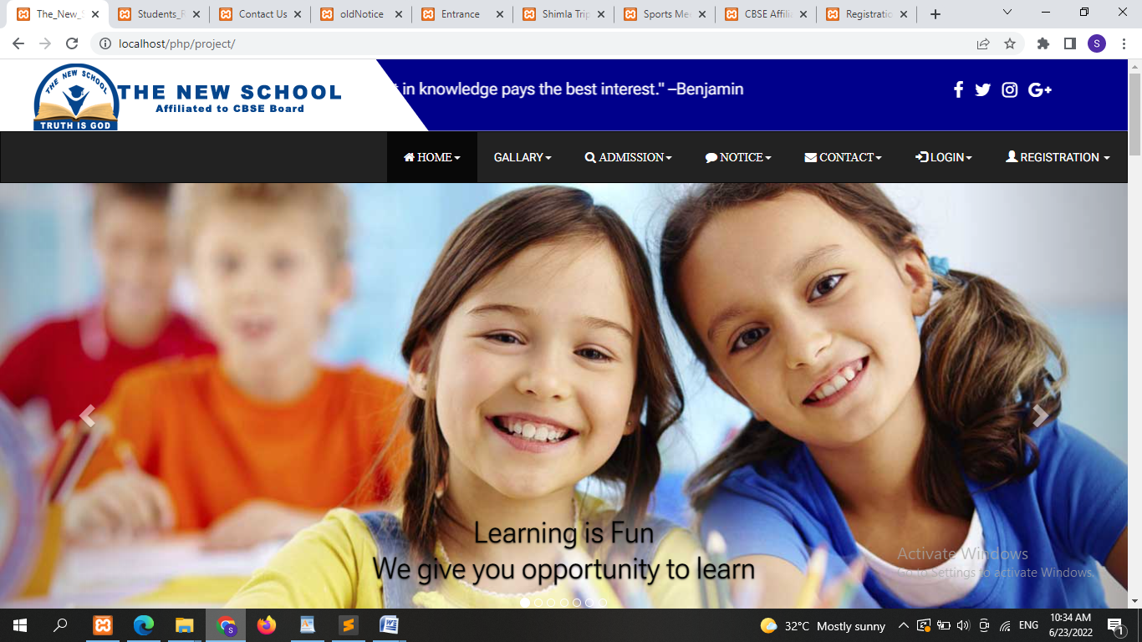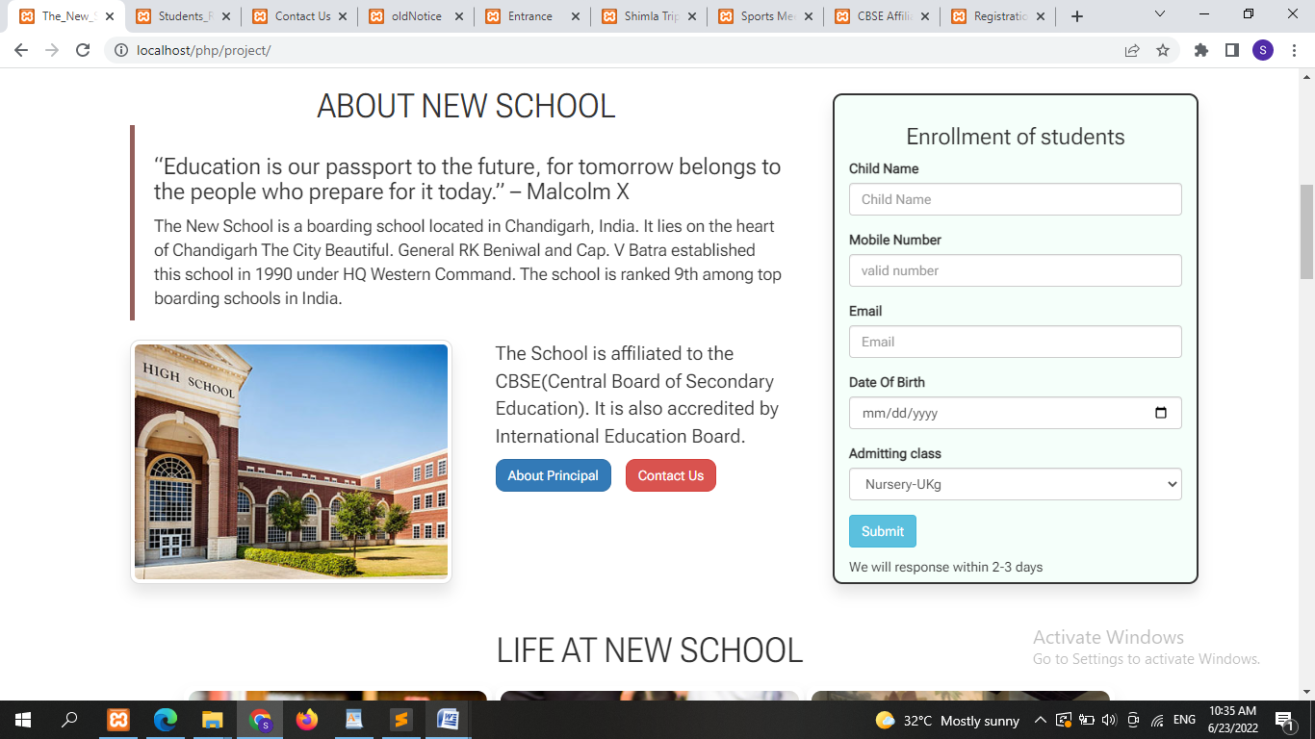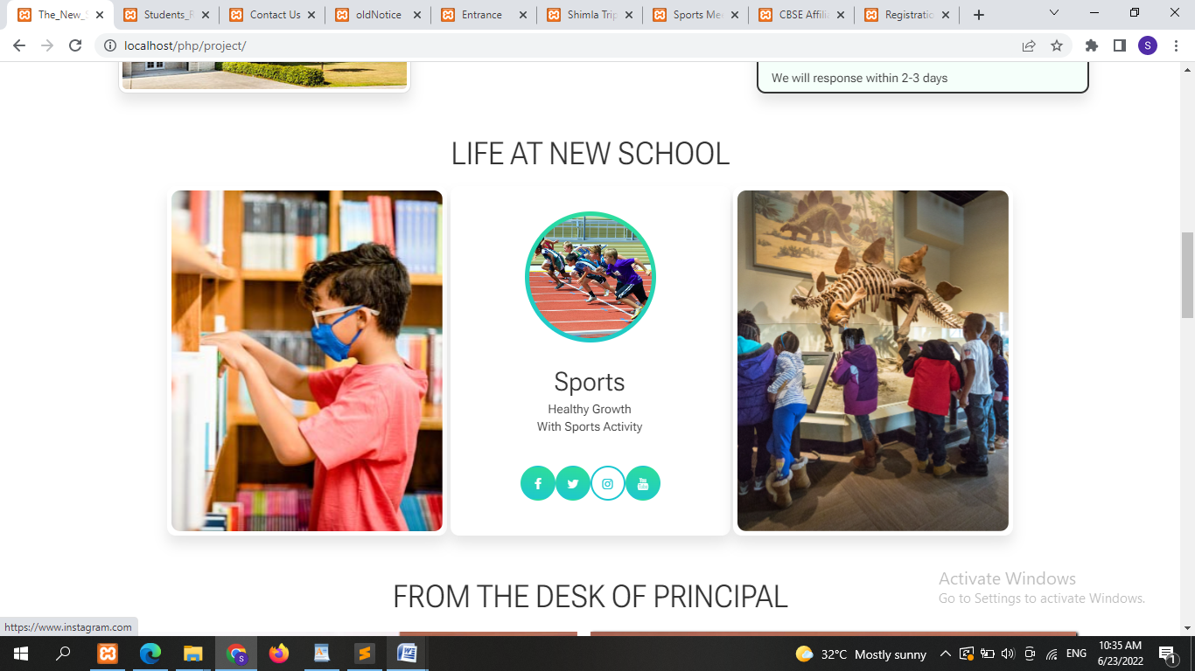

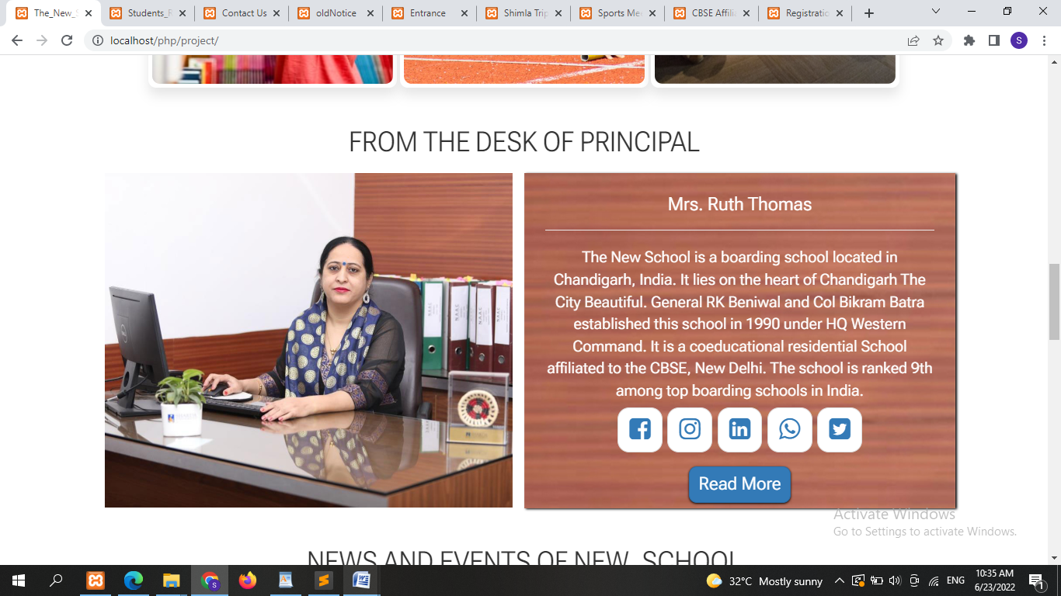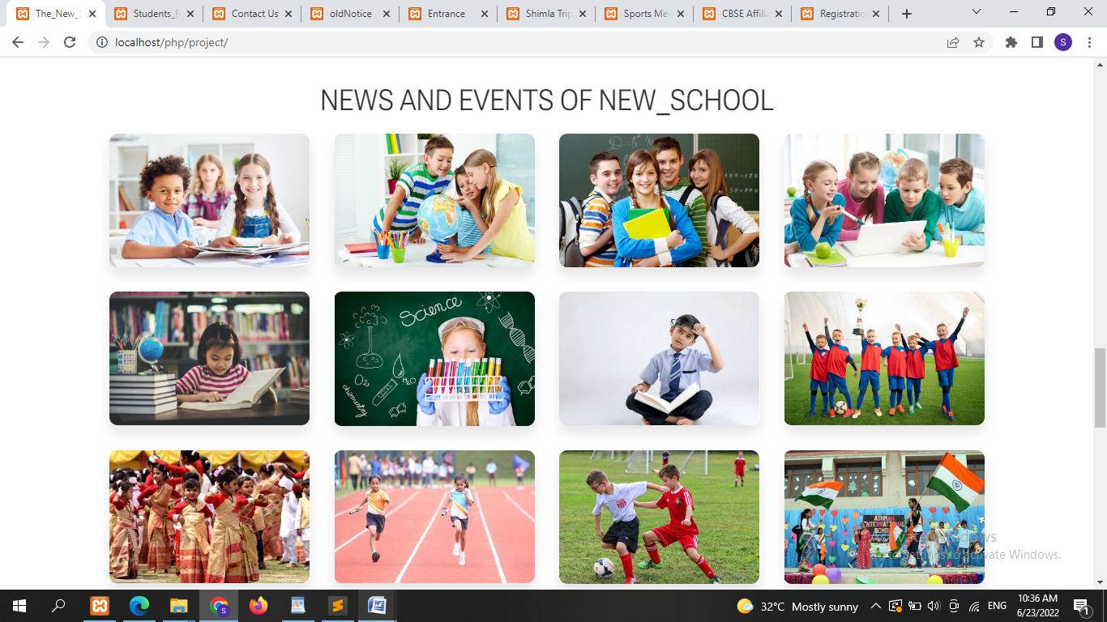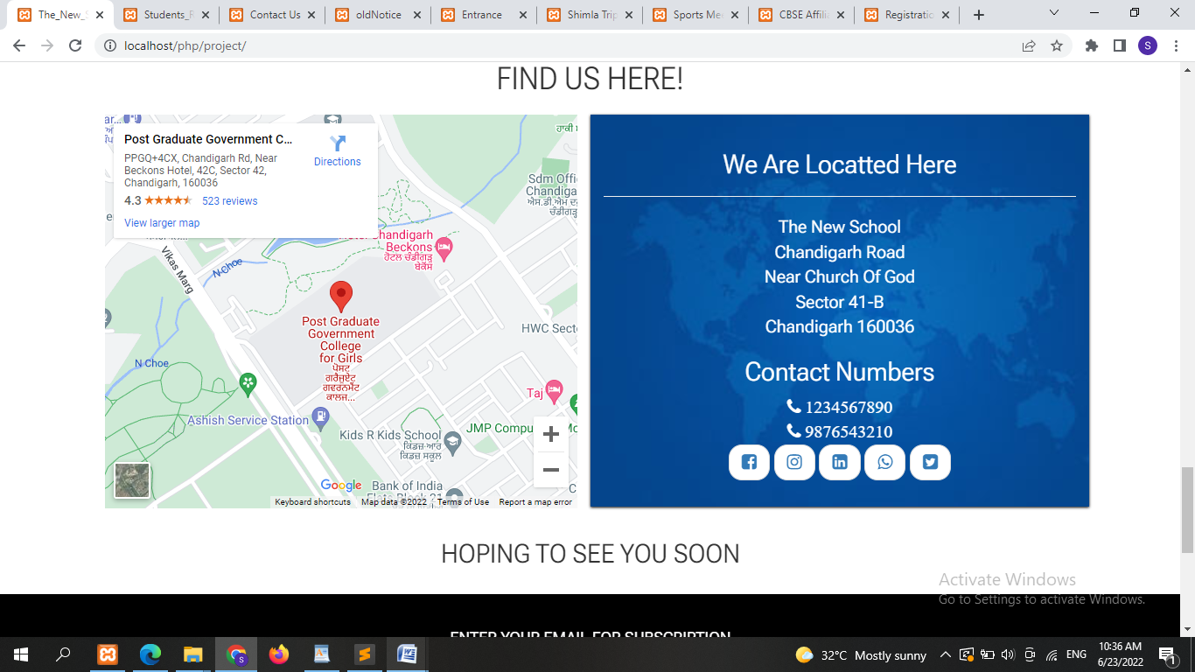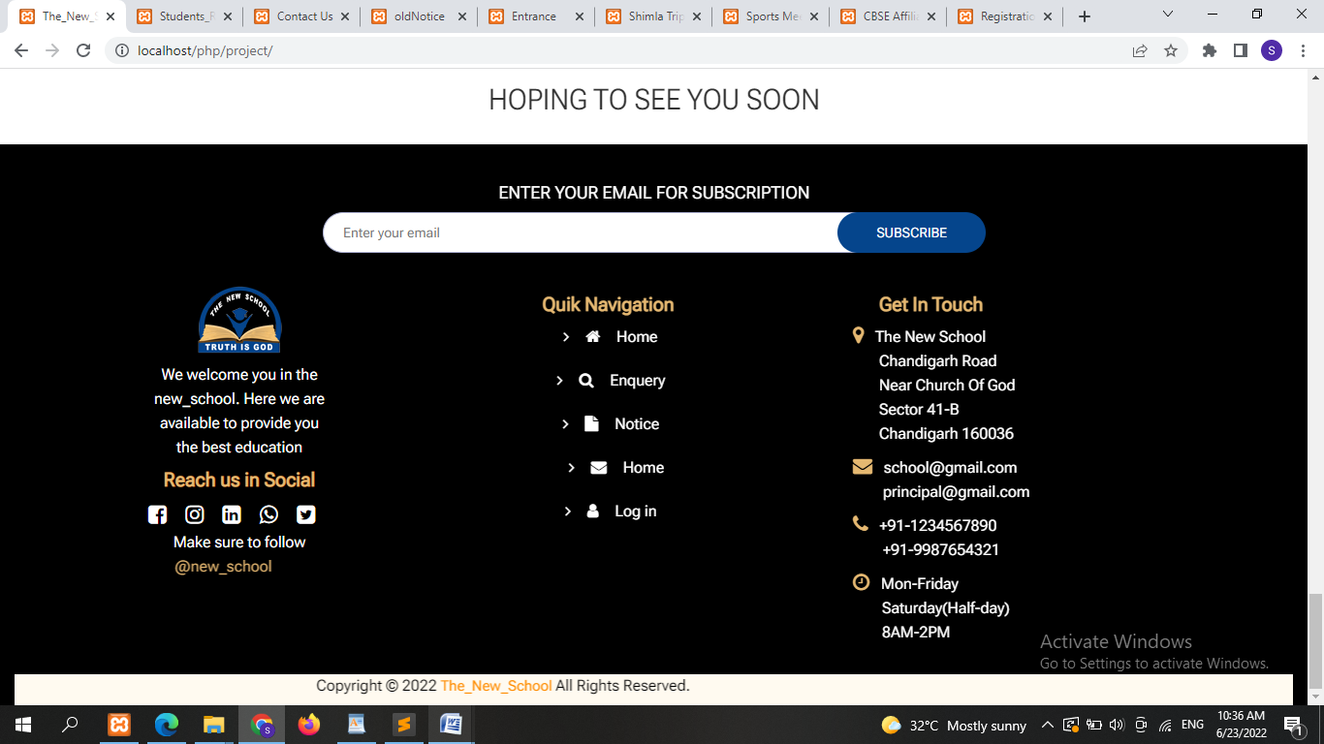



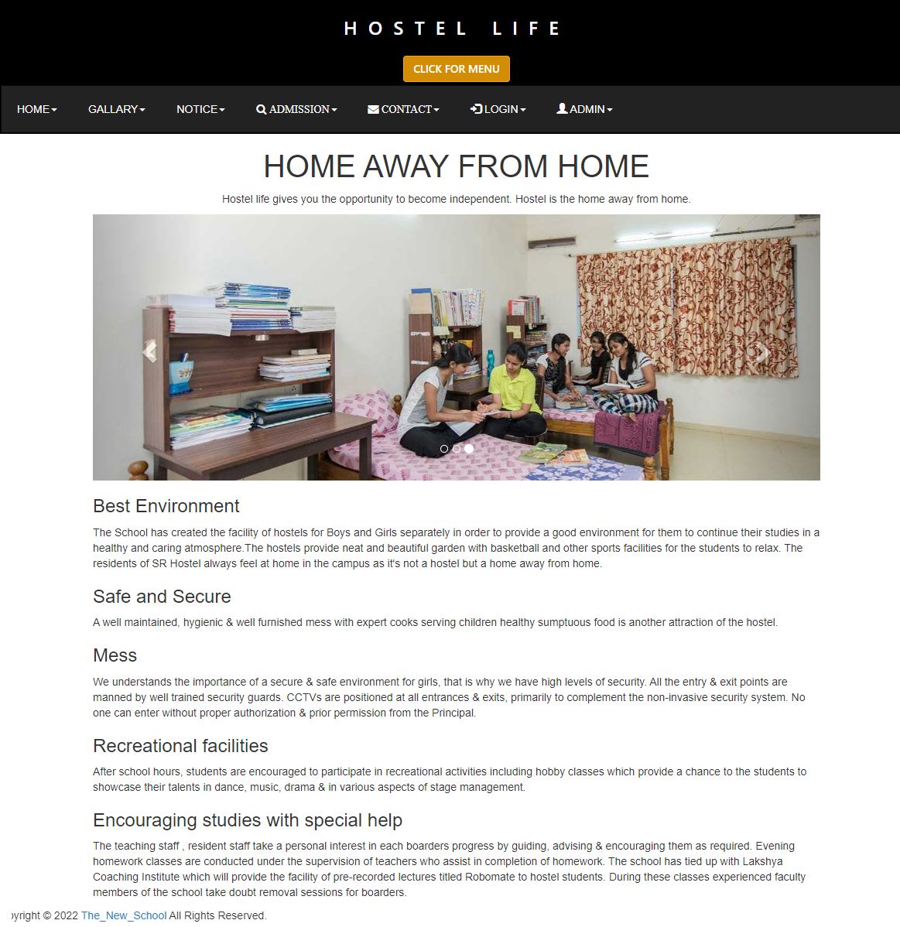

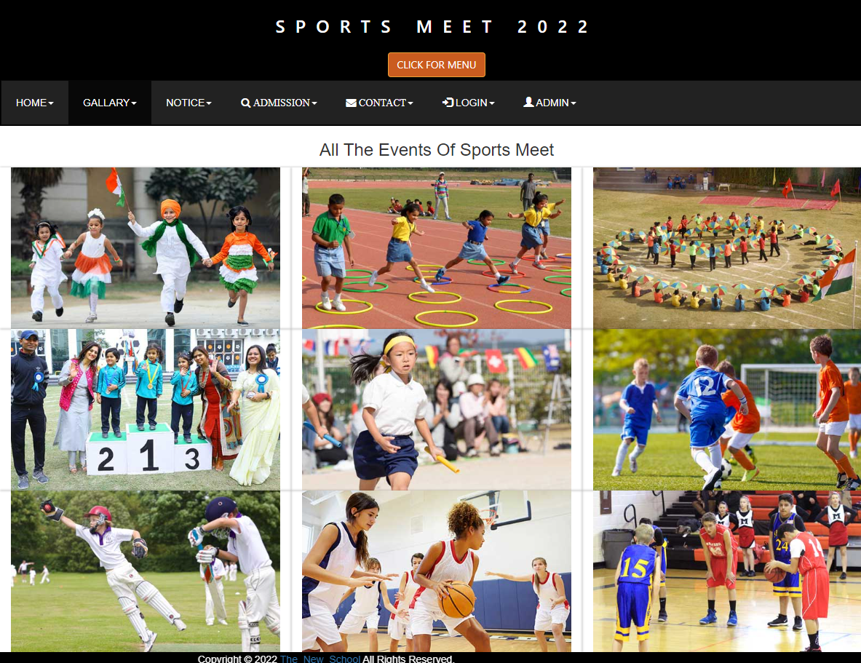

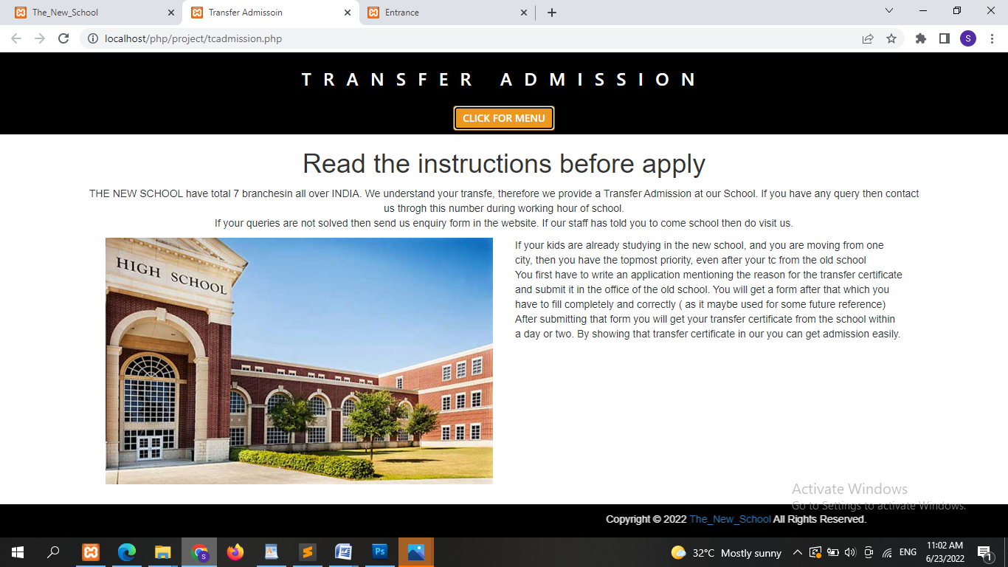

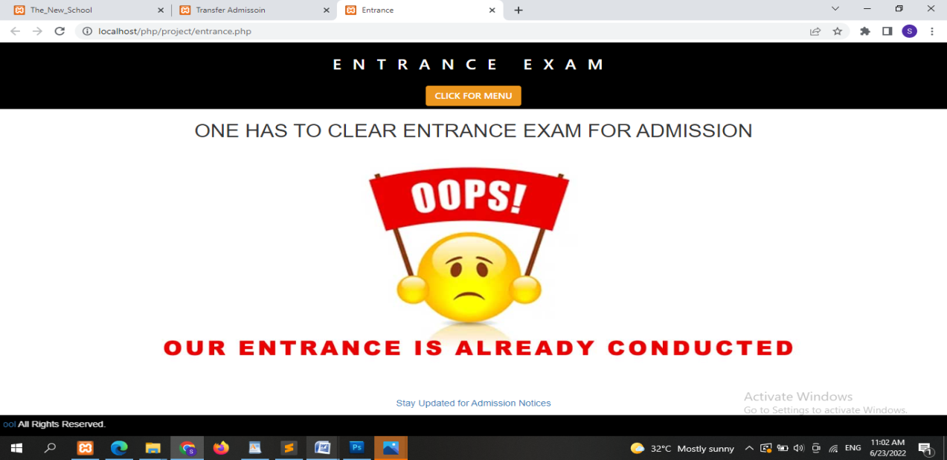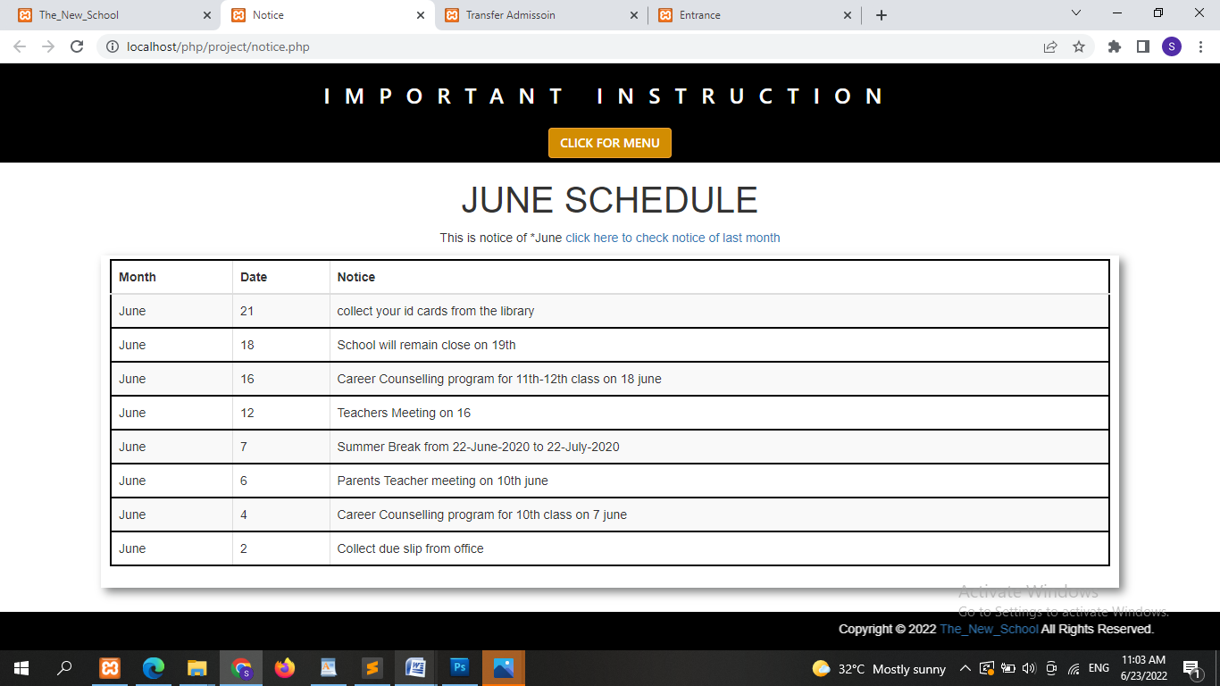

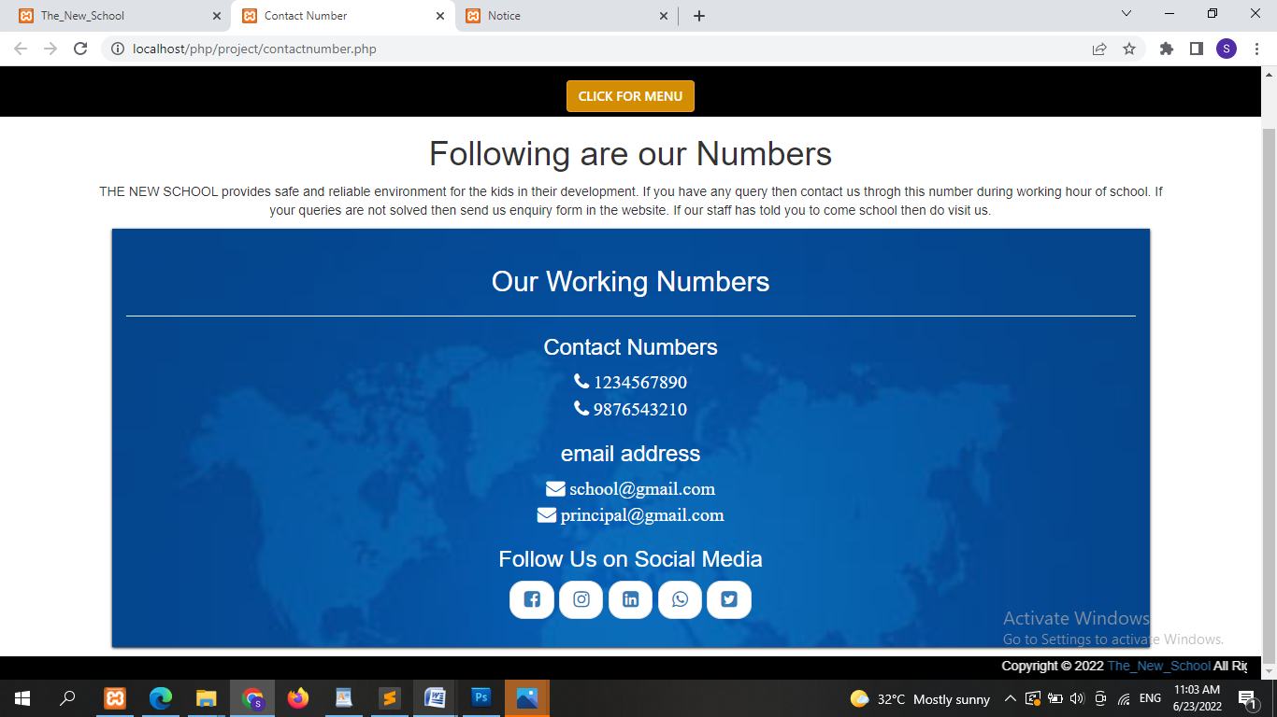

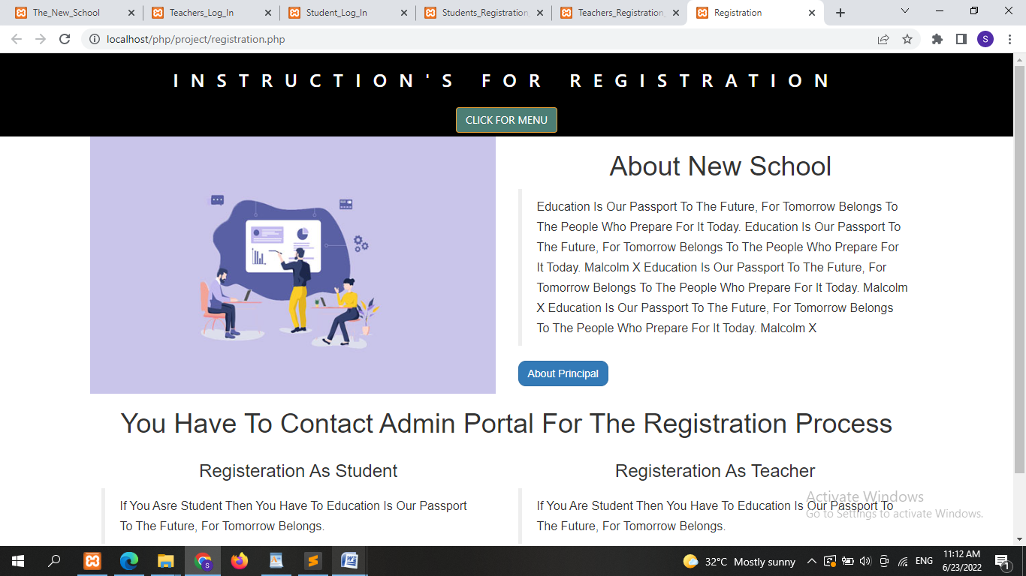

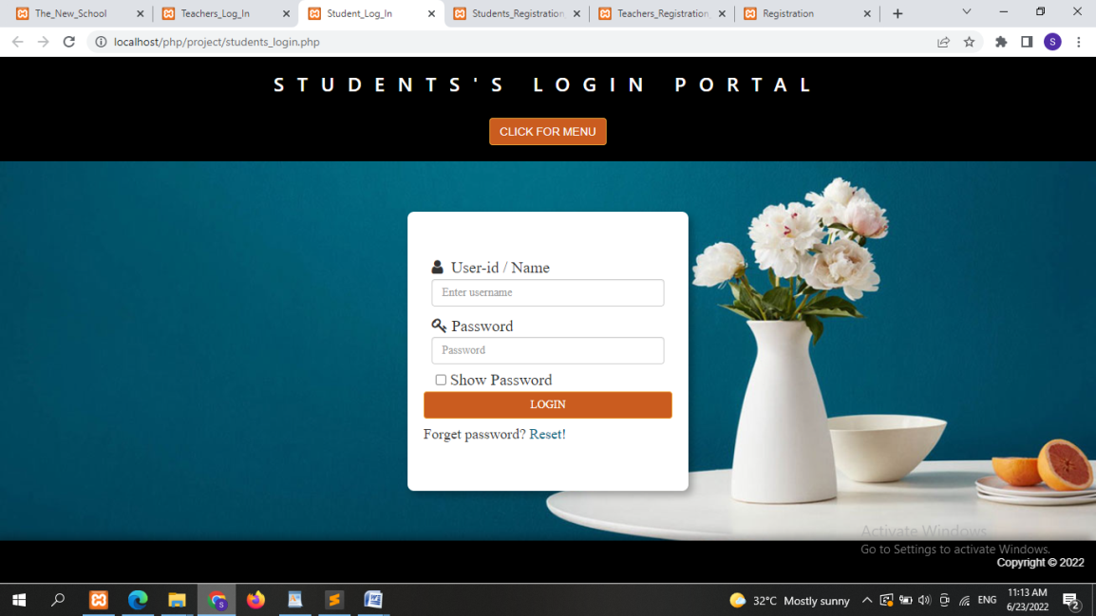

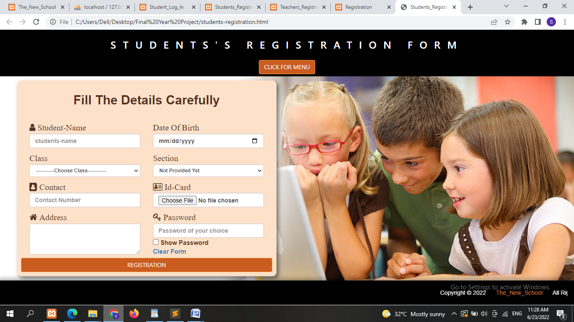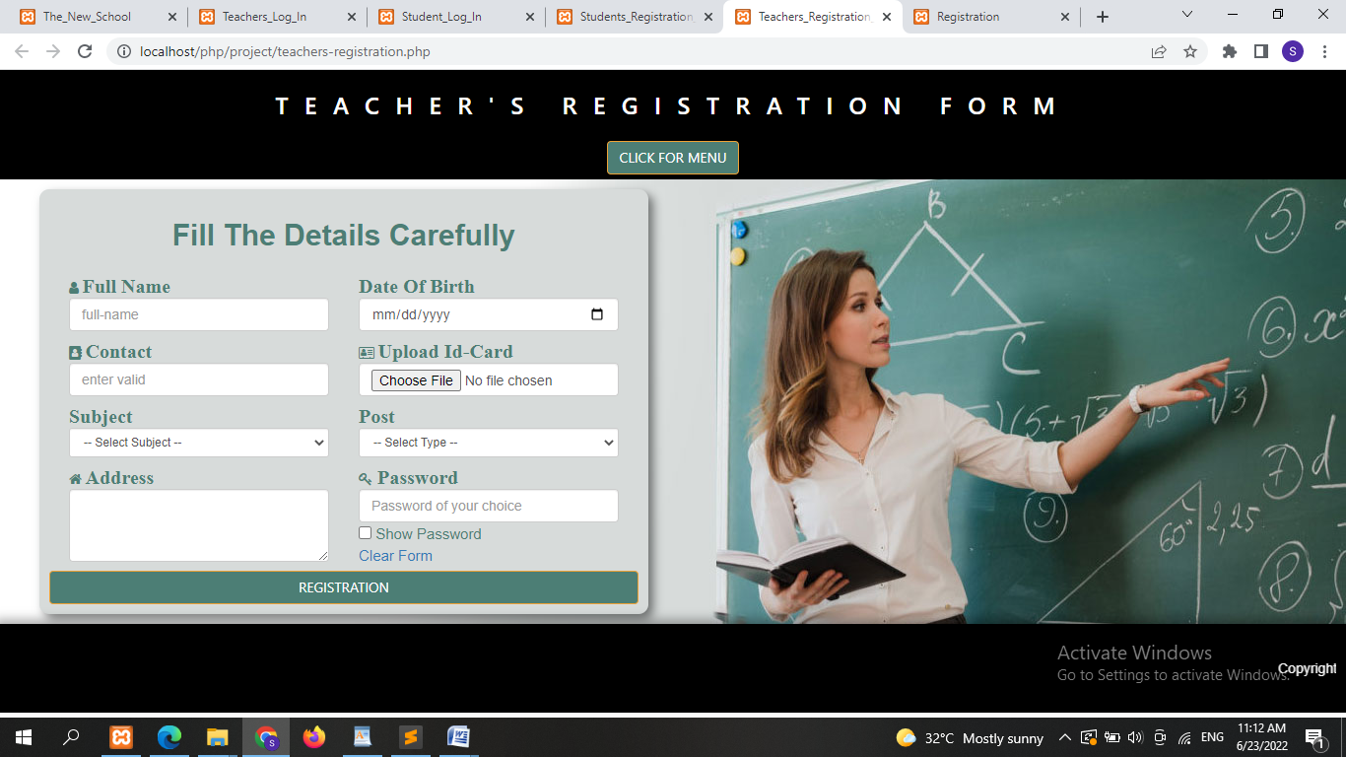

**DATA BASE TABLE**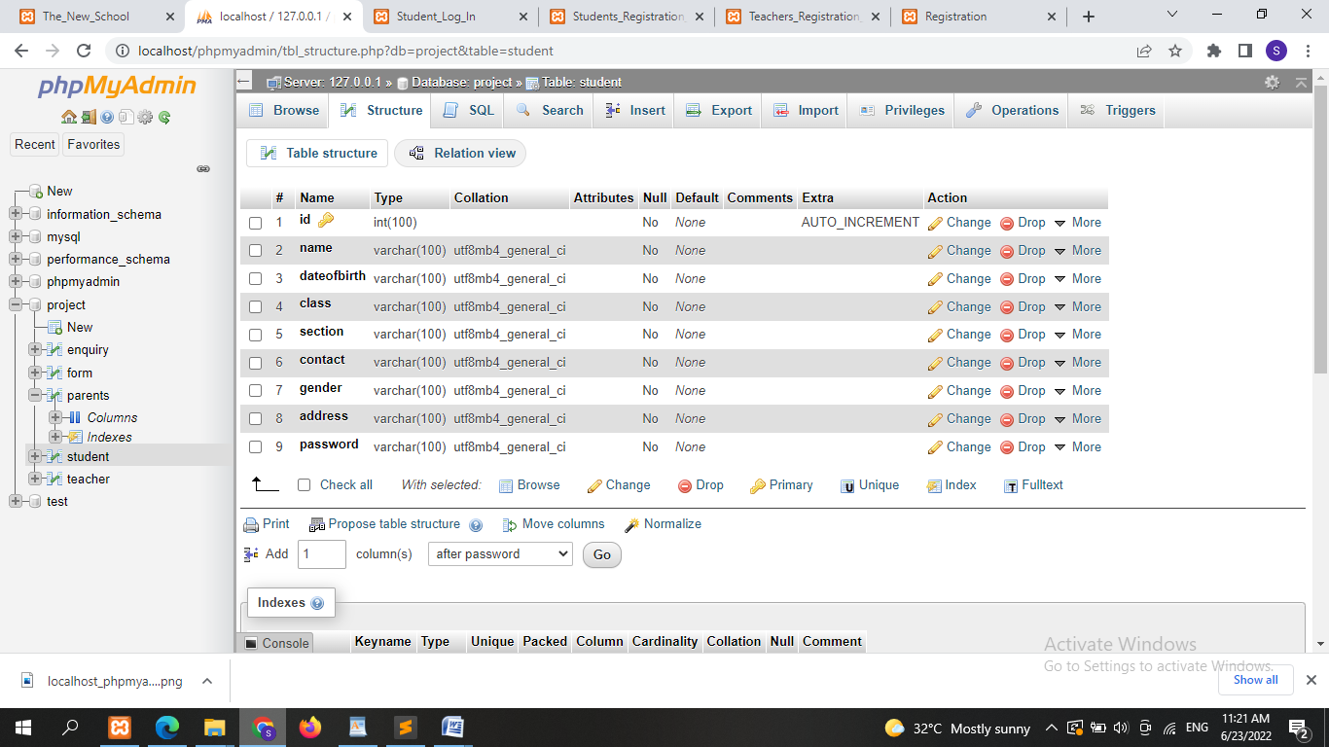

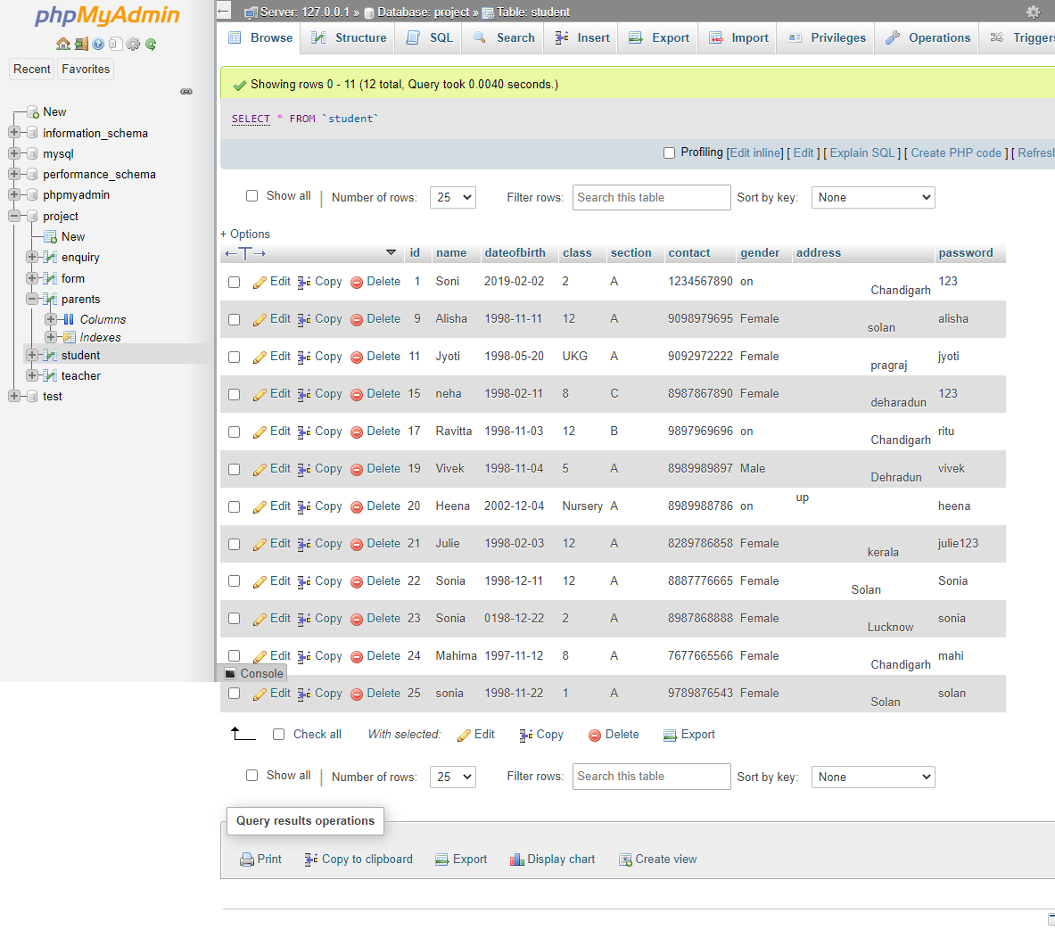

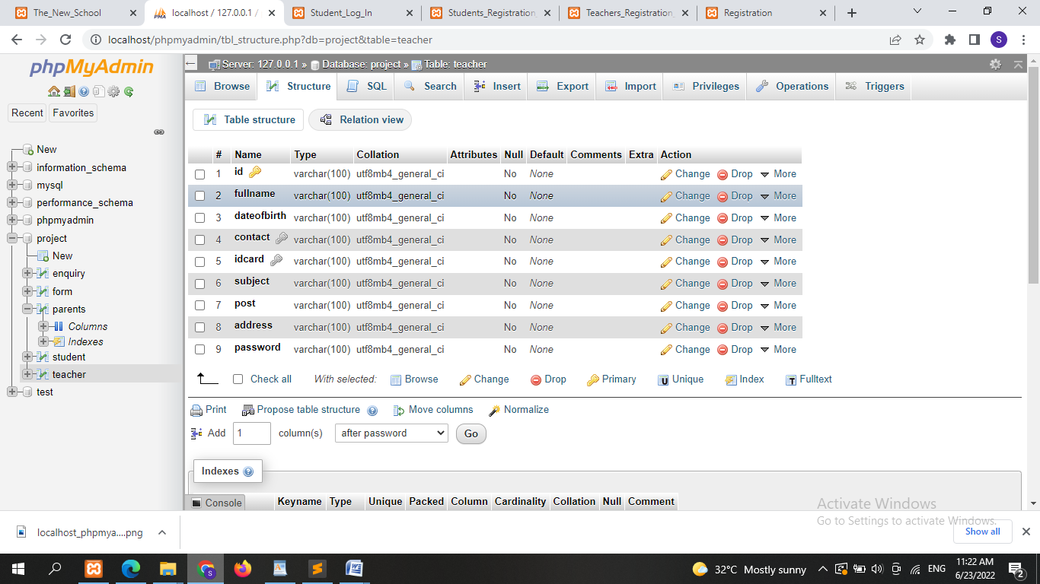

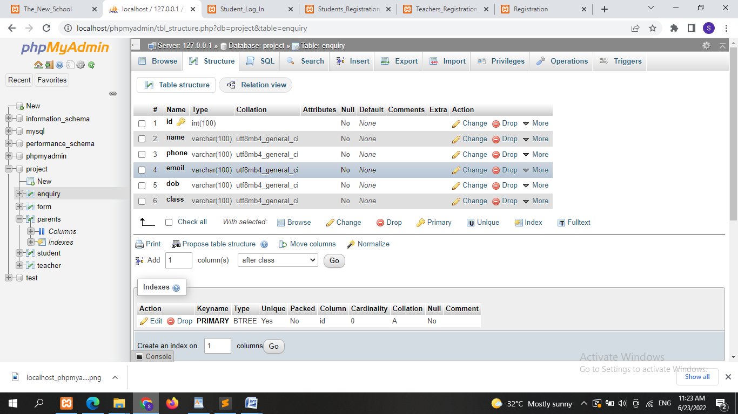

**Future Scope**

Nothing is perfect in this world. So, we are also no exception. Although, I have tried my best to present the information effectively, yet, there can be further enhancement in the Website. I have taken care of all the critical aspects, which need to take care of during the development of the Project.

Like the things this project also has some limitations and can further be enhances by some one else, because there are certain drawbacks that do not permit the system to be 100%accurate.

**Bibliography**

The following websites were consulted for relevant materials:

1. https://www.tutorialspoint.com
2. https://www.mysql.com/about
3. https://data-flair.training
4. <https://www.javatpoint.com>
5. https://www.w3school.com